**Name :** Patel Jeshankumar K. **Date :** 26/01/2024

**Roll No :** 038

**Semester :**  8th – Sem. **Year :** 2023-24

**Subject :** (801/802) – JAVA

**ProblemSheet-1**

* **Assignment based on Java Collection Framework. Write one program for every category.**

1. **Array List :**

ArrayList<String> Books = new ArrayList<String>();

System.out.println("\nHow Many Books You Want to Insert ? ");

System.out.print("> ");

int n = in.nextInt();

System.out.println("\nEnter Books Name List : ");

for (int i = 0; i < n; i++) {

Books.add(in.next());

}

1. **Write a Java program to create an array list, add some colors (strings) and print out the collection.**

**Source Code :**

protected void printBooks(ArrayList<String> books)

{

System.out.print("Available Book List : "+books);

System.out.println();

}

**Output :**

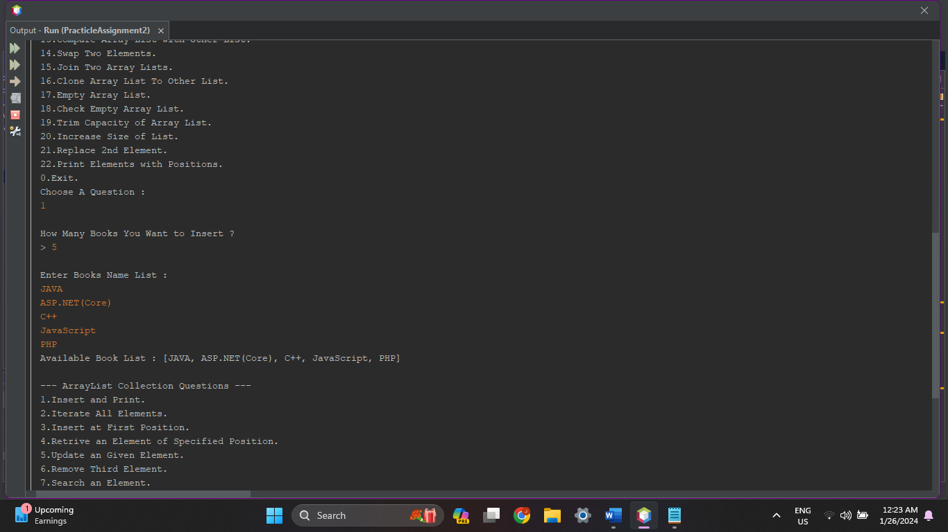

1. **Write a Java program to iterate through all elements in an array list.**

**Source Code :**

protected void IterateArraylist(ArrayList<String> books)

{

System.out.print("\n\nAvailable Books : ");

int cnt = 0;

for(String c: books)

{

System.out.print("["+cnt+"] "+ c+"\t");

cnt++;

}

System.out.println();

}

**Output :**

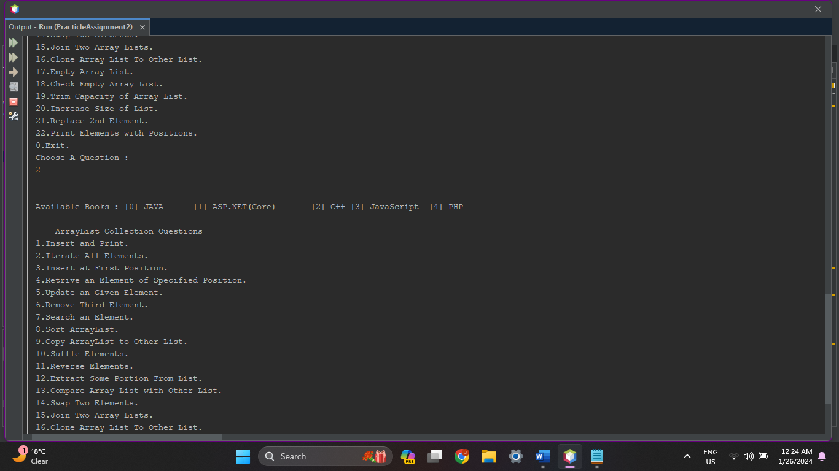

1. **Write a Java program to insert an element into the array list at the first position.**

**Source Code :**

protected void InsertAtFirstPosition(ArrayList<String> books)

{

String book;

System.out.print("\nBook List : "+books);

System.out.print("\nAdd Book At First : ");

book = in.next();

books.add(0, book);

System.out.println("Book Added At First!!");

System.out.print("\nBook List : "+books);

System.out.println();

}

**Output :**

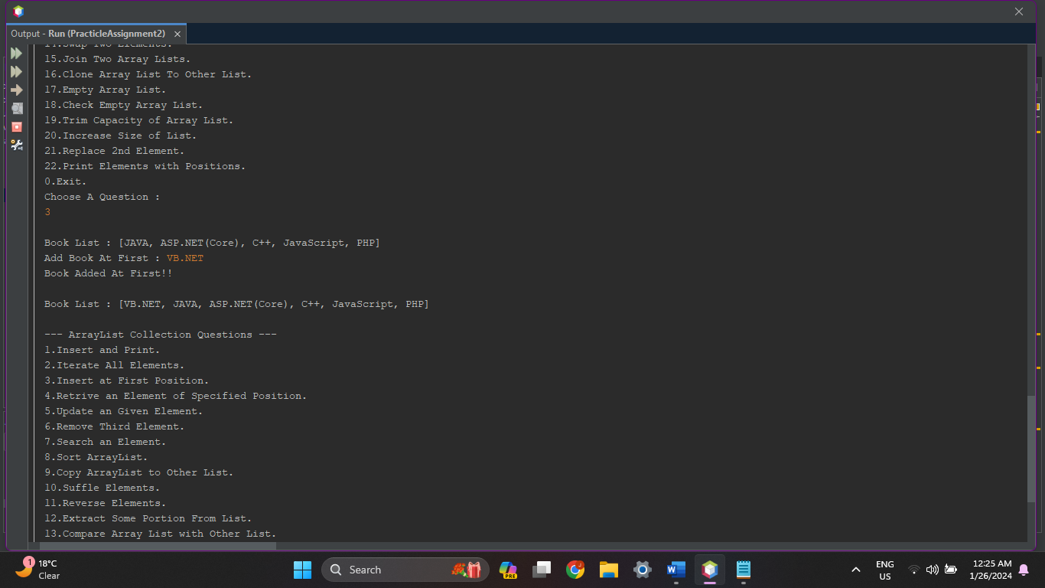

1. **Write a Java program to retrieve an element (at a specified index) from a given array list.**

**Source Code :**

protected void RetriveElement(ArrayList<String> Books)

{

int i;

System.out.print("\nBook List : "+Books);

System.out.print("\nEnter Index : ");

i = in.nextInt();

System.out.println("Book at Index ["+i+"] : "+Books.get(i));

System.out.println();

}

**Output :**

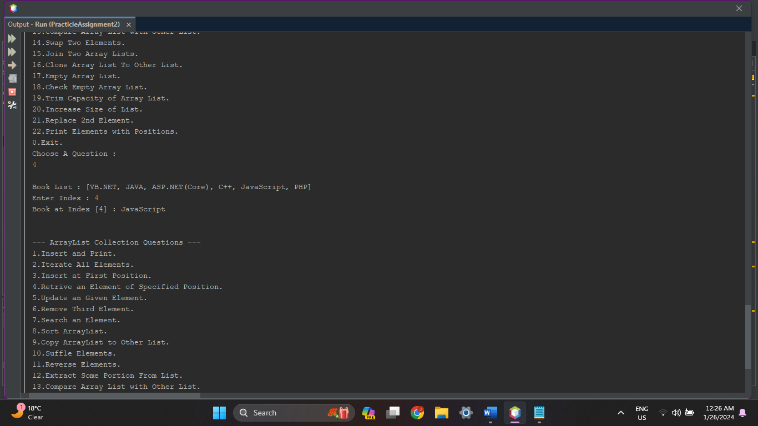

1. **Write a Java program to update an array element by the given element.**

**Source Code :**

protected void UpdateElement(ArrayList<String> Books)

{

int i;

String book;

System.out.print("\nBook List : "+Books);

System.out.println("\nIndex to Update : ");

i = in.nextInt();

System.out.println("\nBook Value for Update : ");

book = in.next();

Books.set(i, book);

System.out.println("Book Updated At Index ["+i+"]!!");

System.out.print("\nBook List : "+Books);

System.out.println();

}

**Output :**

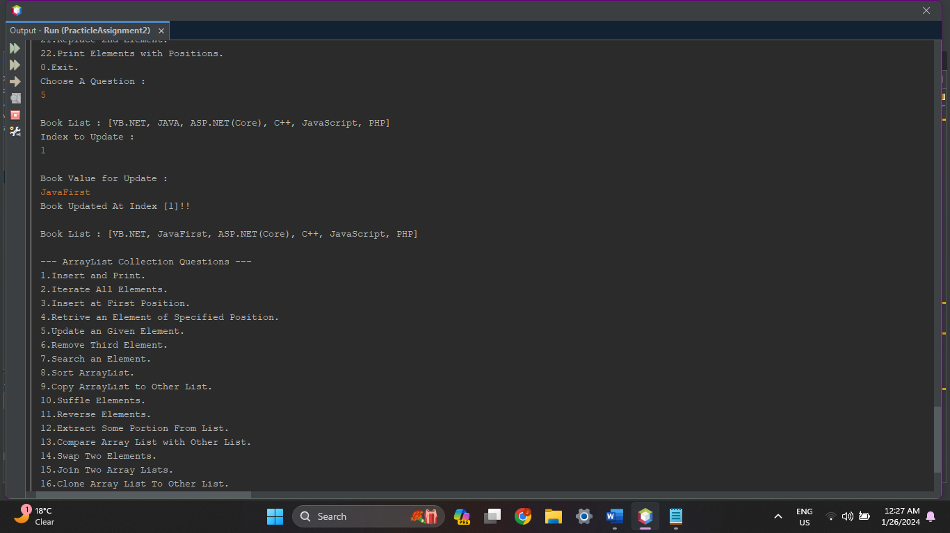

1. **Write a Java program to remove the third element from an array list.**

**Source Code :**

protected void RemoveThirdElement(ArrayList<String> Books)

{

System.out.println("Third Element ["+Books.get(2)+"] Deleted!!");

Books.remove(2);

System.out.println();

}

**Output :**

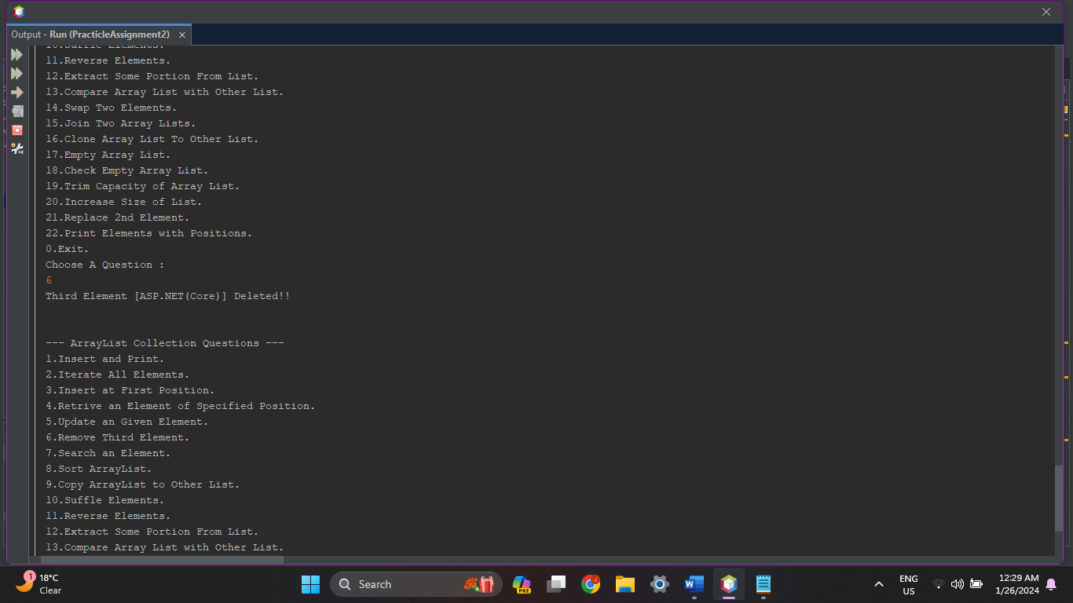

1. **Write a Java program to search for an element in an array list.**

**Source Code :**

protected void SearchElement(ArrayList<String> Books)

{

String book;

System.out.print("\nBook List : "+Books);

System.out.print("\nSearch a Book : ");

book = in.next();

System.out.println();

for(int i=0;i<Books.size();i++)

{

if(Books.get(i).equalsIgnoreCase(book))

{

System.out.println("Book "+book+" Found At Index ["+i+"]!!");

}

}

}

**Output :**

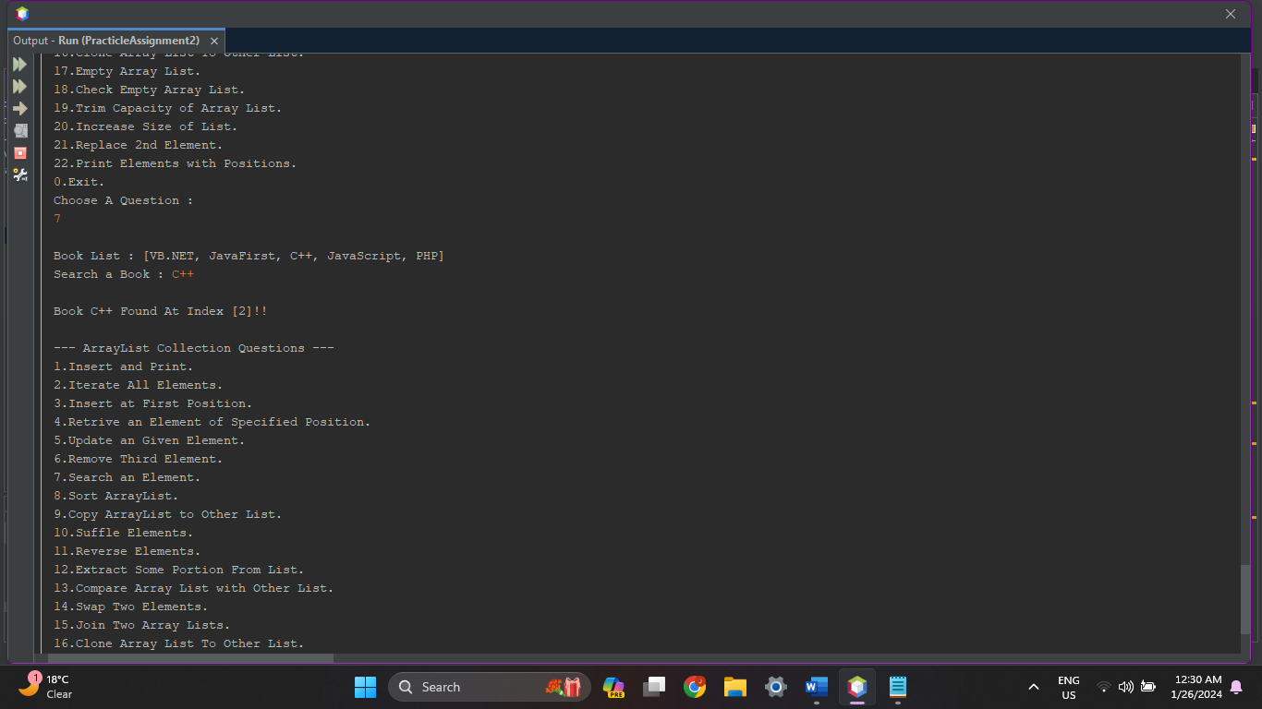

1. **Write a Java program to sort a given array list.**

**Source Code :**

protected void SortArrayList(ArrayList<String> Books)

{

System.out.print("\nBook List Before Sorting : "+Books);

Collections.sort(Books);

System.out.print("\nBook List After Sorting : "+Books);

System.out.println();

}

**Output :**

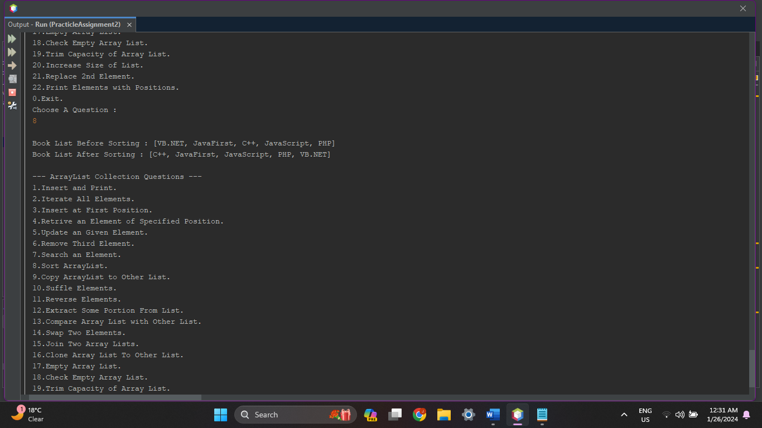

1. **Write a Java program to copy one array list into another.**

**Source Code :**

protected void CopyArrayListToAnotherArrayList(ArrayList<String> Books)

{

ArrayList<String> CopyCat = new ArrayList<String>();

System.out.print("\nBook List : "+Books);

System.out.println("\n\nCopying Book List To Other List...");

CopyCat.addAll(Books);

System.out.println("Successfully Coppied Book List To Other List...");

System.out.print("\nCoppied Book List : "+CopyCat);

System.out.println();

}

**Output :**

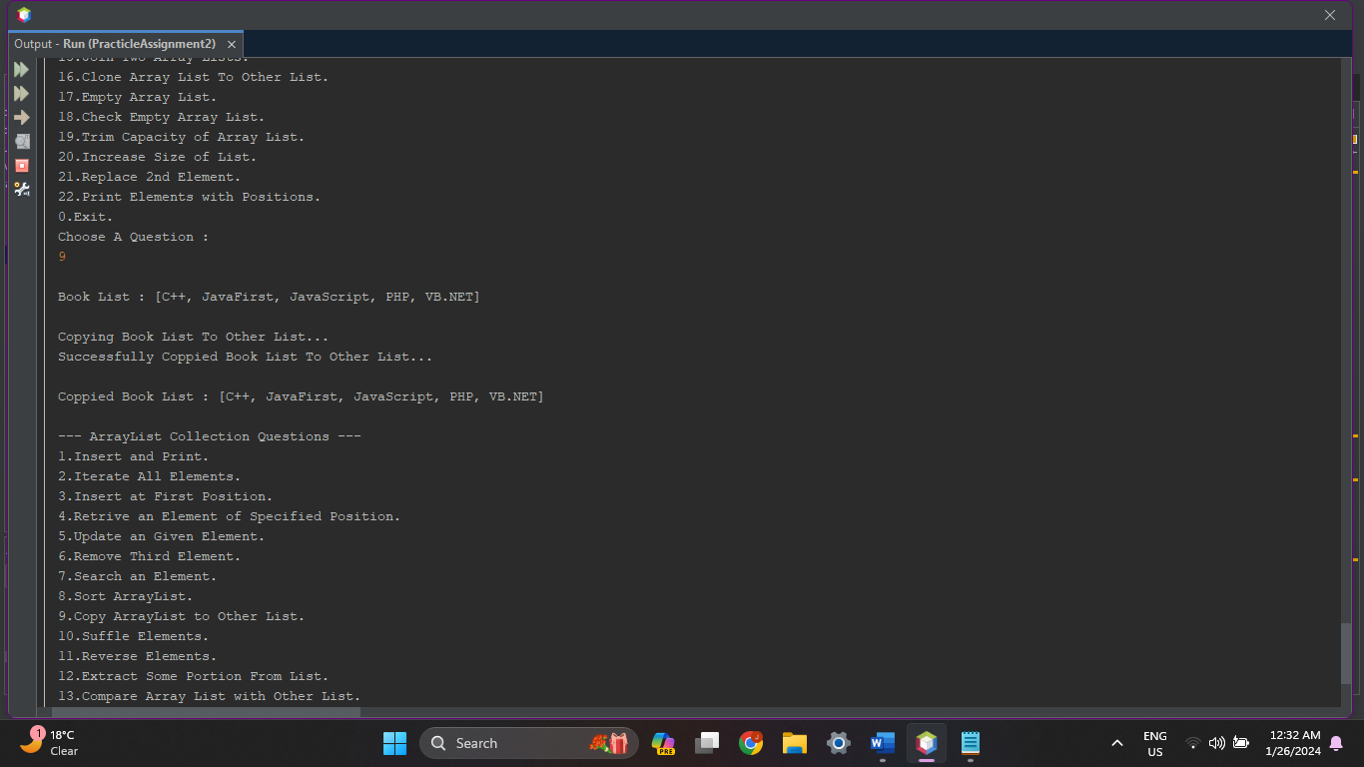

1. **Write a Java program to shuffle elements in an array list.**

**Source Code :**

protected void SuffleElements(ArrayList<String> Books)

{

System.out.print("\nBook List Before Suffling : "+Books);

Collections.shuffle(Books);

System.out.print("\nBook List After Suffling : "+Books);

System.out.println();

}

**Output :**

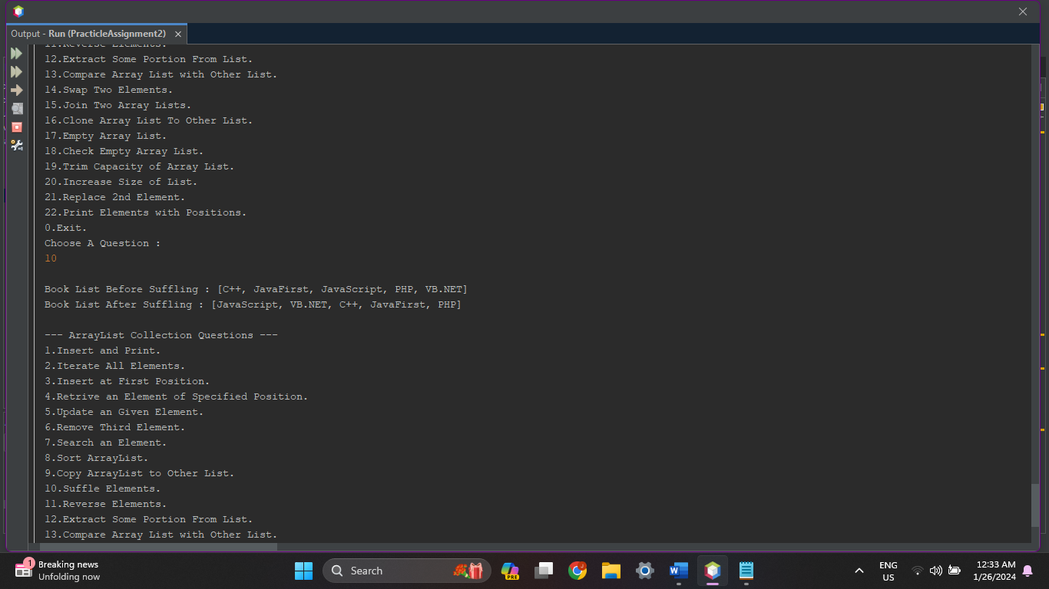

1. **Write a Java program to reverse elements in an array list.**

**Source Code :**

protected void ReverseElements(ArrayList<String> Books)

{

System.out.print("\nBook List Before Reversing : "+Books);

Collections.reverse(Books);

System.out.print("\nBook List After Reversing : "+Books);

System.out.println();

}

**Output :**

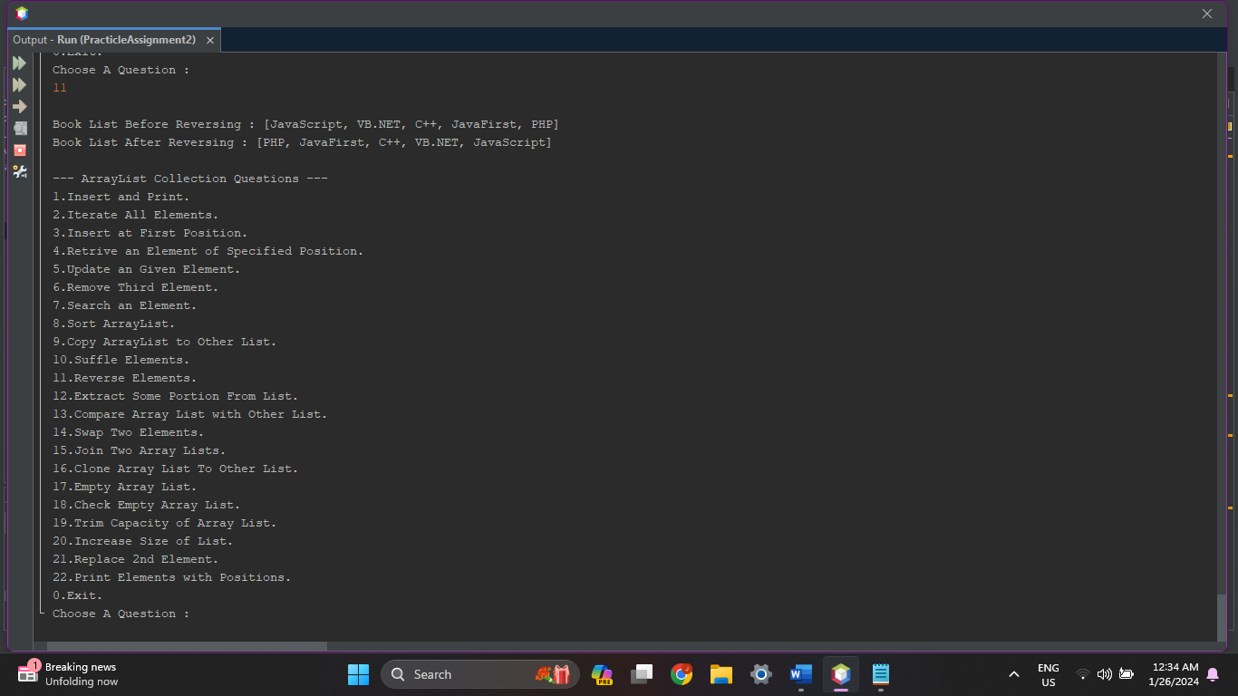

1. **Write a Java program to extract a portion of an array list.**

**Source Code :**

protected void ExtractPortion(ArrayList<String> Books)

{

System.out.print("\nFull Book List : "+Books);

System.out.print("\n3 Elements From Book List : "+Books.subList(1, 4));

System.out.println();

}

**Output :**

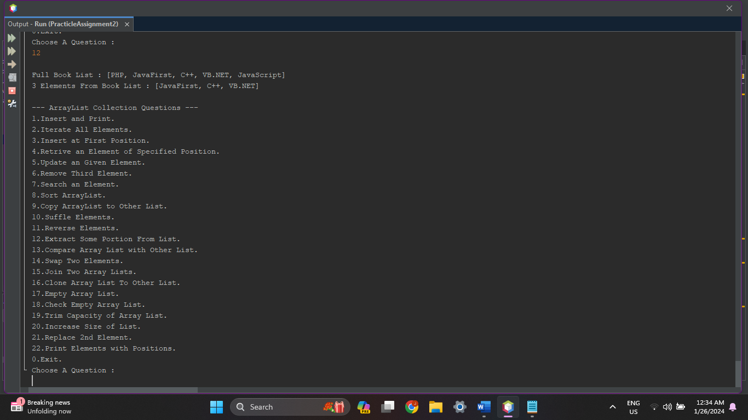

1. **Write a Java program to compare two array lists.**

**Source Code :**

protected void CompareArrayLists(ArrayList<String> Books)

{

ArrayList<String> Book1 = new ArrayList<String>();

ArrayList<String> Book2 = new ArrayList<String>();

Book1.add("Java");

Book1.add("JavaScript");

Book1.add("HTML");

Book1.add("CSS");

Book2.addAll(Books);

System.out.print("\nYour Book List : "+Books);

System.out.print("\nBook List 1 : "+Book1);

System.out.print("\nBook List 2 : "+Book2);

System.out.println();

if(Books.equals(Book1))

{

System.out.print("\nYour Book List & Book List 1 is Equal!!");

}

else

{

System.out.print("\nYour Book List & Book List 1 is Different!!");

}

if(Books.equals(Book2))

{

System.out.print("\nYour Book List & Book List 2 is Equal!!");

}

else

{

System.out.print("\nYour Book List & Book List 2 is Different!!");

}

System.out.println();

}

**Output :**

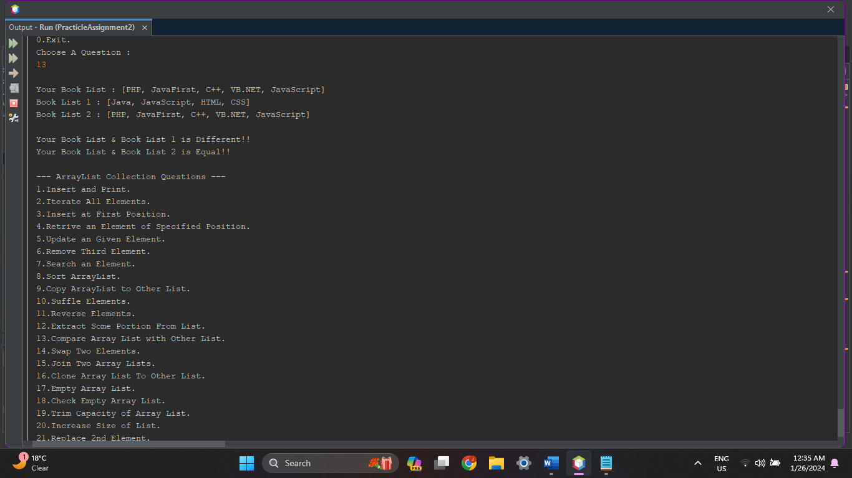

1. **Write a Java program that swaps two elements in an array list.**

**Source Code :**

protected void SwapTwoElements(ArrayList<String> Books)

{

String ele1, ele2;

int i1, i2;

i1 = 0;

i2 = 0;

System.out.print("\nBook List : "+Books);

System.out.print("\nEnter Element1 : ");

ele1 = in.next();

System.out.print("\nEnter Element2 : ");

ele2 = in.next();

for(int i=0;i<Books.size();i++)

{

if(Books.get(i).equalsIgnoreCase(ele1))

{

i1 = i;

}

else if(Books.get(i).equalsIgnoreCase(ele2))

{

i2 = i;

}

}

Collections.swap(Books, i1, i2);

System.out.print("\nSwapped Elements Book List : "+Books);

System.out.println();

}

**Output :**

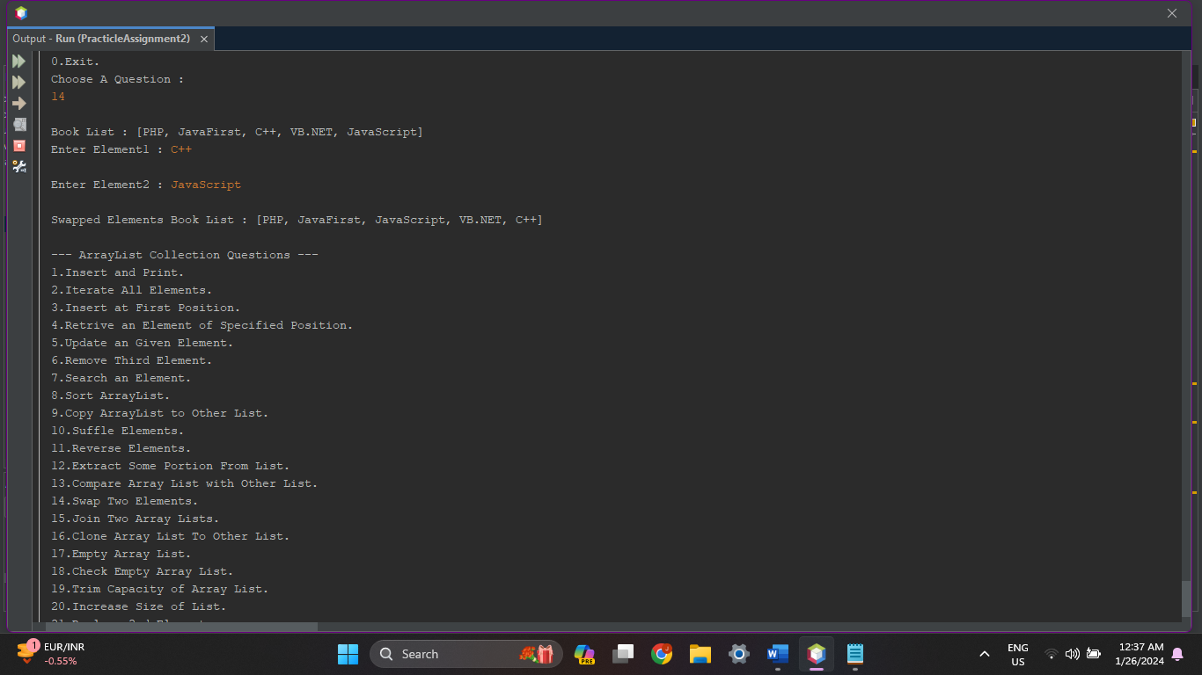

1. **Write a Java program to join two array lists.**

**Source Code :**

protected void JoinTwoArrayLists(ArrayList<String> Books)

{

ArrayList<String> Books2 = new ArrayList<String>();

int n;

System.out.println("Insert Elements in Second Arraylist");

System.out.println("How Many Books You Want to Insert ? ");

System.out.print("> ");

n = in.nextInt();

System.out.println("\nEnter Books Name List : ");

for (int i = 0; i < n; i++) {

Books2.add(in.next());

}

System.out.print("\nYour Book List : "+Books);

System.out.print("\nSecond Book List : "+Books2);

System.out.println();

Books.removeAll(Books2);

Books.addAll(Books2);

System.out.print("\nJoined Book List : "+Books);

System.out.println();

}

**Output :**

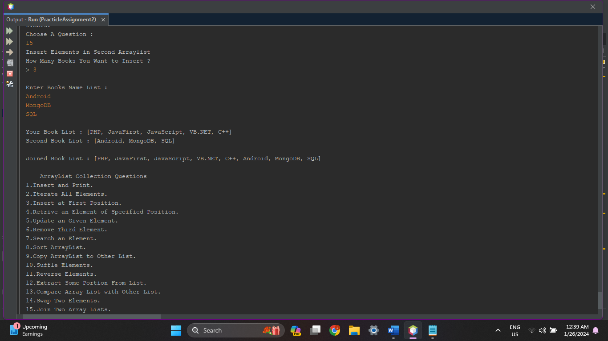

1. **Write a Java program to clone an array list to another array list.**

**Source Code :**

protected void CloneArrayListToOtherList(ArrayList<String> Books)

{

ArrayList Books2 = (ArrayList)Books.clone();

System.out.print("\nYour Book List : "+Books);

System.out.print("\nCloned Book List : "+Books2);

System.out.println();

}

**Output :**

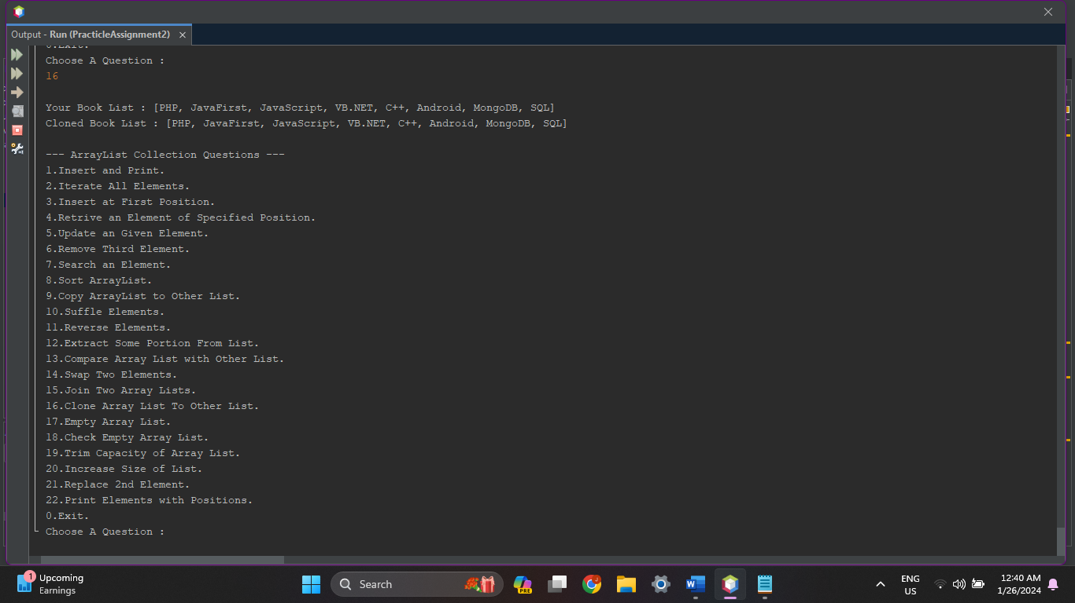

1. **Write a Java program to empty an array list.**

**Source Code :**

protected void MakeListEmpty(ArrayList<String> Books)

{

System.out.print("\nYour Book List : "+Books);

Books.removeAll(Books);

System.out.print("\nEmpty Book List : "+Books);

System.out.println();

}

**Output :**

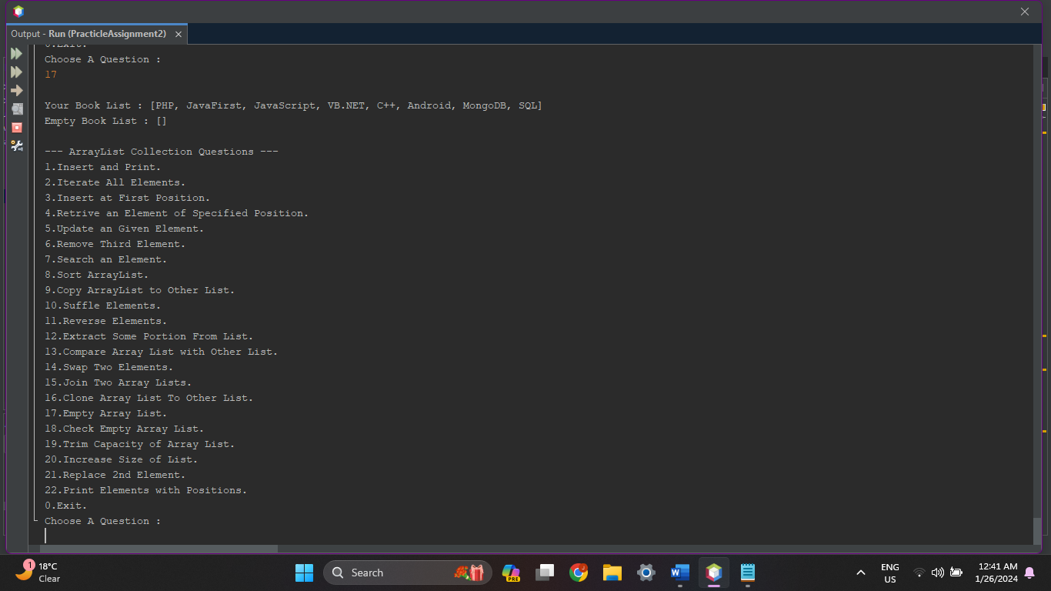

1. **Write a Java program to test whether an array list is empty or not.**

**Source Code :**

protected void CheckListEmpty(ArrayList<String> Books)

{

if(Books.isEmpty())

{

System.out.print("\nYour Book List is Empty!!");

}

else

{

System.out.print("\nYour Book List is not Empty, contains : "+Books);

}

System.out.println();

}

**Output :**

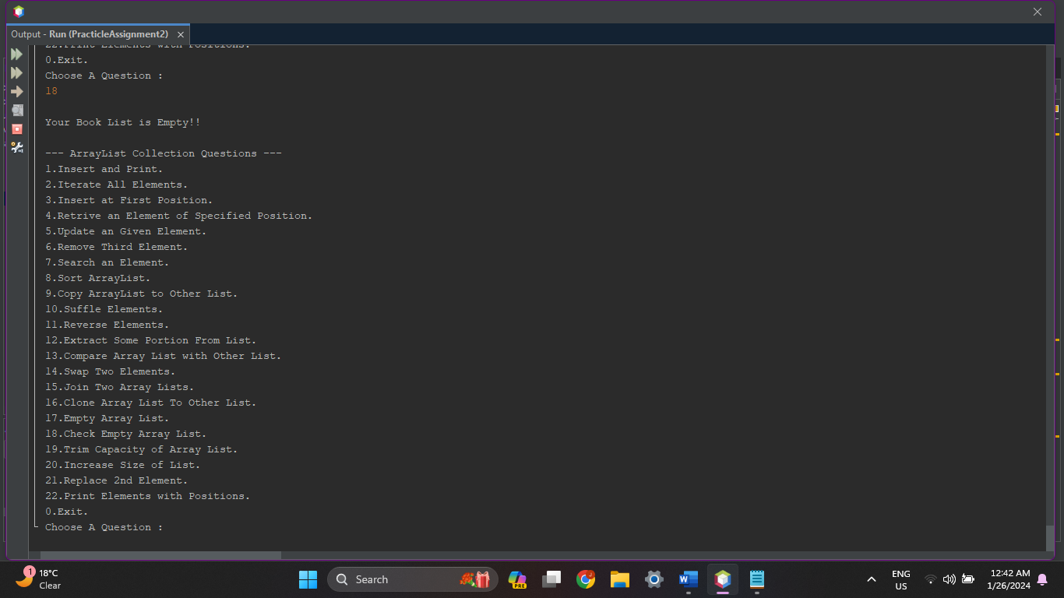

1. **Write a Java program for trimming the capacity of an array list.**

**Source Code :**

protected void TrimCapacity(ArrayList<String> Books)

{

System.out.print("\nYour Book List : "+Books);

Books.trimToSize();

System.out.print("\nList Trimmed Size : "+Books.size());

System.out.println();

}

**Output :**

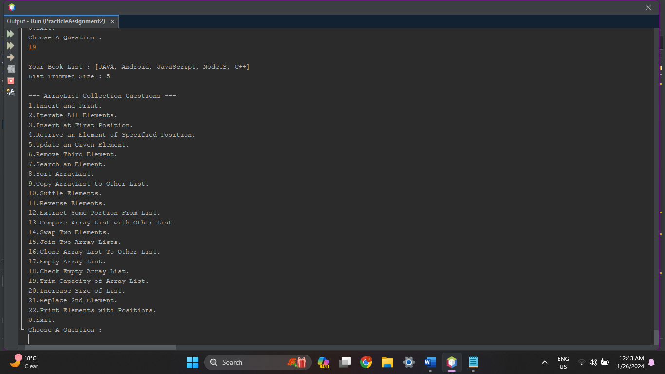

1. **Write a Java program to increase an array list size.**

**Source Code :**

protected void IncreaseSize(ArrayList<String> Books)

{

int capacity;

System.out.print("\nYour Book List : "+Books);

System.out.print("\nList Size : "+Books.size());

System.out.print("\n\nGive Numbers to Increase the Size of List : ");

capacity = in.nextInt();

Books.ensureCapacity(capacity);

System.out.println("Your List Capacity is Now Increased to "+capacity);

System.out.println();

}

**Output :**

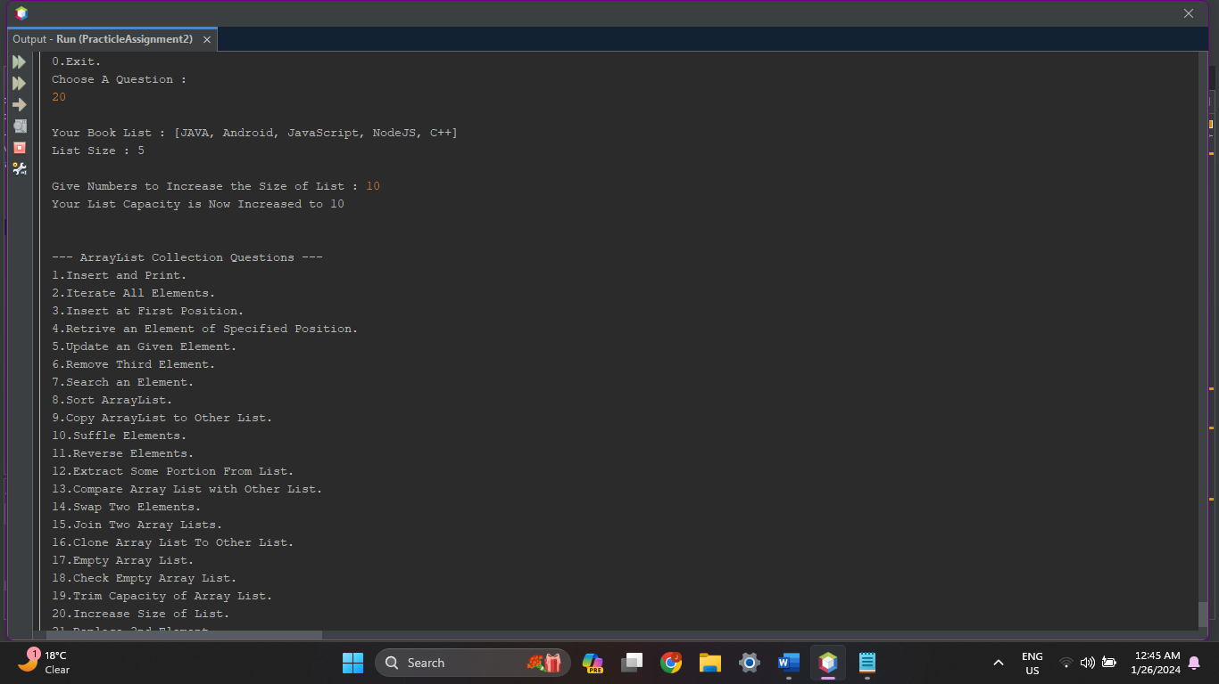

1. **Write a Java program to replace the second element of an ArrayList with the specified element.**

**Source Code :**

protected void Replace2ndElement(ArrayList<String> Books)

{

System.out.print("\nYour Book List : "+Books);

System.out.println();

System.out.print("\nGive Value to Replace 2nd Element : ");

Books.set(1, in.next());

System.out.println();

System.out.print("\nUpdated Book List : "+Books);

System.out.println();

}

**Output :**

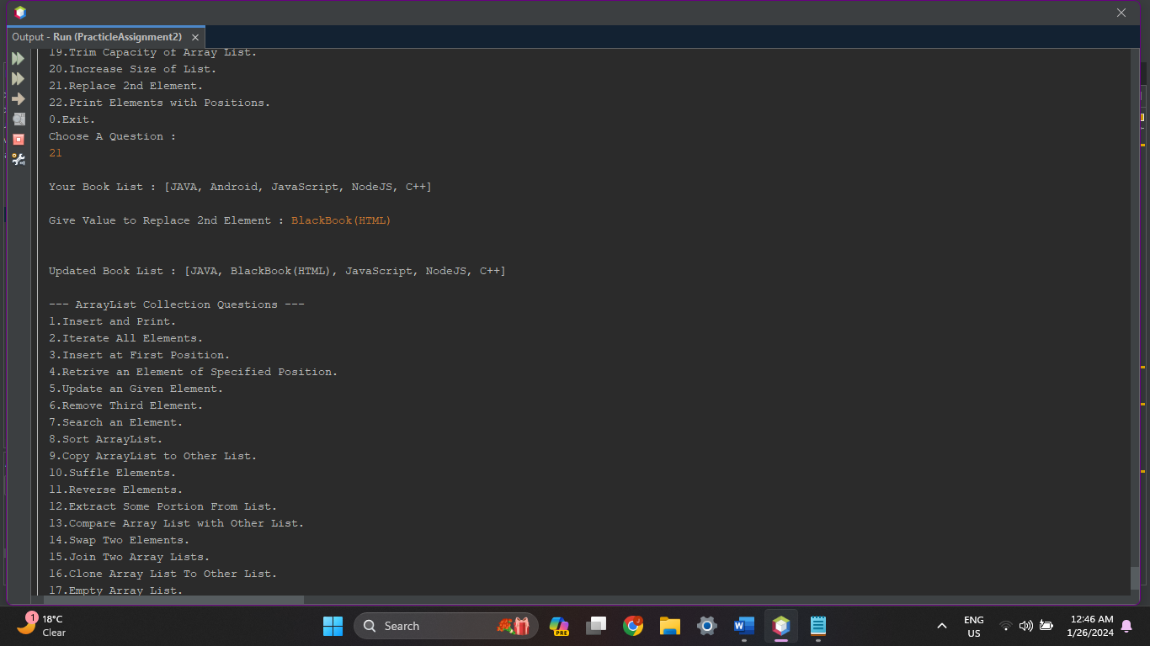

1. **Write a Java program to print all the elements of an ArrayList using the elements position.**

**Source Code :**

protected void PrintAllElements(ArrayList<String> Books)

{

System.out.println();

int cnt = 0;

for(String c: Books)

{

System.out.println("Position ["+cnt+"], Element["+ c+"]\t");

cnt++;

}

System.out.println();

}

**Output :**

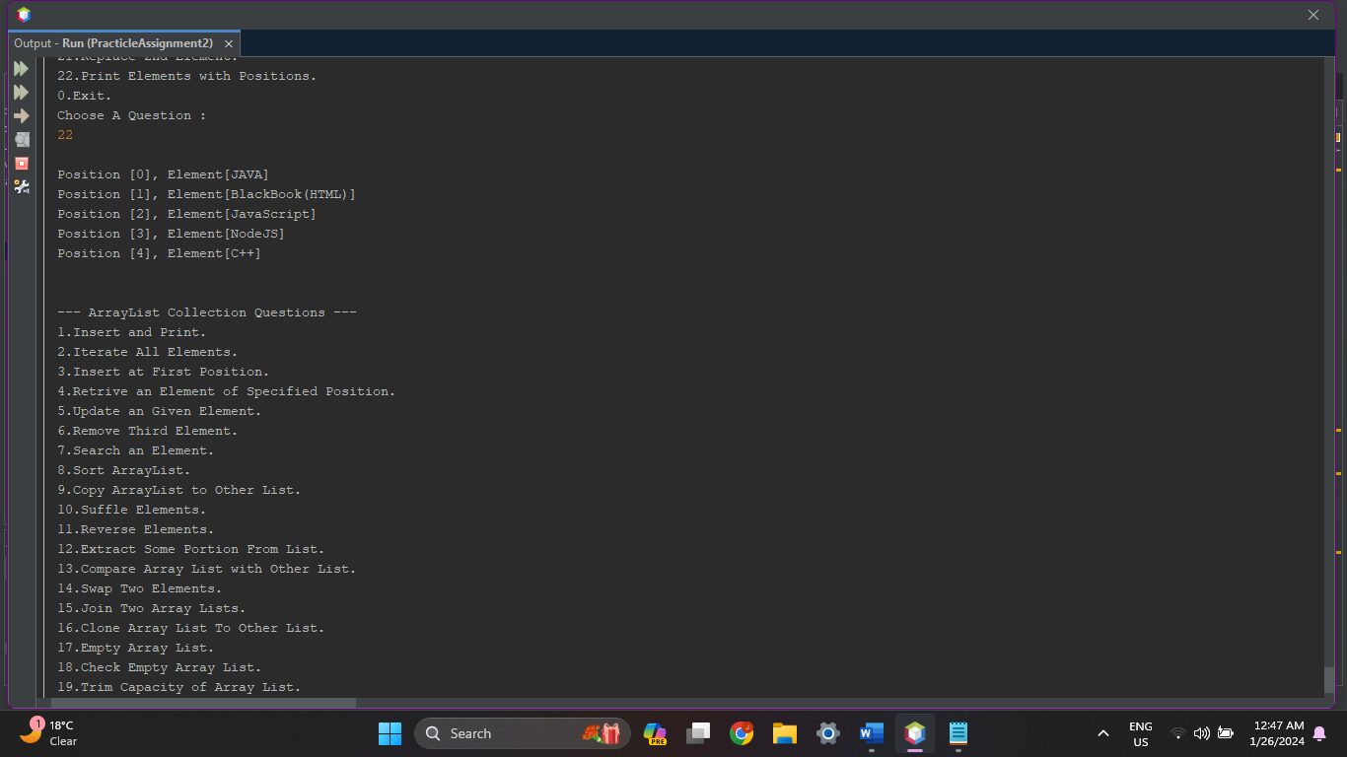

1. **Linked List :**

int ch1, n;

LinkedList<String> Movies = new LinkedList<String>();

System.out.println("\nHow Many Movies You Want to Insert ? ");

System.out.print("> ");

n = in.nextInt();

System.out.println("Enter Movie List : ");

for (int i = 0; i < n; i++) {

Movies.add(in.next());

}

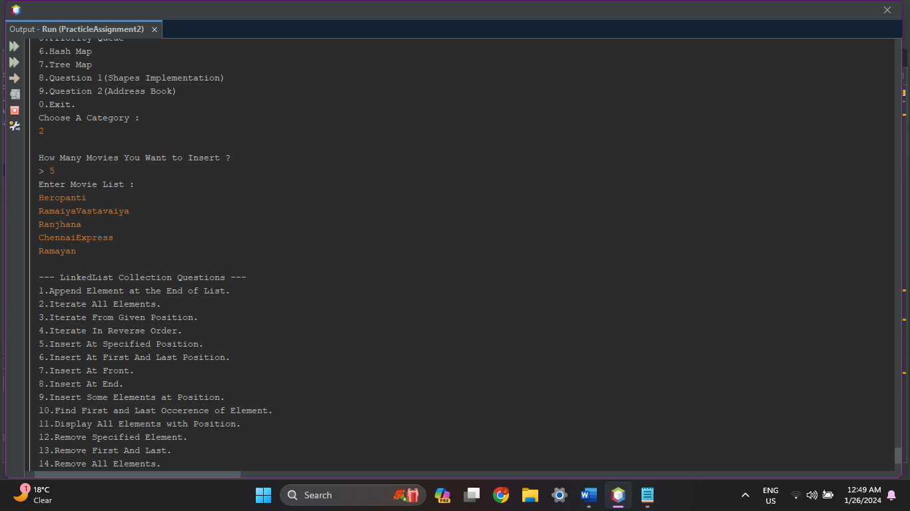

1. **Write a Java program to append the specified element to the end of a linked list.**

**Source Code :**

protected void AppenEnd(LinkedList<String> Movies) {

System.out.print("Movie List : " + Movies);

System.out.println();

System.out.print("Give Movie Name To Append at End : ");

Movies.addLast(in.next());

System.out.println("Movie Added!!");

System.out.print("Movie List : " + Movies);

System.out.println();

}

**Output :**

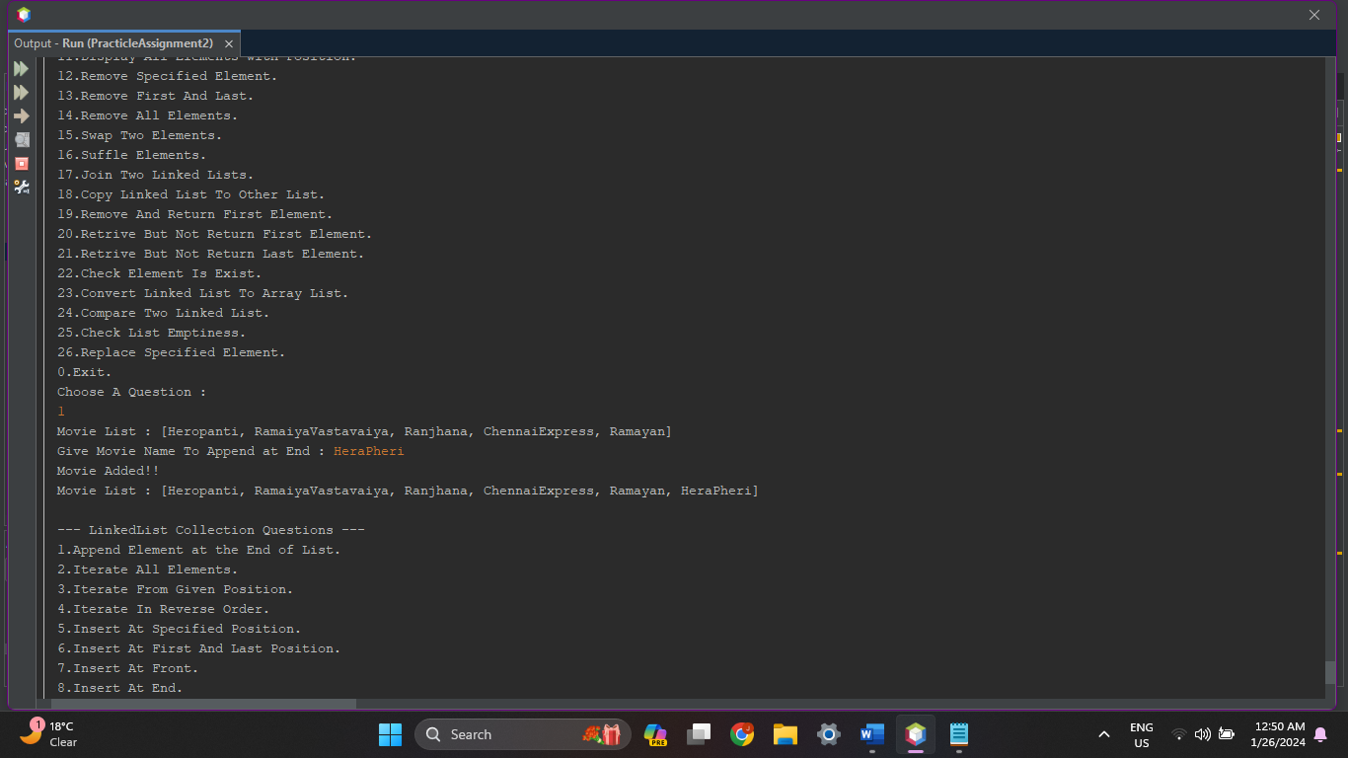

1. **Write a Java program to iterate through all elements in a linked list.**

**Source Code :**

protected void IterateAllElements(LinkedList<String> Movies) {

System.out.print("\n\nAvailable Movies : ");

int cnt = 0;

for (String m : Movies) {

System.out.print("[" + cnt + "] " + m + "\t");

cnt++;

}

System.out.println();

}

**Output :**

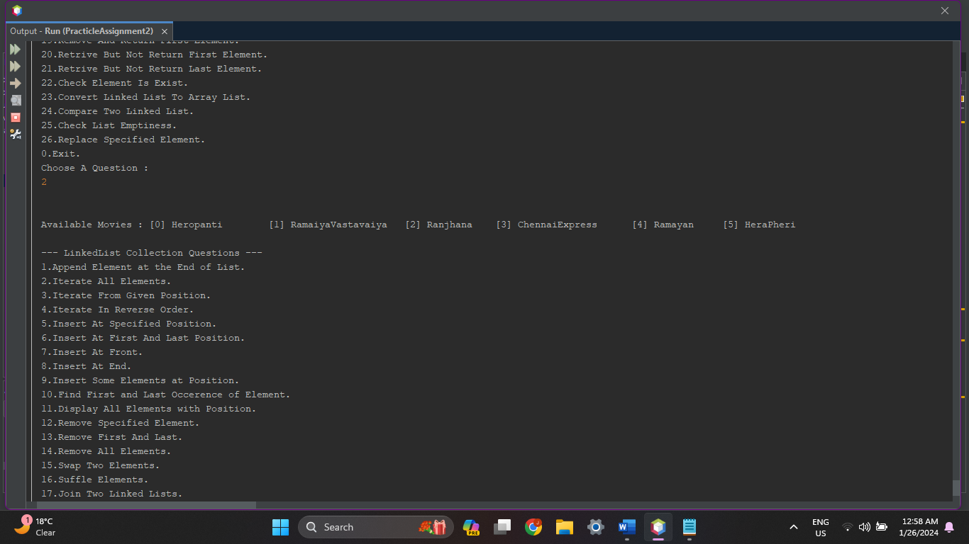

1. **Write a Java program to iterate through all elements in a linked list starting at the specified position.**

**Source Code :**

protected void IterateAllElementsPosition(LinkedList<String> Movies) {

int pos;

int cnt = 0;

System.out.print("Give Position (Start with 0) : ");

pos = in.nextInt();

System.out.print("\n\nAvailable Movies : ");

for (int i = pos; i < Movies.size(); i++) {

System.out.print("[" + i + "] " + Movies.get(i) + "\t");

}

System.out.println();

}

**Output :**

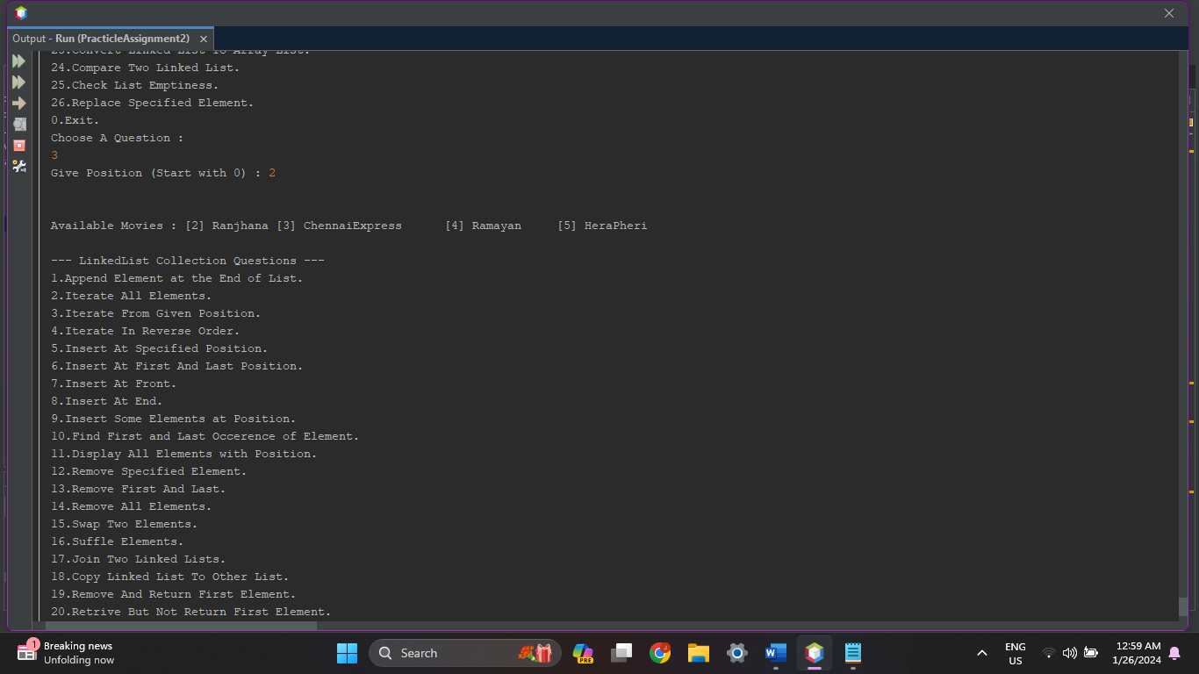

1. **Write a Java program to iterate a linked list in reverse order.**

**Source Code :**

protected void IterateReverse(LinkedList<String> Movies) {

System.out.print("\nMovie List : \n");

for (int i = 0; i < Movies.size(); i++) {

System.out.println("Position[" + i + "], Movie[" + Movies.get(i) + "]");

}

Collections.reverse(Movies);

System.out.print("\nMovie List in Reverse Order : \n");

for (int i = 0; i < Movies.size(); i++) {

System.out.println("Position[" + i + "], Movie[" + Movies.get(i) + "]");

}

System.out.println();

}

**Output :**

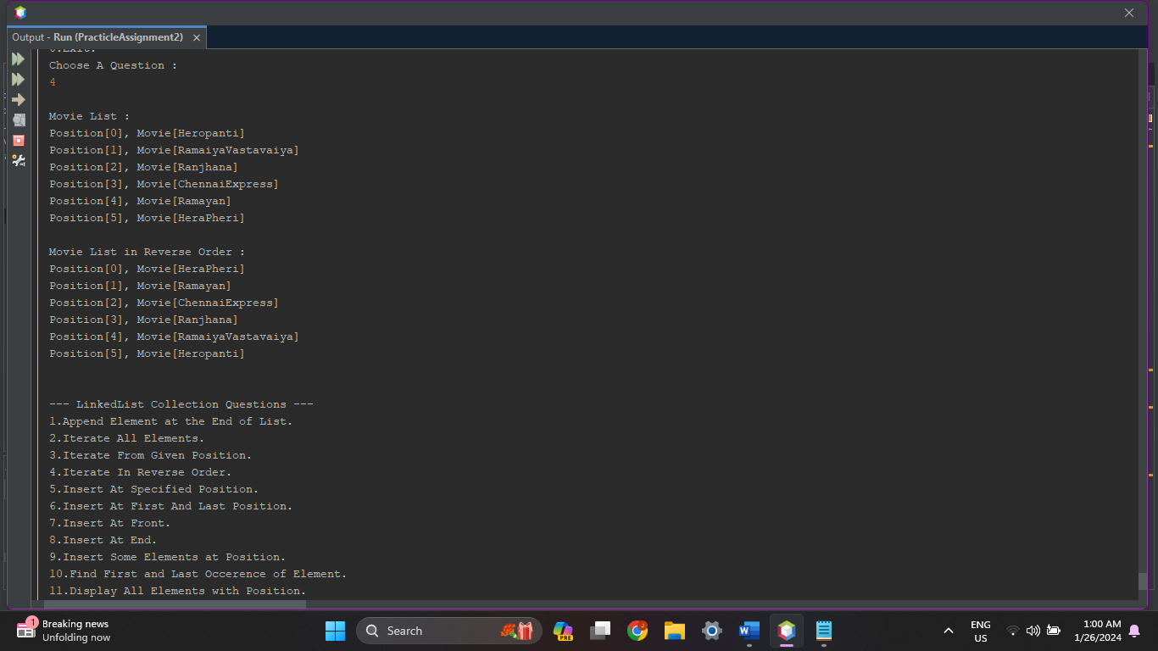

1. **Write a Java program to insert the specified element at the specified position in the linked list.**

**Source Code :**

protected void InsertAtPosition(LinkedList<String> Movies) {

System.out.print("\nMovie List : ");

for (int i = 0; i < Movies.size(); i++) {

System.out.print("[" + i + "] " + Movies.get(i) + "\t");

}

int pos;

System.out.print("\nGive Position (Start with 0) : ");

pos = in.nextInt();

System.out.println();

System.out.print("\nGive Movie Name : ");

Movies.add(pos, in.next());

System.out.println("\nMovie Added at " + pos + " Position!!");

System.out.print("\nNew Movie List : \n");

for (int i = 0; i < Movies.size(); i++) {

System.out.print("[" + i + "] " + Movies.get(i) + "\t");

}

System.out.println();

}

**Output :**

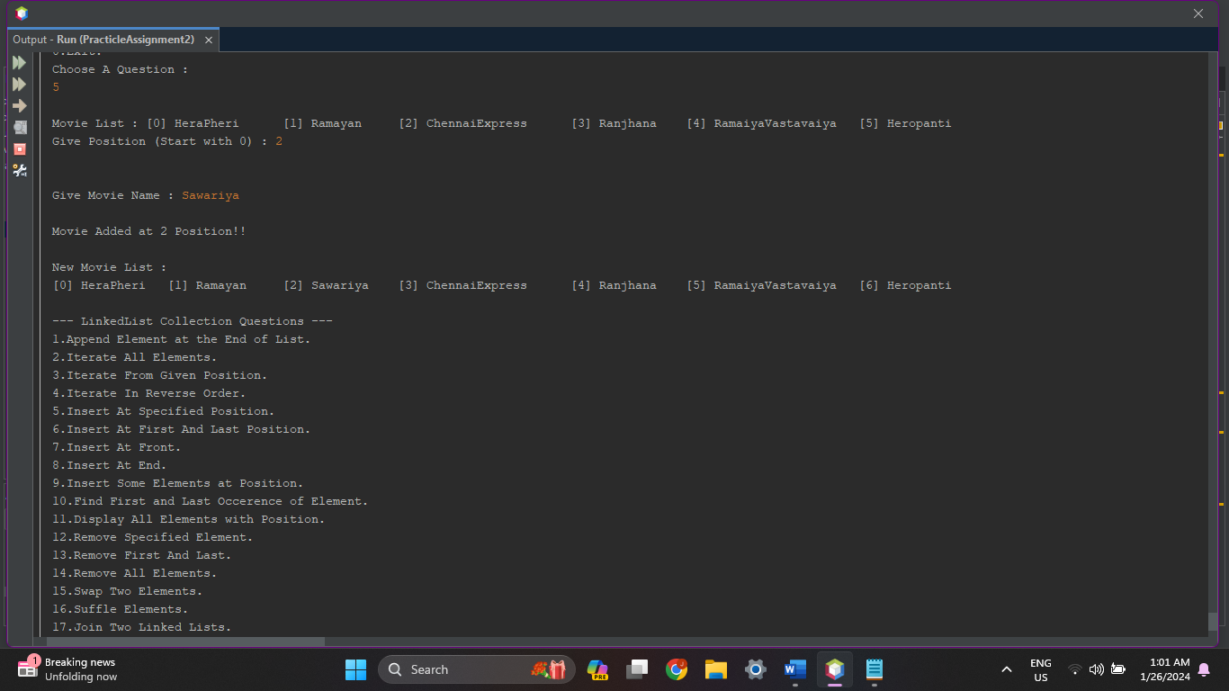

1. **Write a Java program to insert elements into the linked list at the first and last positions.**

**Source Code :**

protected void InsertAtFirstLast(LinkedList<String> Movies) {

System.out.print("\nMovie List : " + Movies);

System.out.println();

System.out.print("\nGive Movie To Insert at First : ");

Movies.addFirst(in.next());

System.out.print("\nGive Movie To Insert at Last : ");

Movies.addLast(in.next());

System.out.print("\nNew Movie List : " + Movies);

System.out.println();

}

**Output :**

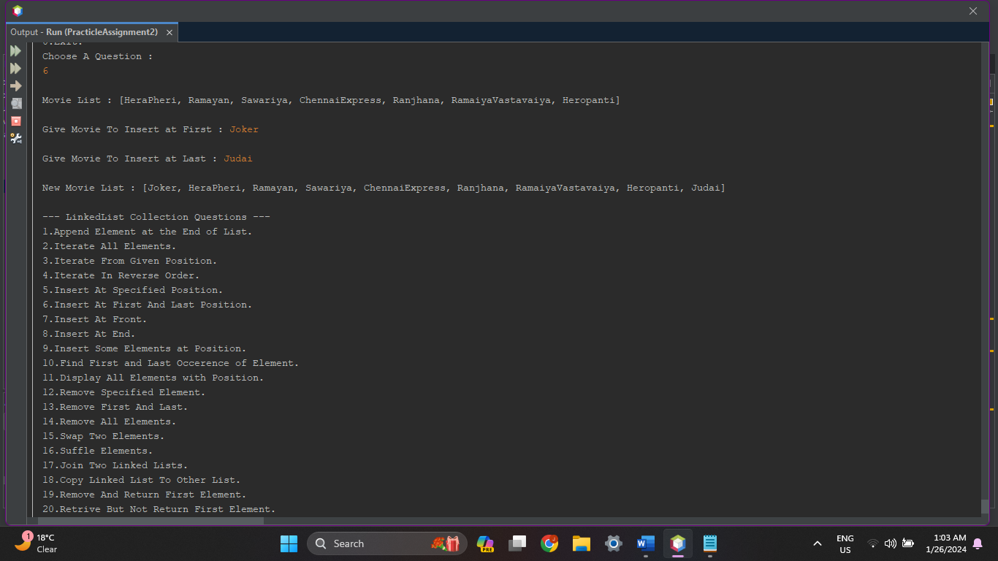

1. **Write a Java program to insert the specified element at the front of a linked list.**

**Source Code :**

protected void InsertAtFront(LinkedList<String> Movies) {

System.out.print("\nMovie List : " + Movies);

System.out.println();

System.out.print("\nGive Movie To Insert at Front : ");

Movies.addFirst(in.next());

System.out.print("\nNew Movie List : " + Movies);

System.out.println();

}

**Output :**

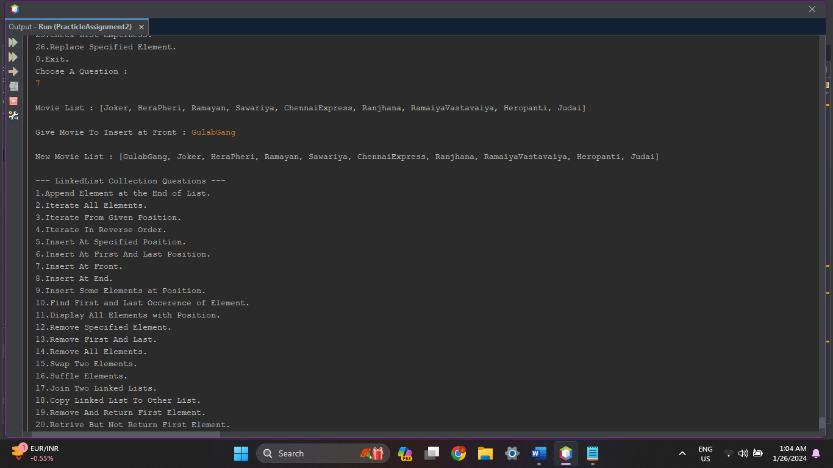

1. **Write a Java program to insert the specified element at the end of a linked list.**

**Source Code :**

protected void InsertAtEnd(LinkedList<String> Movies) {

System.out.print("\nMovie List : " + Movies);

System.out.println();

System.out.print("\nGive Movie To Insert at End : ");

Movies.addLast(in.next());

System.out.print("\nNew Movie List : " + Movies);

System.out.println();

}

**Output :**

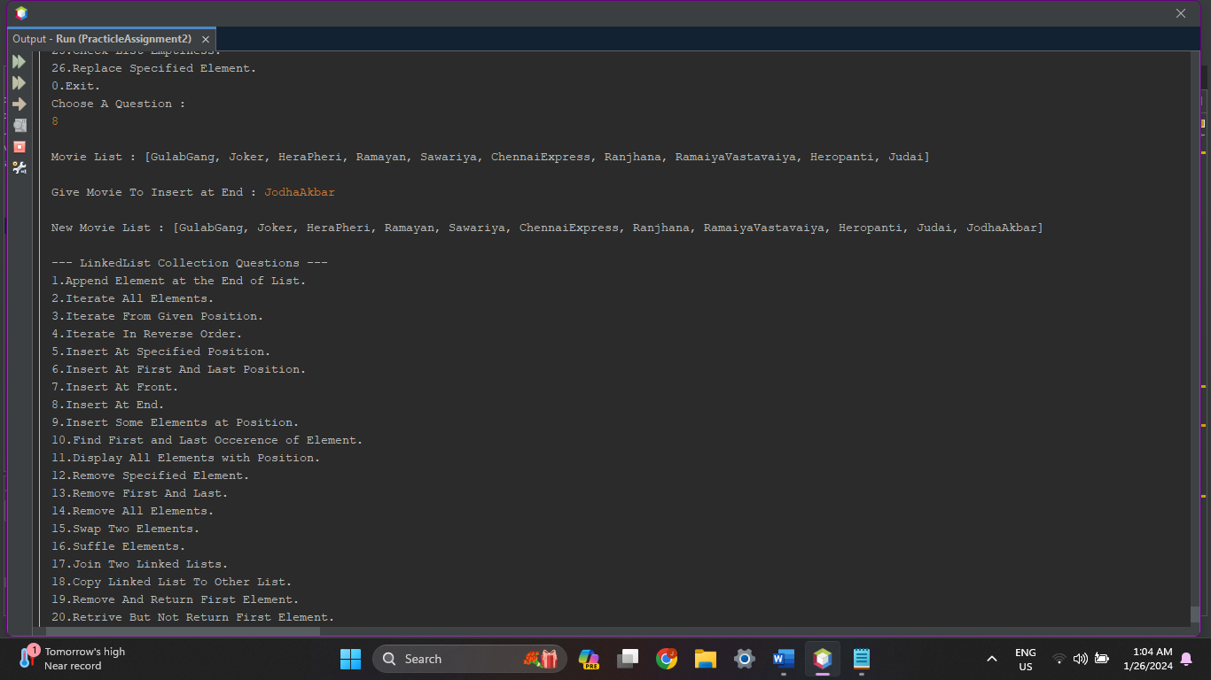

1. **Write a Java program to insert some elements at the specified position into a linked list.**

**Source Code :**

protected void InsertSomeElementsAtPosition(LinkedList<String> Movies) {

int n;

System.out.print("\nMovie List : " + Movies);

System.out.println("\nHow Many Movies You Want to Insert ? ");

System.out.print("> ");

n = in.nextInt();

int[] pos = new int[n];

System.out.println();

System.out.print("\nGive Positions : ");

for (int i = 0; i < pos.length; i++) {

pos[i] = in.nextInt();

}

System.out.println();

System.out.print("\nGive Movies : ");

for (int i : pos) {

System.out.print("\nPosition[" + i + "] : ");

Movies.add(i, in.next());

}

System.out.print("\nNew Movie List : " + Movies);

System.out.println();

}

**Output :**

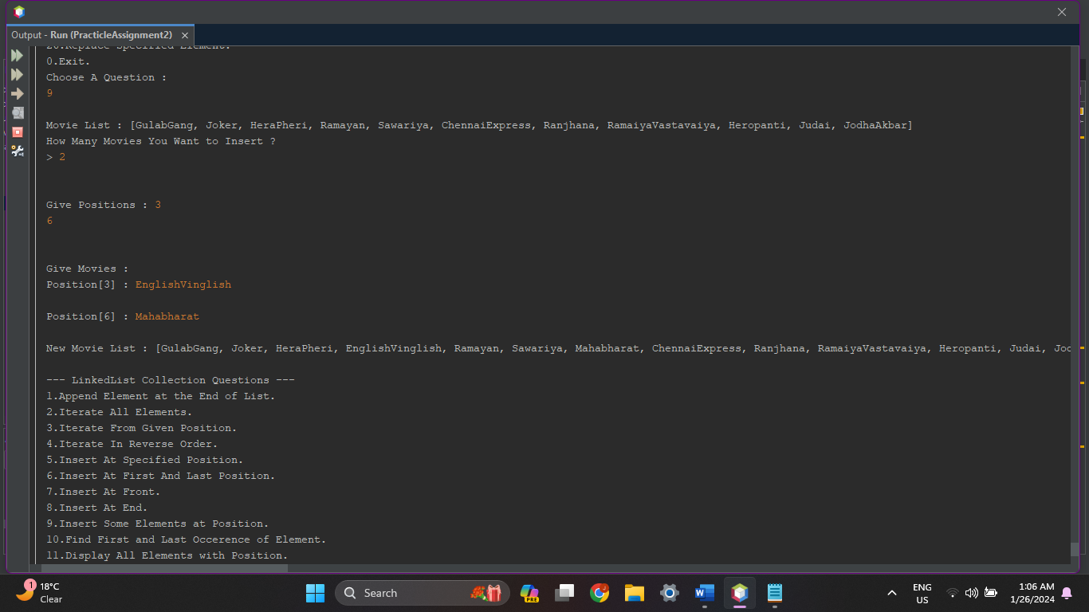

1. **Write a Java program to insert some elements at the specified position into a linked list.**

**Source Code :**

protected void GetFirstAndLastOccerence(LinkedList<String> Movies) {

String ele;

System.out.print("\nMovie List : " + Movies);

System.out.println();

System.out.print("\nGive Movie : ");

ele = in.next();

System.out.print("\nFirst Occerence " + Movies.indexOf(ele) + " Last Occerence " + Movies.lastIndexOf(ele));

System.out.println();

}

**Output :**

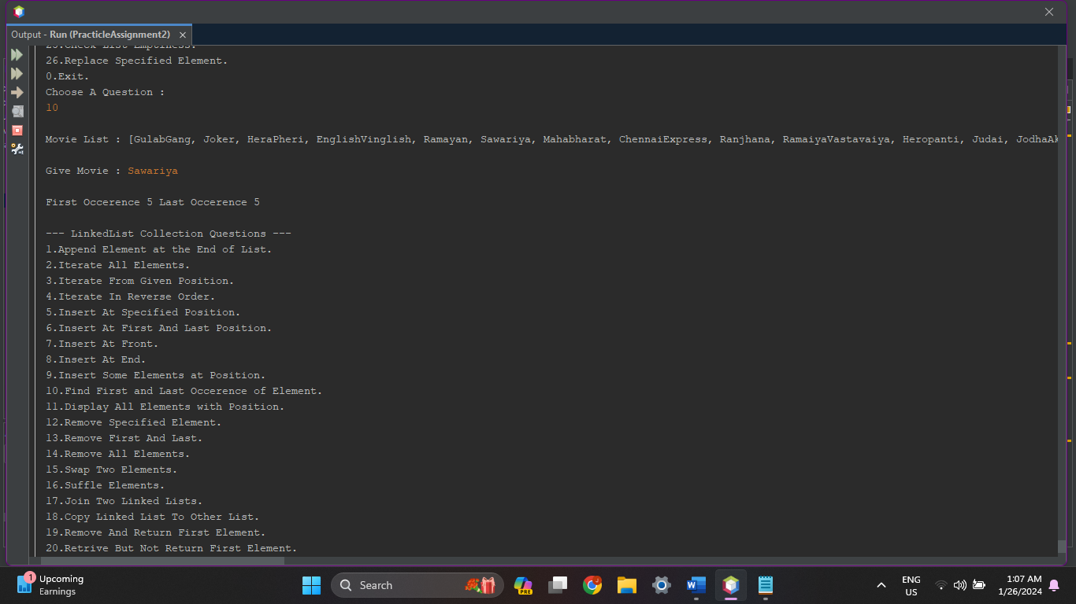

1. **Write a Java program to display elements and their positions in a linked list.**

**Source Code :**

protected void DisplayAllElementsPosition(LinkedList<String> Movies) {

System.out.print("\nMovie List : \n");

for (int i = 0; i < Movies.size(); i++) {

System.out.println("Position[" + i + "], Movie[" + Movies.get(i) + "]");

}

System.out.println();

}

**Output :**

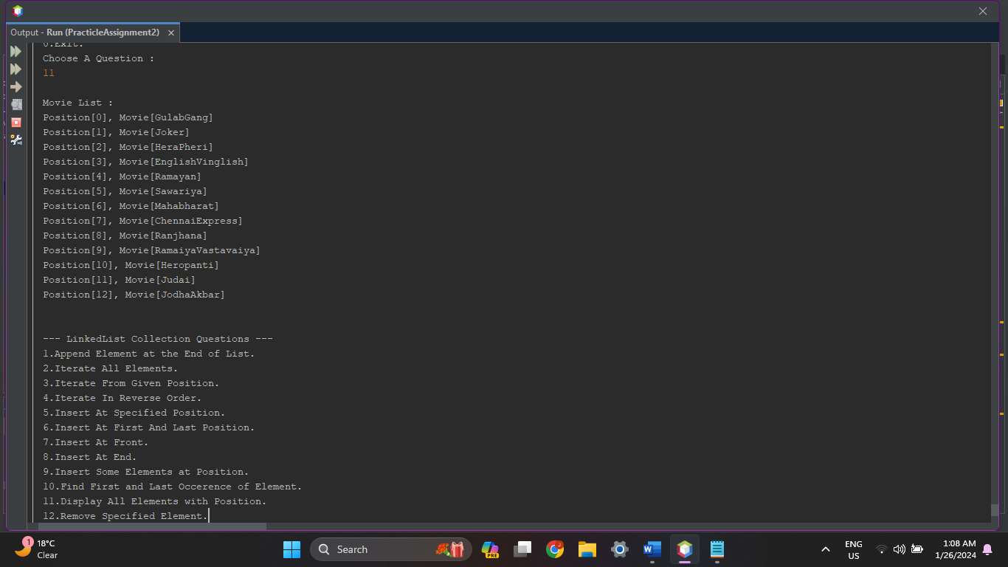

1. **Write a Java program to remove a specified element from a linked list.**

**Source Code :**

protected void RemoveElement(LinkedList<String> Movies) {

String ele;

System.out.print("\nMovie List : " + Movies);

System.out.println();

if (Movies.size() > 0) {

System.out.print("\nGive Movie To Remove : ");

ele = in.next();

if (Movies.contains(ele)) {

Movies.remove(ele);

System.out.println(ele + " Movie Removed!!");

System.out.print("\nMovie List : " + Movies);

} else {

System.out.println(ele + "Movie Not Found!!");

}

} else {

System.out.println("Movie List Empty!!");

}

System.out.println();

}

**Output :**

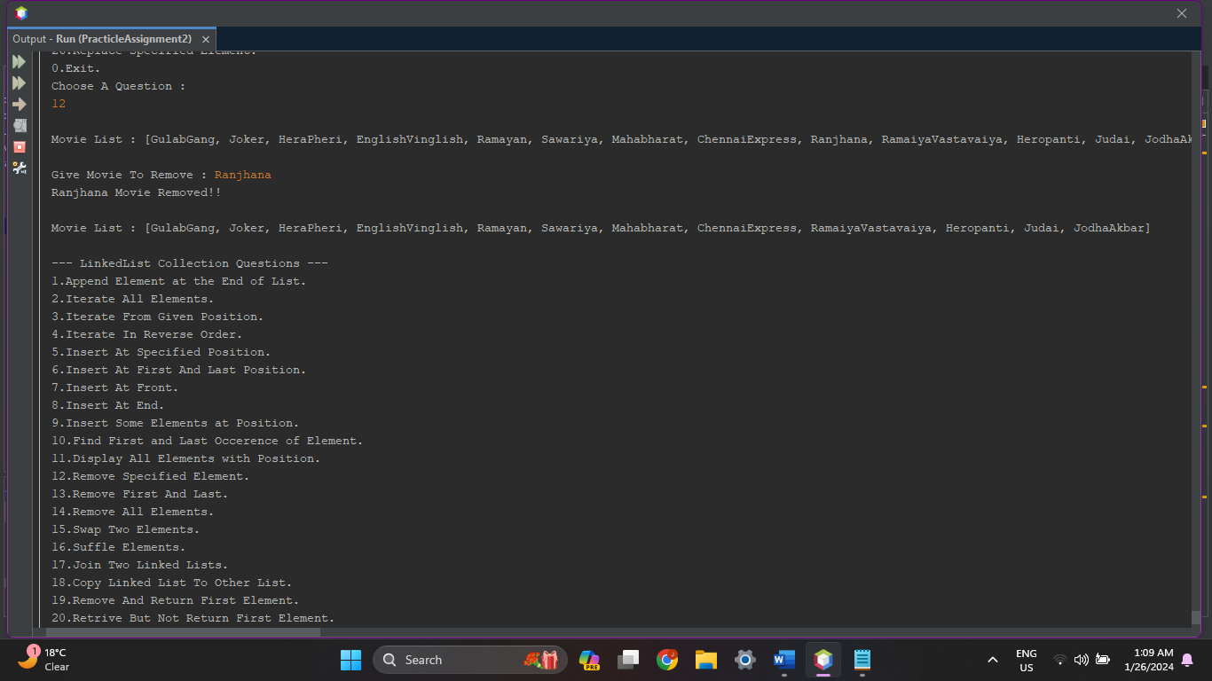

1. **Write a Java program to remove the first and last elements from a linked list.**

**Source Code :**

protected void RemoveFirstAndLastElement(LinkedList<String> Movies) {

String eleF, eleL;

System.out.print("\nMovie List : " + Movies);

System.out.println();

if (Movies.size() > 0) {

eleF = Movies.getFirst();

eleL = Movies.getLast();

Movies.removeFirst();

System.out.println("First "+ eleF + " Movie Removed!!");

Movies.removeLast();

System.out.println("Last "+ eleL + " Movie Removed!!");

System.out.print("\nMovie List : " + Movies);

} else {

System.out.println("Movie List Empty!!");

}

System.out.println();

}

**Output :**

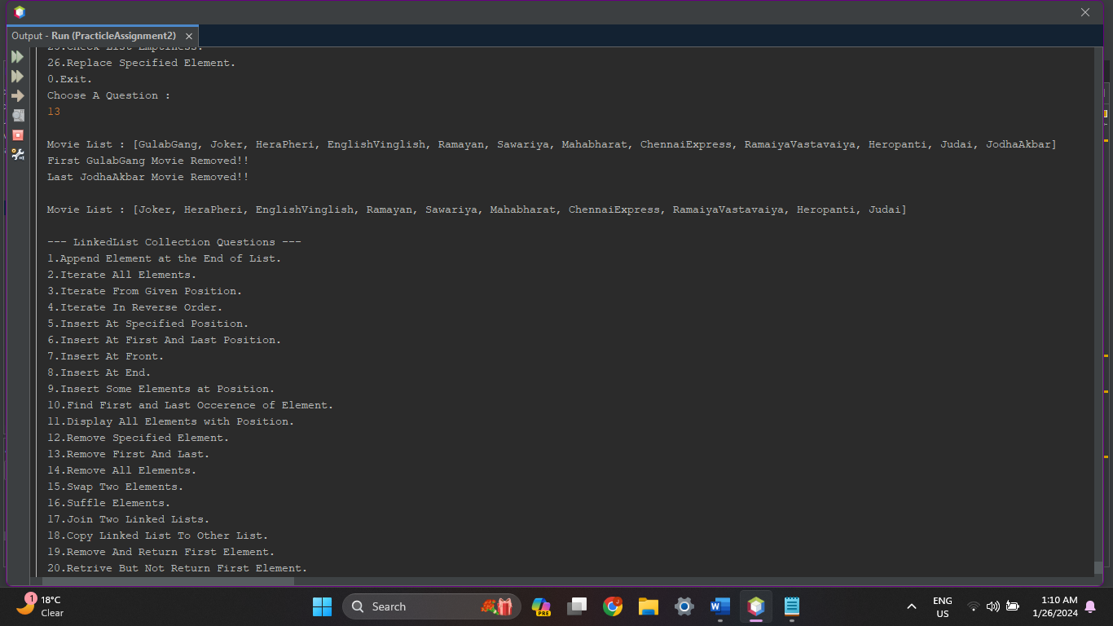

1. **Write a Java program to remove all elements from a linked list.**

**Source Code :**

protected void RemoveAllElements(LinkedList<String> Movies) {

System.out.print("\nMovie List : " + Movies);

System.out.println();

if (Movies.size() > 0) {

Movies.removeAll(Movies);

System.out.println("All Movies Removed!!");

System.out.print("\nMovie List : " + Movies);

} else {

System.out.println("Movie List Empty!!");

}

System.out.println();

}

**Output :**

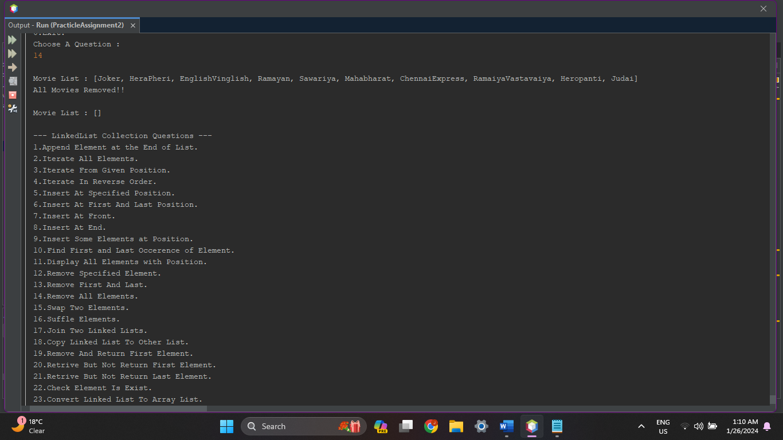

1. **Write a Java program that swaps two elements in a linked list.**

**Source Code :**

protected void SwapTwoElements(LinkedList<String> Movies) {

String ele1, ele2;

int i1, i2;

i1 = 0;

i2 = 0;

System.out.print("\nMovie List : " + Movies);

System.out.print("\nEnter Movie 1 : ");

ele1 = in.next();

System.out.print("\nEnter Movie 2 : ");

ele2 = in.next();

for (int i = 0; i < Movies.size(); i++) {

if (Movies.get(i).equalsIgnoreCase(ele1)) {

i1 = i;

} else if (Movies.get(i).equalsIgnoreCase(ele2)) {

i2 = i;

}

}

Collections.swap(Movies, i1, i2);

System.out.print("\nSwapped Movie List : " + Movies);

System.out.println();

}

**Output :**

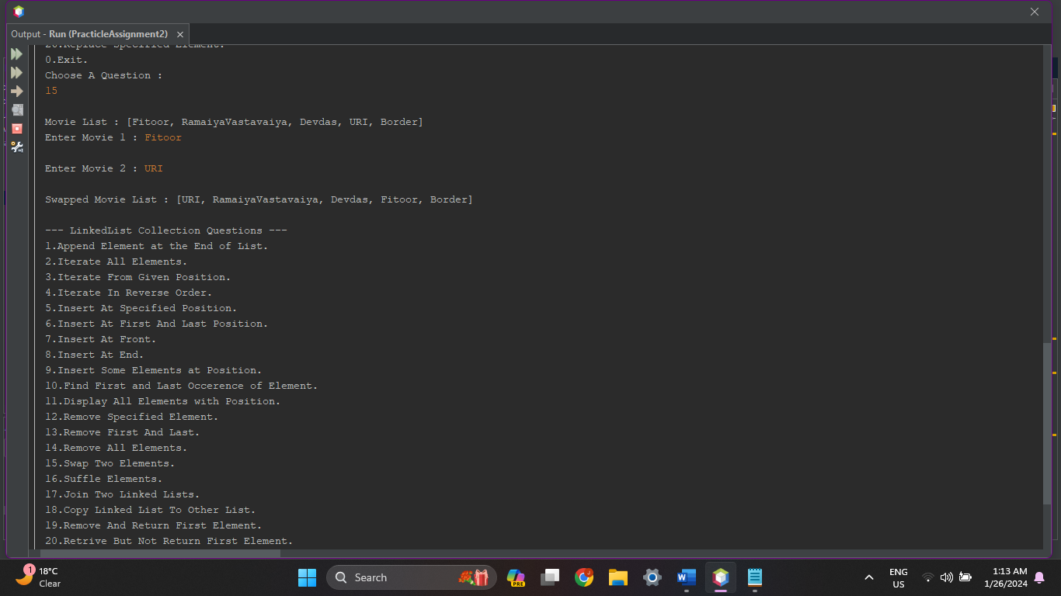

1. **Write a Java program to shuffle elements in a linked list.**

**Source Code :**

protected void SuffleElements(LinkedList<String> Movies) {

System.out.print("\nMovie List Before Suffling : " + Movies);

Collections.shuffle(Movies);

System.out.print("\nMovie List After Suffling : " + Movies);

System.out.println();

}

**Output :**

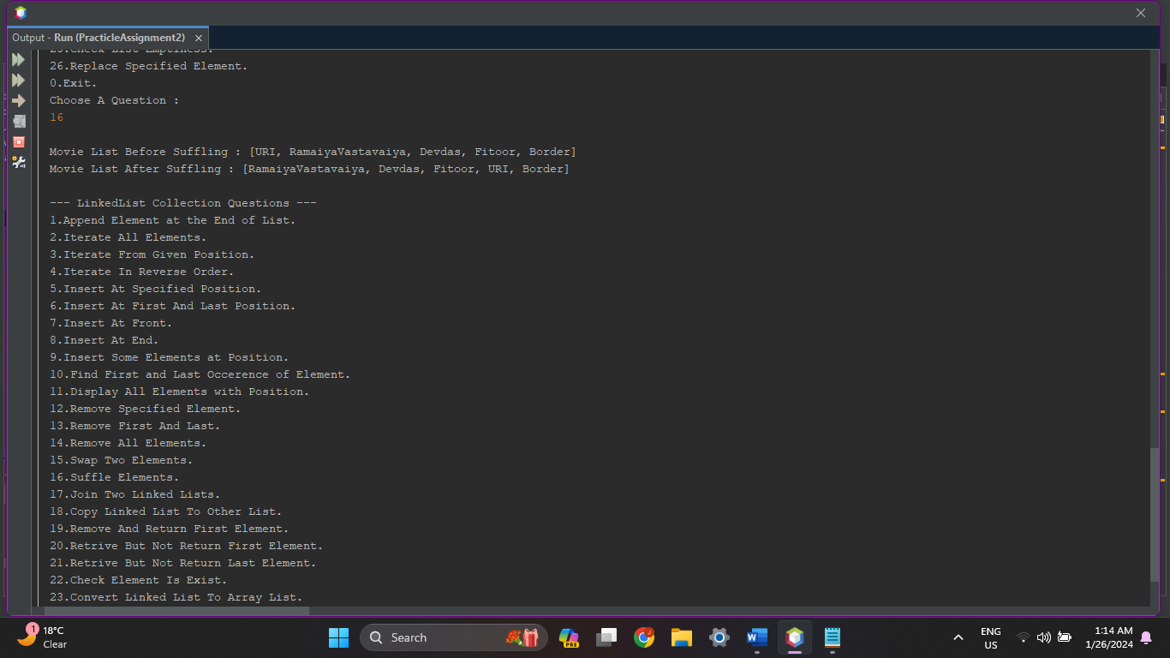

1. **Write a Java program to join two linked lists.**

**Source Code :**

protected void JoinTwoLinkedLists(LinkedList<String> Movies) {

LinkedList<String> Movies2 = new LinkedList<String>();

int n;

System.out.println("Insert Movies in Second LinkedList");

System.out.println("How Many Movies You Want to Insert ? ");

System.out.print("> ");

n = in.nextInt();

System.out.println("\nEnter Movie Name List : ");

for (int i = 0; i < n; i++) {

Movies2.add(in.next());

}

System.out.print("\nYour Movie List : " + Movies);

System.out.print("\nSecond Movie List : " + Movies2);

System.out.println();

Movies.removeAll(Movies2);

Movies.addAll(Movies2);

System.out.print("\nJoined Movies List : " + Movies);

System.out.println();

}

**Output :**

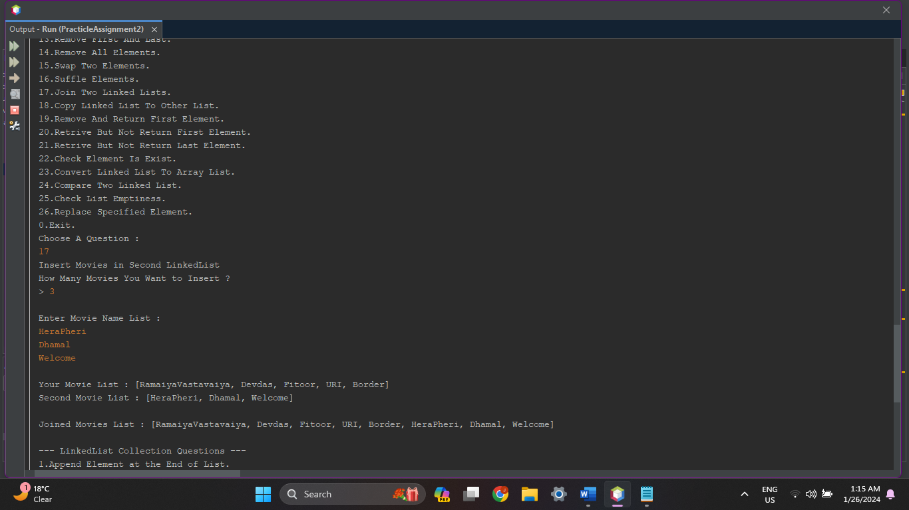

1. **Write a Java program to copy a linked list to another linked list.**

**Source Code :**

protected void CopyLinkedListToAnotherLinkedList(LinkedList<String> Movies) {

LinkedList<String> CopyCat = new LinkedList<String>();

System.out.print("\nMovie List : " + Movies);

System.out.println("\n\nCopying Movie List To Other List...");

CopyCat.addAll(Movies);

System.out.println("Successfully Coppied Movie List To Other List...");

System.out.print("\nCoppied Movie List : " + CopyCat);

System.out.println();

}

**Output :**

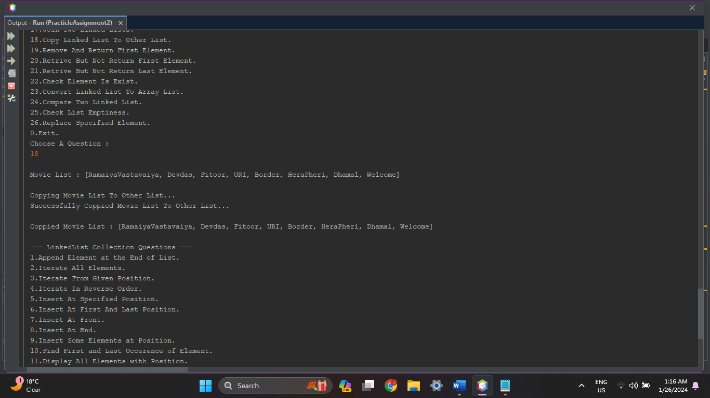

1. **Write a Java program to remove and return the first element of a linked list.**

**Source Code :**

protected void RemoveAndReturnFirst(LinkedList<String> Movies) {

System.out.print("\nMovie List : " + Movies);

System.out.println("\nDeletinging First Movie From List...");

System.out.println("Successfully Deleted "+Movies.removeFirst()+" From List...");

System.out.print("\nUpdated Movie List : " + Movies);

System.out.println();

}

**Output :**

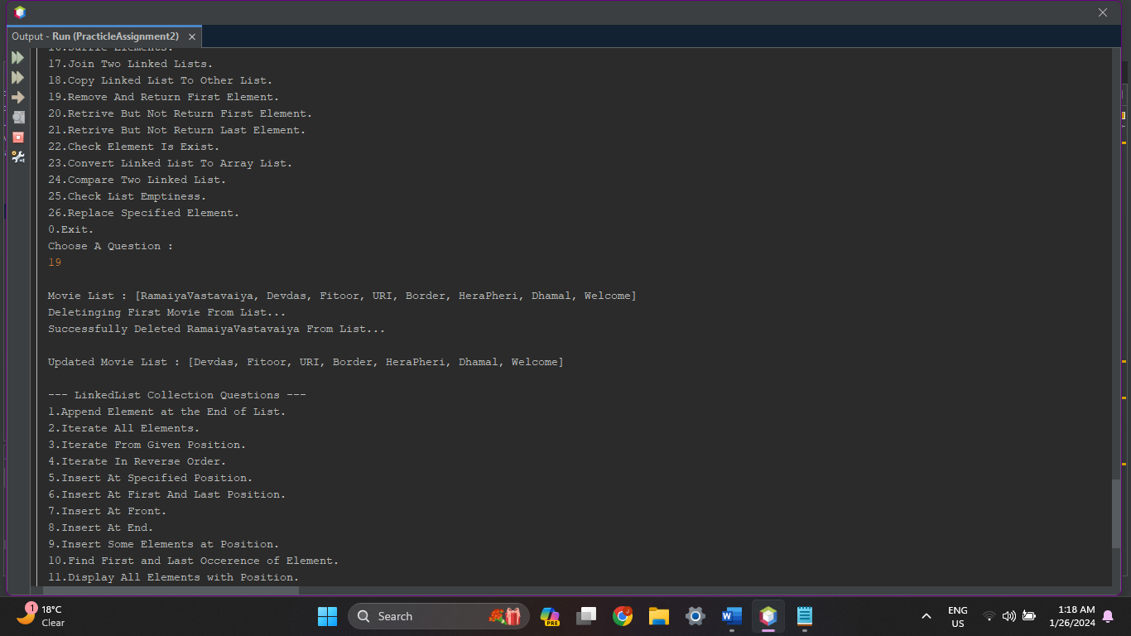

1. **Write a Java program to retrieve, but not remove, the first element of a linked list.**

**Source Code :**

protected void RetriveFirst(LinkedList<String> Movies) {

System.out.print("\nMovie List : " + Movies);

System.out.print("\nFirst Movie In List : "+Movies.peekFirst());

System.out.println();

}

**Output :**

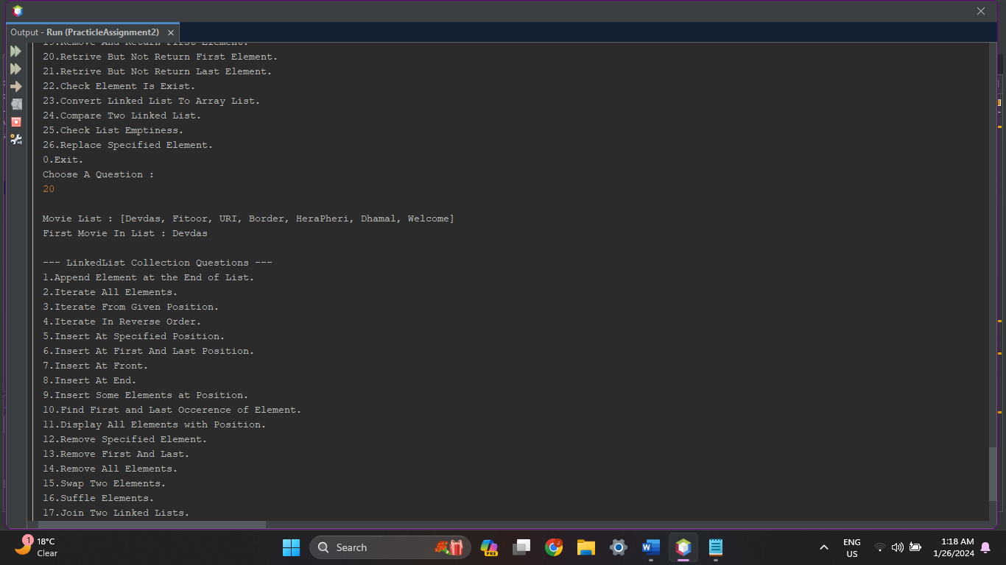

1. **Write a Java program to retrieve, but not remove, the last element of a linked list.**

**Source Code :**

protected void RetriveLast(LinkedList<String> Movies) {

System.out.print("\nMovie List : " + Movies);

System.out.print("\nLast Movie In List : "+Movies.peekLast());

System.out.println();

}

**Output :**

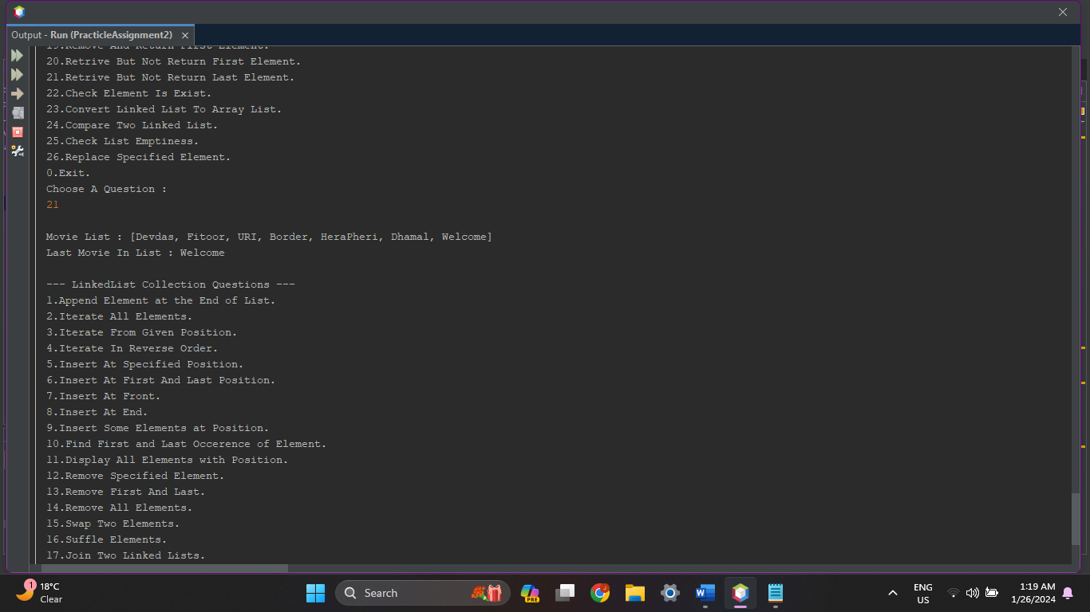

1. **Write a Java program to check if a particular element exists in a linked list.**

**Source Code :**

protected void CheckElement(LinkedList<String> Movies){

String Movie;

System.out.print("\nMovie List : "+Movies);

System.out.print("\nSearch a Movie : ");

Movie = in.next();

System.out.println();

if (Movies.contains(Movie)) {

System.out.println("Movie " + Movie + " Found At Index [" + Movies.indexOf(Movie) + "]!!");

}

else{

System.out.println(Movie+" Movie Not Found!!");

}

System.out.println();

}

**Output :**

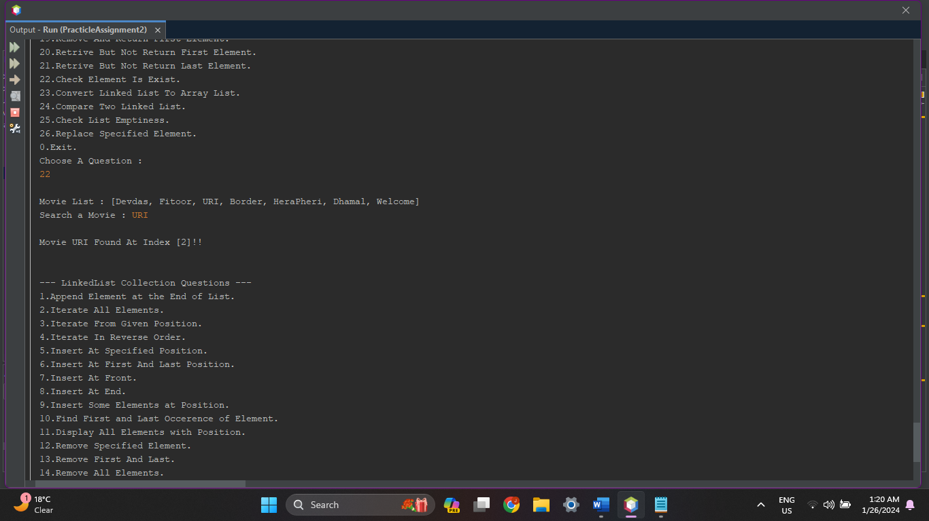

1. **Write a Java program to convert a linked list to an array list.**

**Source Code :**

protected void ConvertLinkedToArrayList(LinkedList<String> Movies){

System.out.print("\nMovie List(LinkedList) : "+Movies);

ArrayList<String> Movie = new ArrayList<String>(Movies);

System.out.print("\nMovie List(ArrayList) : "+Movie);

System.out.println();

}

**Output :**

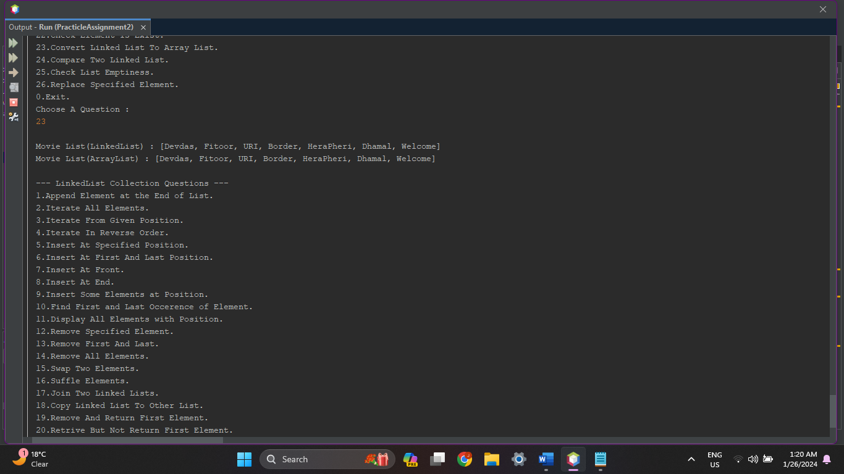

1. **Write a Java program to compare two linked lists.**

**Source Code :**

protected void CompareLinkedLists(LinkedList<String> Movies){

LinkedList<String> Movies1 = new LinkedList<String>();

LinkedList<String> Movies2 = new LinkedList<String>();

Movies1.add("Pari");

Movies1.add("1920");

Movies1.add("Manikarnika");

Movies1.add("Mimi");

Movies2.addAll(Movies);

System.out.print("\nYour Movie List : "+Movies);

System.out.print("\nMovie List 1 : "+Movies1);

System.out.print("\nMovie List 2 : "+Movies2);

System.out.println();

if(Movies.equals(Movies1))

{

System.out.print("\nYour Movie List & Movie List 1 is Equal!!");

}

else

{

System.out.print("\nYour Movie List & Movie List 1 is Different!!");

}

if(Movies.equals(Movies2))

{

System.out.print("\nYour Movie List & Movie List 2 is Equal!!");

}

else

{

System.out.print("\nYour Movie List & Movie List 2 is Different!!");

}

System.out.println();

}

**Output :**

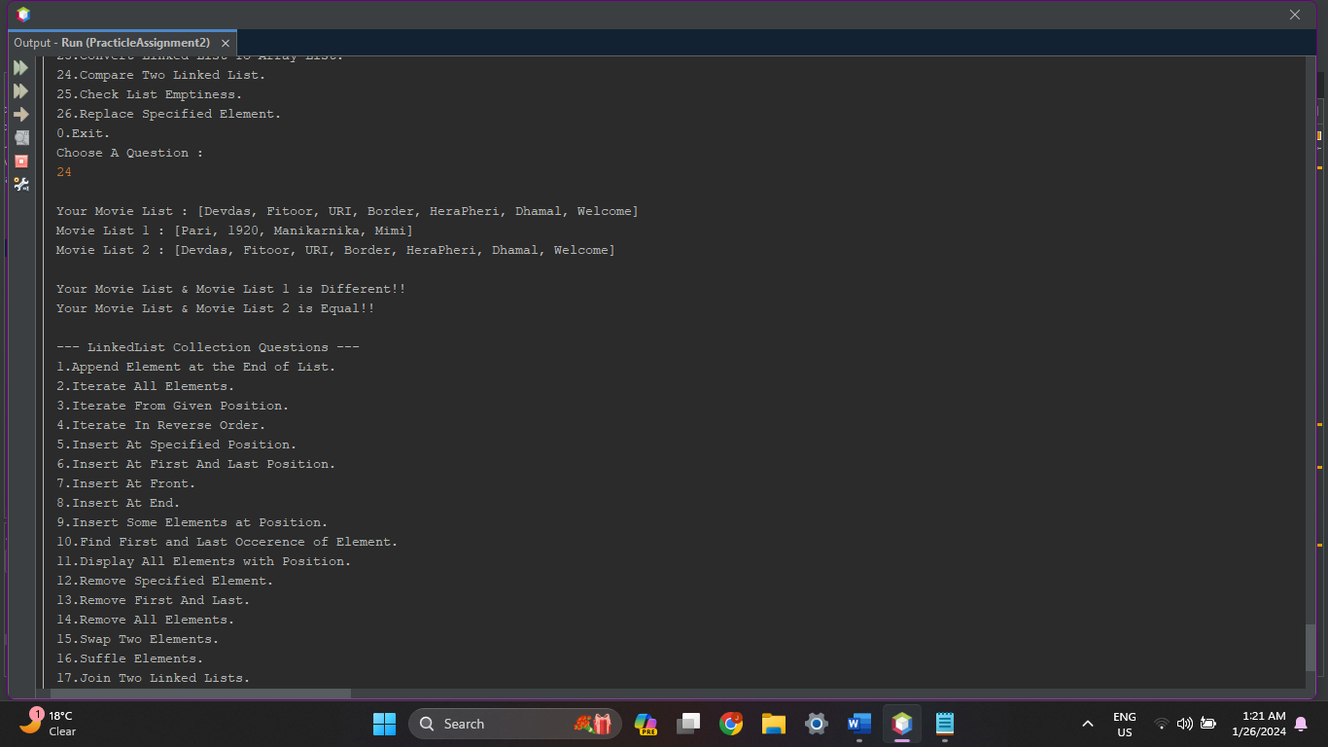

1. **Write a Java program to check if a linked list is empty or not.**

**Source Code :**

protected void CheckListEmpty(LinkedList<String> Movies){

if(Movies.isEmpty())

{

System.out.print("\nYour Movie List is Empty!!");

}

else

{

System.out.print("\nYour Movie List is not Empty, contains : "+Movies);

}

System.out.println();

}

**Output :**

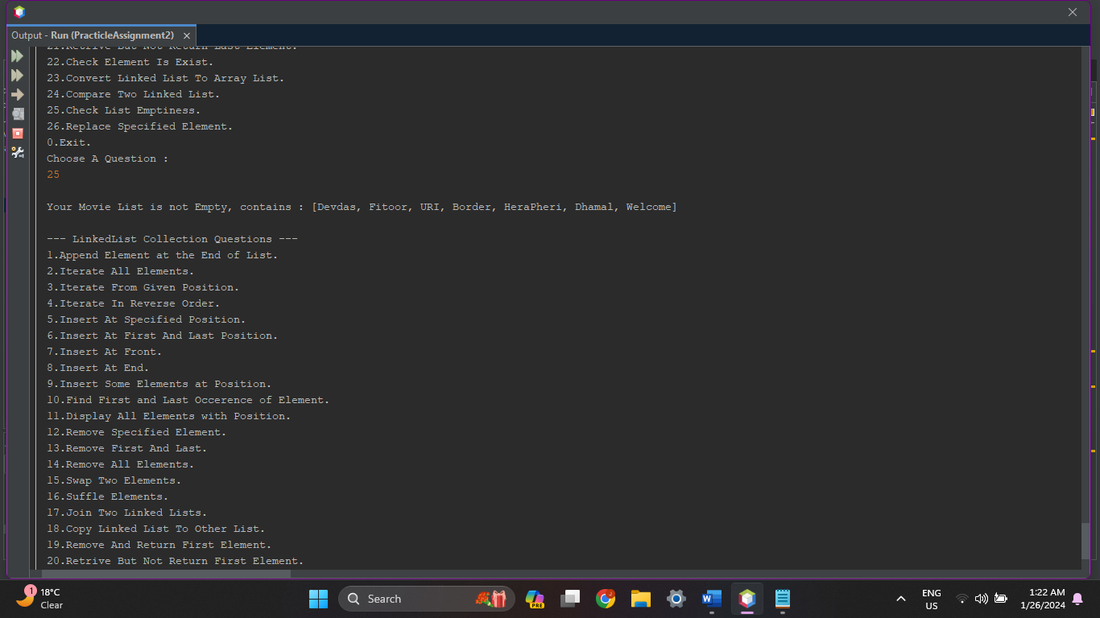

1. **Write a Java program to replace an element in a linked list.**

**Source Code :**

protected void ReplaceElement(LinkedList<String> Movies){

int i;

String ele, ele2;

System.out.print("\nYour Movie List : "+Movies);

System.out.print("\nGive Movie Name To Replace From List : ");

ele = in.next();

if(Movies.contains(ele))

{

System.out.print("\nGive Movie Name To Replace : ");

ele2 = in.next();

Movies.set(Movies.indexOf(ele), ele2);

System.out.println("List Updated!!");

System.out.print("\nUpdated Movie List : "+Movies);

}

else

{

System.out.println(ele+" Movie Not Found!!");

}

System.out.println();

}

**Output :**

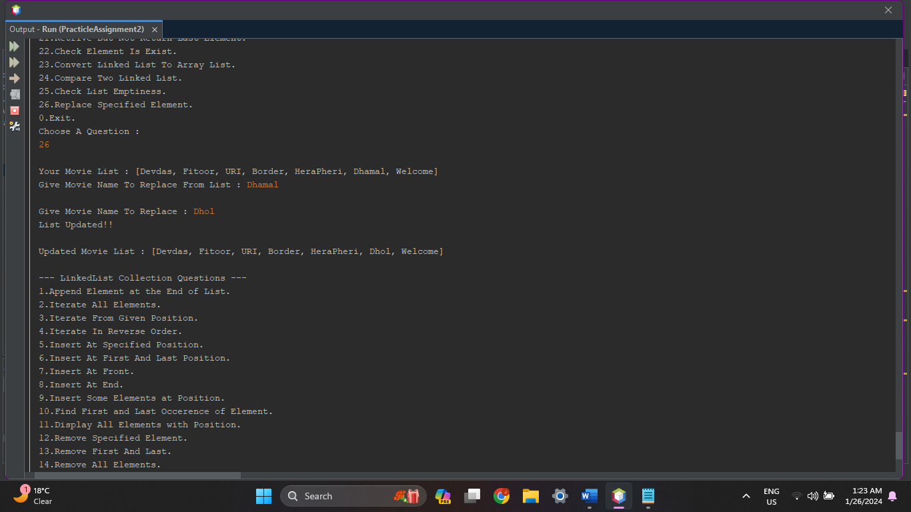

1. **Hash Set :**

int n;

HashSet<String> Actors = new HashSet<String>();

System.out.println("\nHow Many Actors You Want to Insert ? ");

System.out.print("> ");

n = in.nextInt();

System.out.println("Enter Actor List : ");

for (int i = 0; i < n; i++) {

Actors.add(in.next());

}

**Output :**

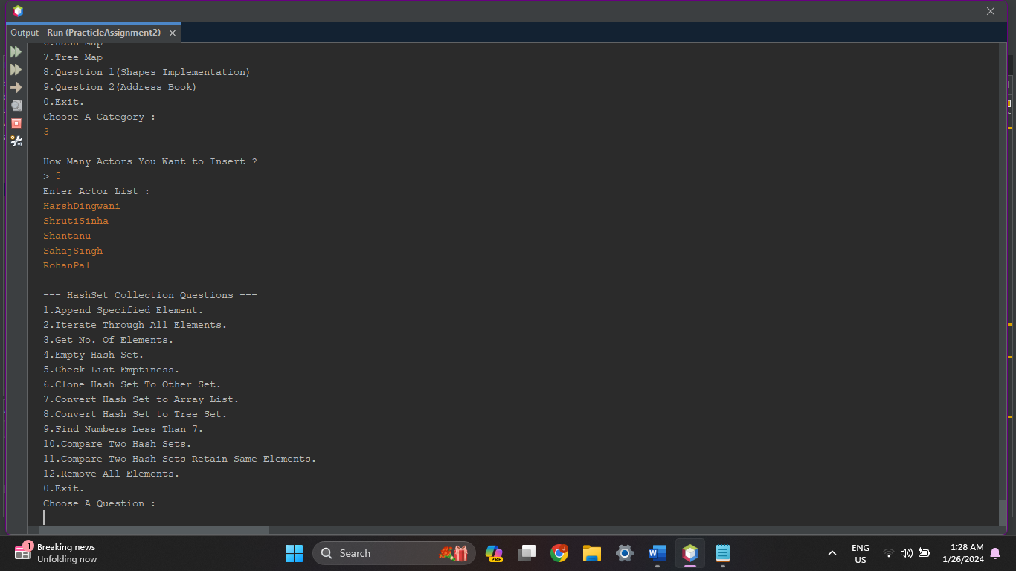

1. **Write a Java program to append the specified element to the end of a hash set.**

**Source Code :**

protected void AppendElement(HashSet<String> Actors) {

System.out.print("\nYour Actor Set : " + Actors);

System.out.print("\nGive Actor Name To Append : ");

Actors.add(in.next());

System.out.print("\nUpdated Actor Set : " + Actors);

System.out.println();

}

**Output :**

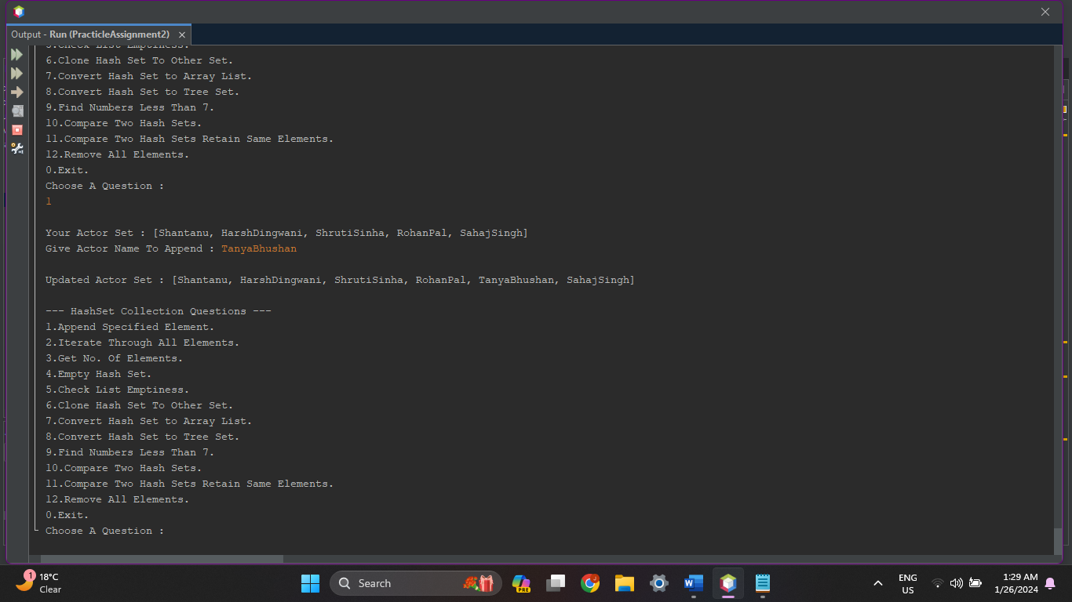

1. **Write a Java program to iterate through all elements in a hash list.**

**Source Code :**

protected void IterateAllElements(HashSet<String> Actors) {

System.out.print("\nAvailable Actors : ");

int cnt = 0;

for (String a : Actors) {

System.out.print("[" + cnt + "] " + a + "\t");

cnt++;

}

System.out.println();

}

**Output :**

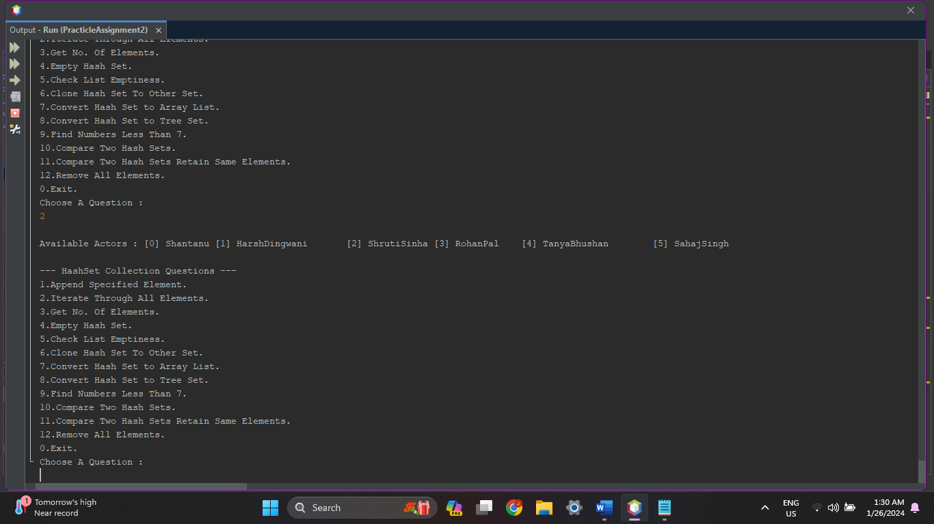

1. **Write a Java program to get the number of elements in a hash set.**

**Source Code :**

protected void GetNoOfElements(HashSet<String> Actors) {

System.out.print("\nNo. Of Actors : "+Actors.size());

System.out.println();

}

**Output :**

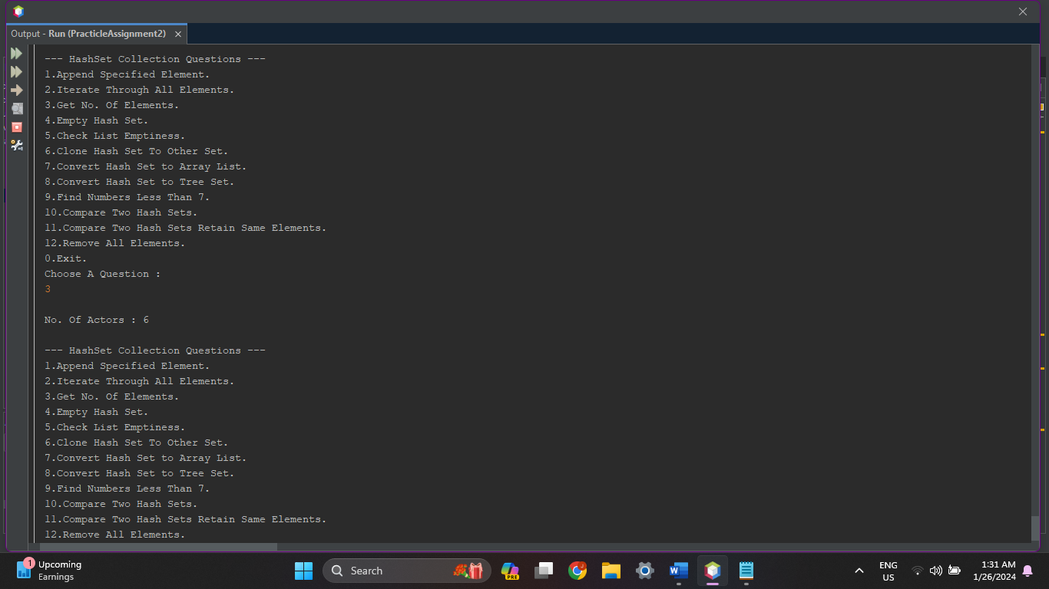

1. **Write a Java program to empty an hash set.**

**Source Code :**

protected void MakeListEmpty(HashSet<String> Actors) {

System.out.print("\nActor Set : " + Actors);

System.out.println();

if (Actors.size() > 0) {

Actors.removeAll(Actors);

System.out.println("All Actors Removed!!");

System.out.print("\nActor Set : " + Actors);

} else {

System.out.println("Actor Set is Empty!!");

}

System.out.println();

}

**Output :**

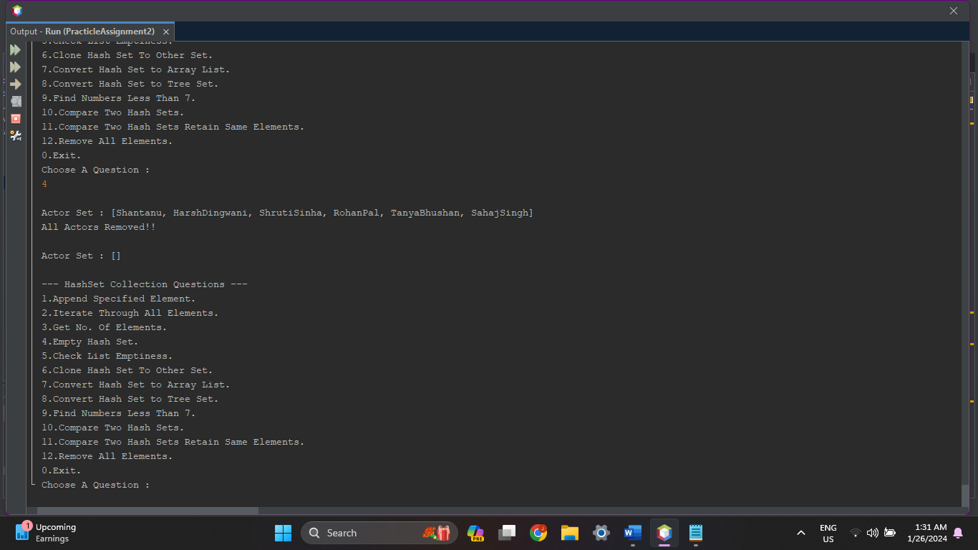

1. **Write a Java program to test if a hash set is empty or not.**

**Source Code :**

protected void CheckListEmpty(HashSet<String> Actors) {

if (Actors.isEmpty()) {

System.out.print("\nYour Actor Set is Empty!!");

} else {

System.out.print("\nYour Actor Set is not Empty, contains : " + Actors);

}

System.out.println();

}

**Output :**

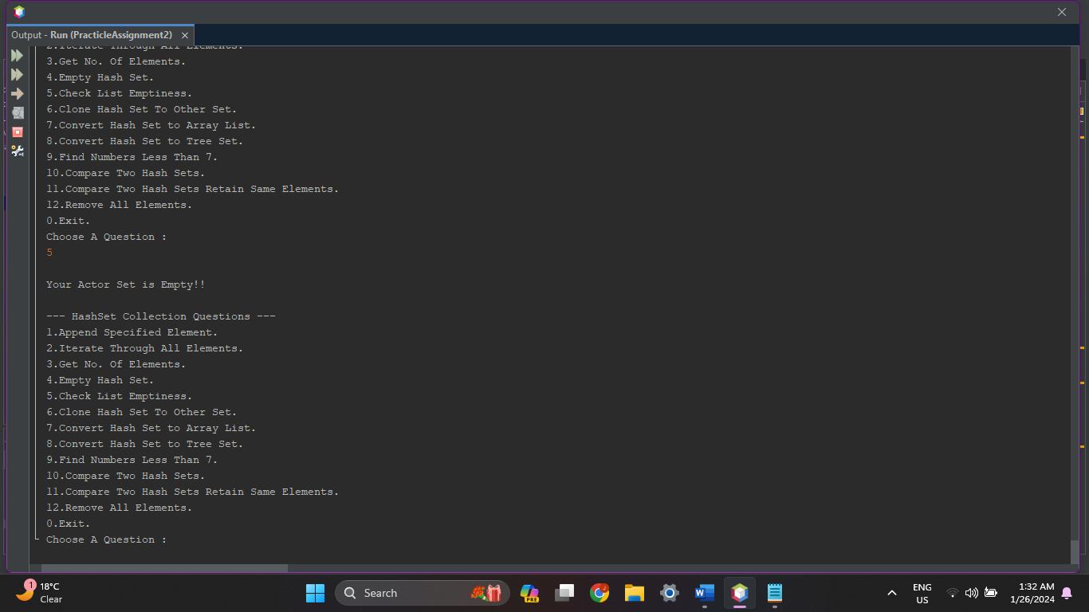

1. **Write a Java program to clone a hash set to another hash set.**

**Source Code :**

protected void CloneHashSetToOtherSet(HashSet<String> Actors){

HashSet Actors2 = (HashSet)Actors.clone();

System.out.print("\nYour Actor Set : "+Actors);

System.out.print("\nCloned Actor Set : "+Actors2);

System.out.println();

}

**Output :**

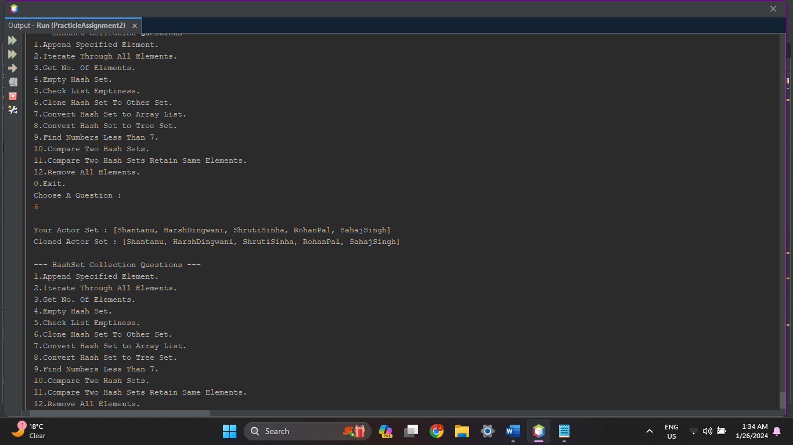

1. **Write a Java program to convert a hash set to an array.**

**Source Code :**

protected void ConvertHashSetToArrayList(HashSet<String> Actors) {

System.out.print("\nActors Set(Hash Set) : " + Actors);

List<String> Actor = new ArrayList<String>(Actors);

System.out.print("\nActor List(Array List) : " + Actor);

System.out.println();

}

**Output :**

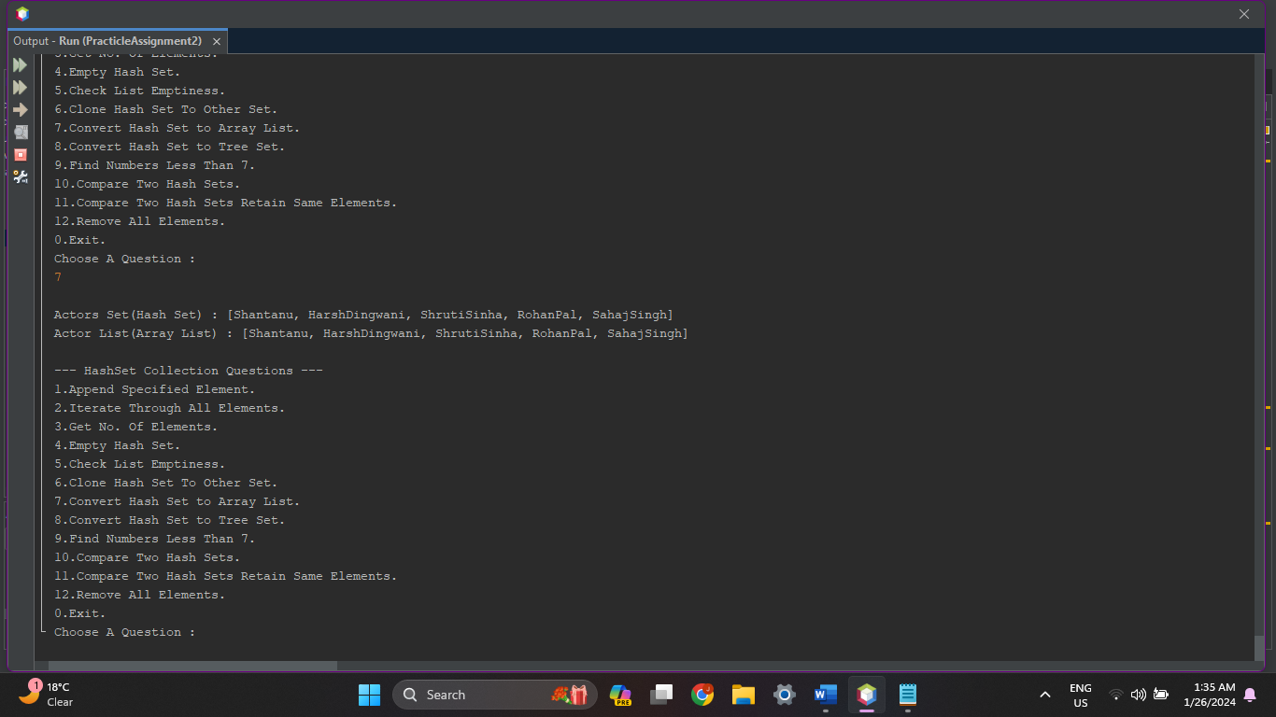

1. **Write a Java program to convert a hash set to a tree set.**

**Source Code :**

protected void ConvertHashSetToTreeSet(HashSet<String> Actors) {

System.out.print("\nActor Set(Hash Set) : " + Actors);

Set<String> Actor = new TreeSet<String>(Actors);

System.out.print("\nActor Set(Tree Set) : " + Actor);

System.out.println();

}

**Output :**

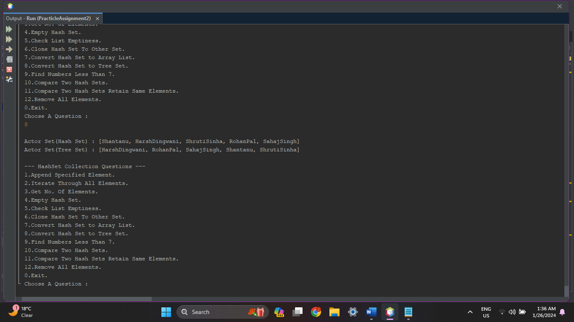

1. **Write a Java program to find numbers less than 7 in a tree set.**

**Source Code :**

protected void NumbersLess7(){

int n;

HashSet<Integer> Numbers = new HashSet<Integer>();

System.out.println("\nHow Many Numbers You Want to Insert ? ");

System.out.print("> ");

n = in.nextInt();

System.out.println("Enter Integers : ");

for(int i=0;i<n;i++)

{

Numbers.add(in.nextInt());

}

System.out.print("\nNumbers < 7 : ");

for (Integer num : Numbers) {

if (num < 7) {

System.out.print(num + "\t");

}

}

}

**Output :**

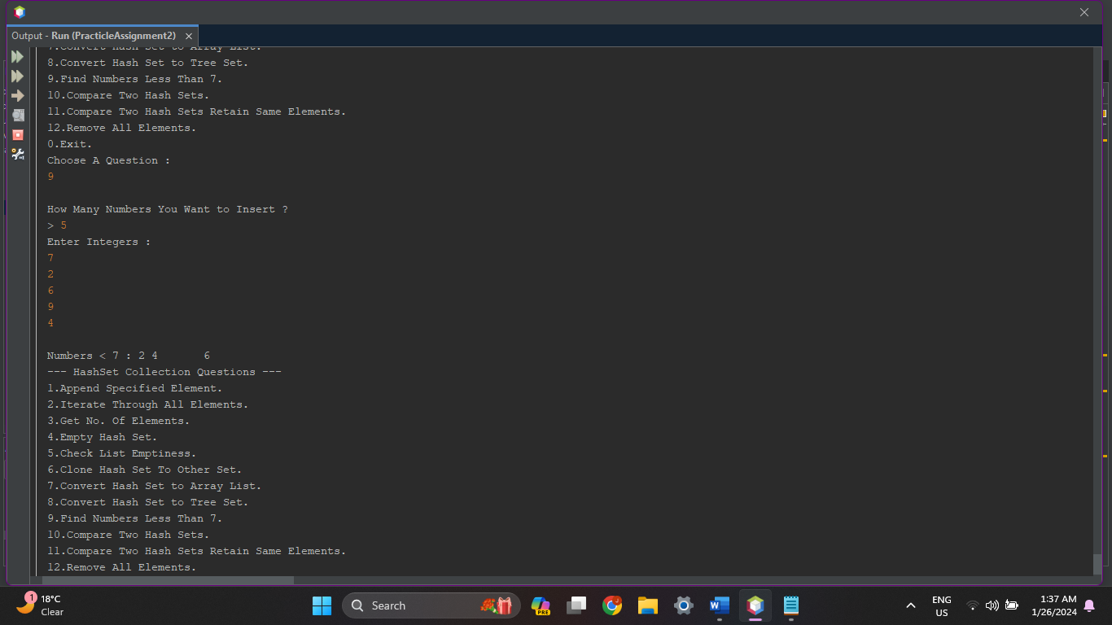

1. **Write a Java program to compare two hash set.**

**Source Code :**

protected void CompareHashSets(HashSet<String> Actors) {

HashSet<String> Actors1 = new HashSet<String>();

HashSet<String> Actors2 = new HashSet<String>();

Actors1.add("AkshayKumar");

Actors1.add("DeepikaPadukon");

Actors1.add("SRK");

Actors1.add("HritikRoshan");

Actors2.addAll(Actors);

System.out.print("\nYour Actor List : " + Actors);

System.out.print("\nActor List 1 : " + Actors1);

System.out.print("\nActor List 2 : " + Actors2);

System.out.println();

if (Actors.equals(Actors1)) {

System.out.print("\nYour Actor List & Actor List 1 is Equal!!");

} else {

System.out.print("\nYour Actor List & Actor List 1 is Different!!");

}

if (Actors.equals(Actors2)) {

System.out.print("\nYour Actor List & Actor List 2 is Equal!!");

} else {

System.out.print("\nYour Actor List & Actor List 2 is Different!!");

}

System.out.println();

}

**Output :**

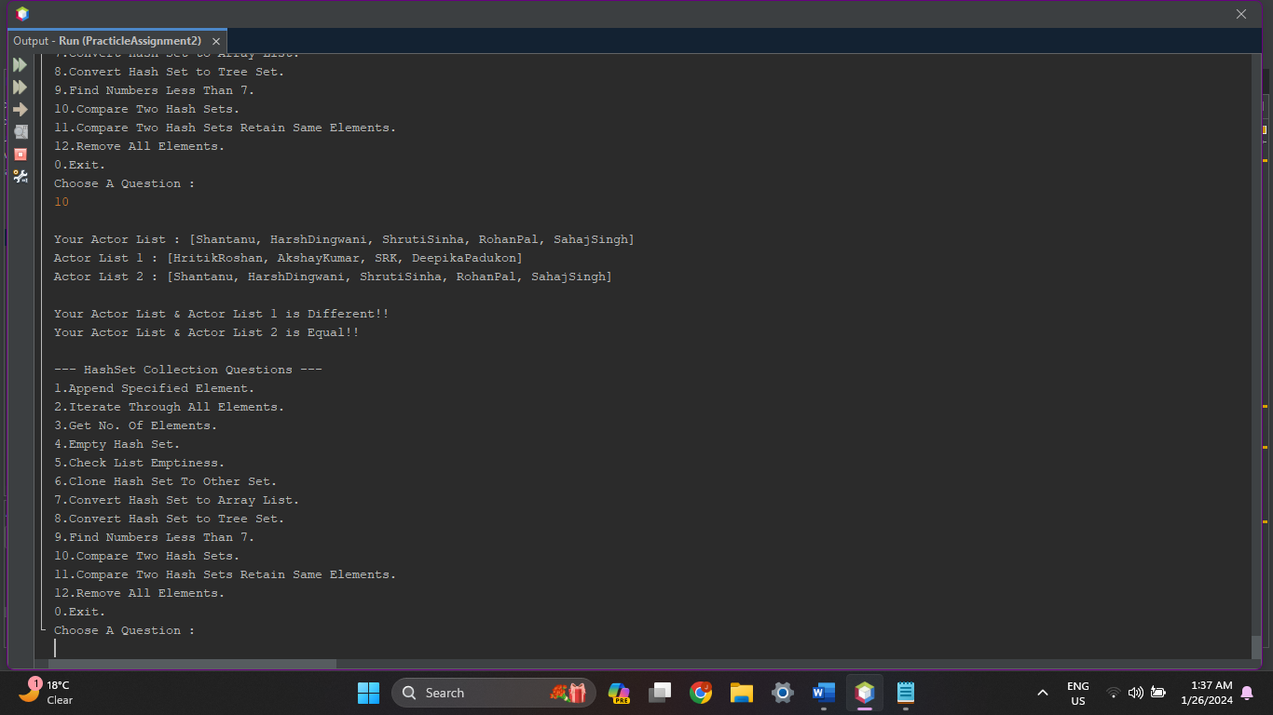

1. **Write a Java program to compare two sets and retain elements that are the same.**

**Source Code :**

protected void CompareHashSetRetainSameElements() {

HashSet<String> Actors = new HashSet<String>();

HashSet<String> Actors1 = new HashSet<String>();

HashSet<String> Actors2 = new HashSet<String>();

System.out.println("\nHow Many Actors You Want to Insert ? ");

System.out.print("> ");

int n = in.nextInt();

System.out.println("Enter Actor List 1 : ");

for (int i = 0; i < n; i++) {

Actors1.add(in.next());

}

Actors.addAll(Actors1);

System.out.println("Enter Actor List 2 : ");

for (int i = 0; i < n; i++) {

Actors2.add(in.next());

}

System.out.print("\nActor List 1 : " + Actors1);

System.out.print("\nActor List 2 : " + Actors2);

System.out.println();

if (Actors1.equals(Actors2)) {

System.out.println("Your Actor List 1 & Actor List 2 is Equal!!");

} else {

System.out.println("Your Actor List 1 & Actor List 2 is Different!!");

Actors.retainAll(Actors2);

if(Actors.size()>0)

{

System.out.print("\nSame Elements : "+Actors);

}

}

System.out.println();

}

**Output :**

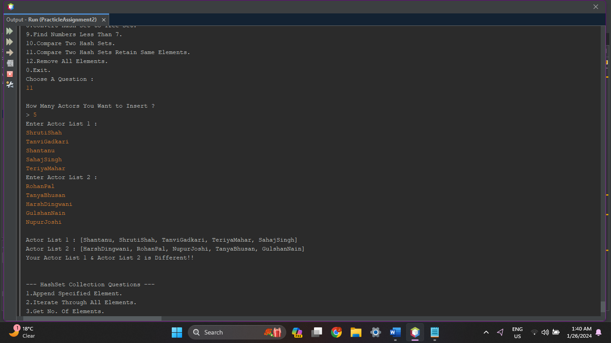

1. **Write a Java program to remove all elements from a hash set.**

**Source Code :**

protected void MakeListEmpty(HashSet<String> Actors) {

System.out.print("\nActor Set : " + Actors);

System.out.println();

if (Actors.size() > 0) {

Actors.removeAll(Actors);

System.out.println("All Actors Removed!!");

System.out.print("\nActor Set : " + Actors);

} else {

System.out.println("Actor Set is Empty!!");

}

System.out.println();

}

**Output :**

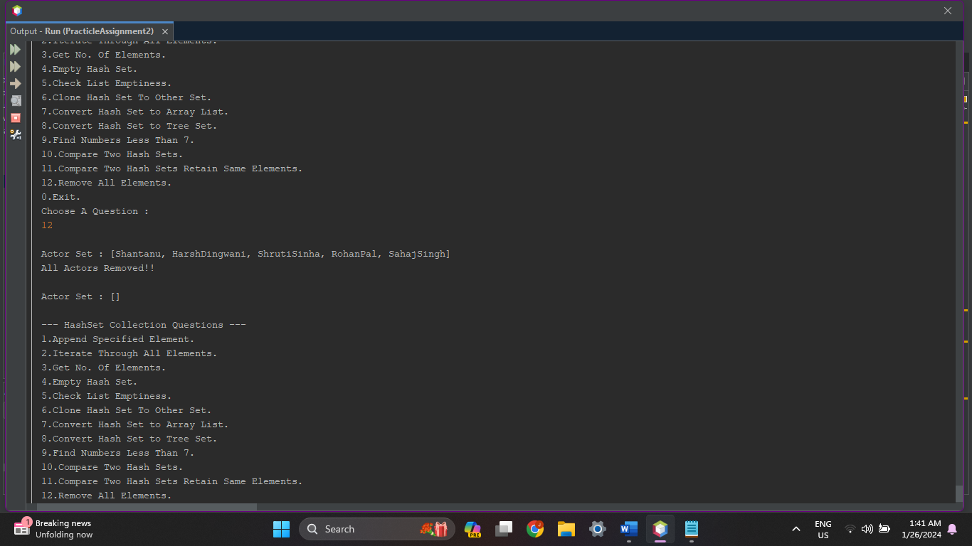

1. **Tree Set :**

TreeSet<String> Temples = new TreeSet<String>();

1. **Write a Java program to create a tree set, add some colors (strings) and print out the tree set.**

**Source Code :**

protected TreeSet<String> CreateInsertPrint(){

int n;

TreeSet<String> Temples = new TreeSet<String>();

System.out.println("\nHow Many Famous Temple Names You want to Insert ?");

System.out.print(">");

n = in.nextInt();

System.out.println("\nEnter Temple List : ");

for (int i = 0; i < n; i++) {

Temples.add(in.next());

}

System.out.print("\nTemple List : "+Temples);

System.out.println();

return Temples;

}

**Output :**

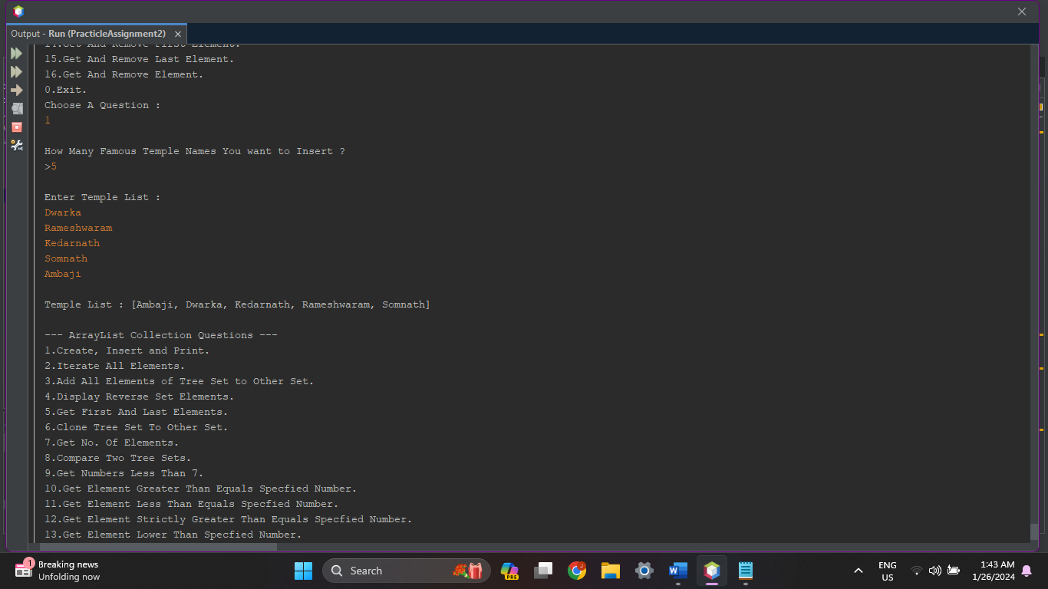

1. **Write a Java program to iterate through all elements in a tree set.**

**Source Code :**

protected void IterateAllElements(TreeSet<String> Temples){

int cnt = 1;

System.out.println("\nTemple List : ");

for (String t: Temples) {

System.out.print("["+cnt+"] "+t+"\t");

cnt++;

}

System.out.println();

}

**Output :**

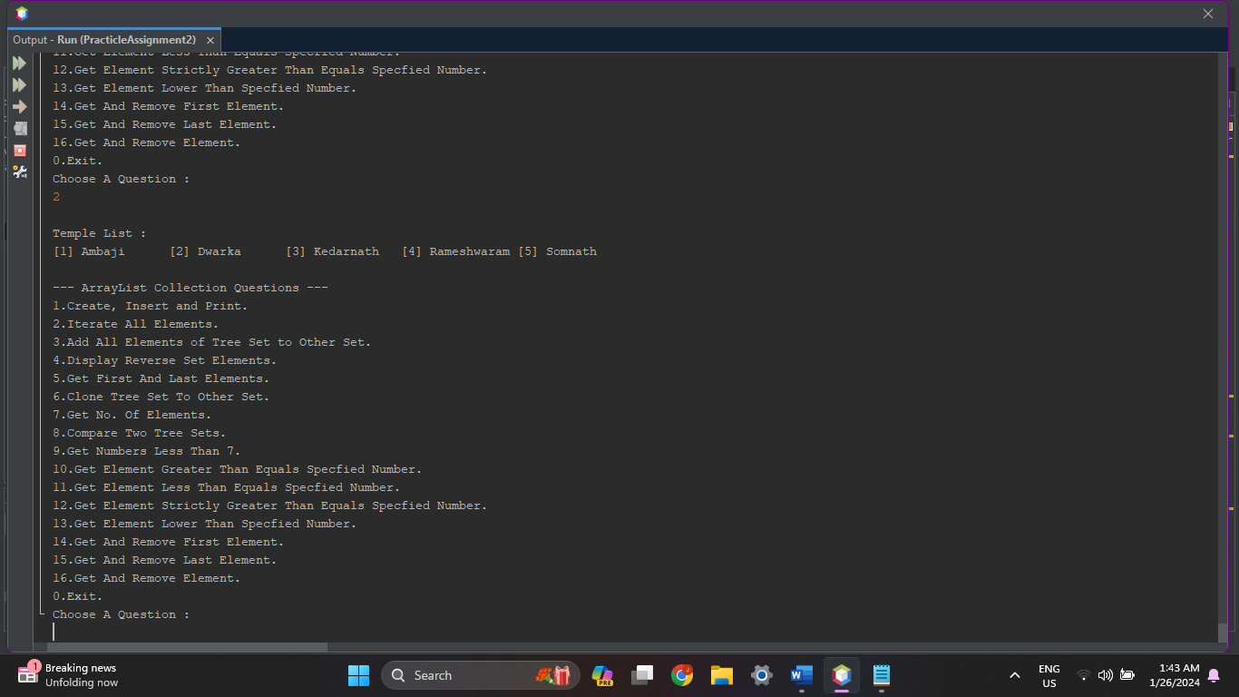

1. **Write a Java program to add all the elements of a specified tree set to another tree set.**

**Source Code :**

protected void ReverseElements(TreeSet<String> Temples){

System.out.print("\nTemple List : "+Temples);

System.out.println();

NavigableSet<String> treeset = Temples.descendingSet();

Iterator<String> temples = treeset.iterator();

System.out.print("\nReversed Temple List : "+Temples);

System.out.println();

}

**Output :**

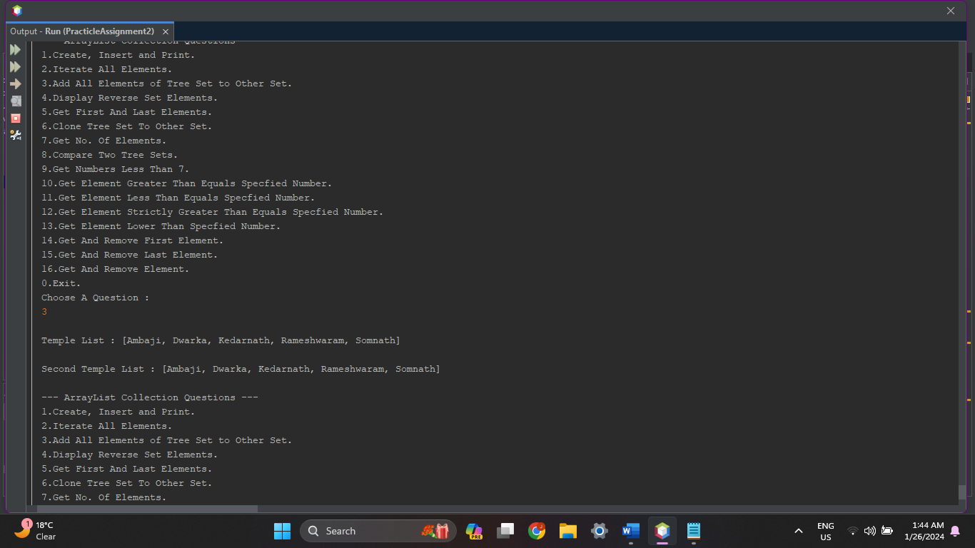

1. **Write a Java program to create a reverse order view of the elements contained in a given tree set.**

**Source Code :**

protected void AddAllElementsToOtherSet(TreeSet<String> Temples){

System.out.print("\nTemple List : "+Temples);

System.out.println();

Set<String> temples2 = new TreeSet<String>(Temples);

System.out.print("\nSecond Temple List : "+temples2);

System.out.println();

}

**Output :**

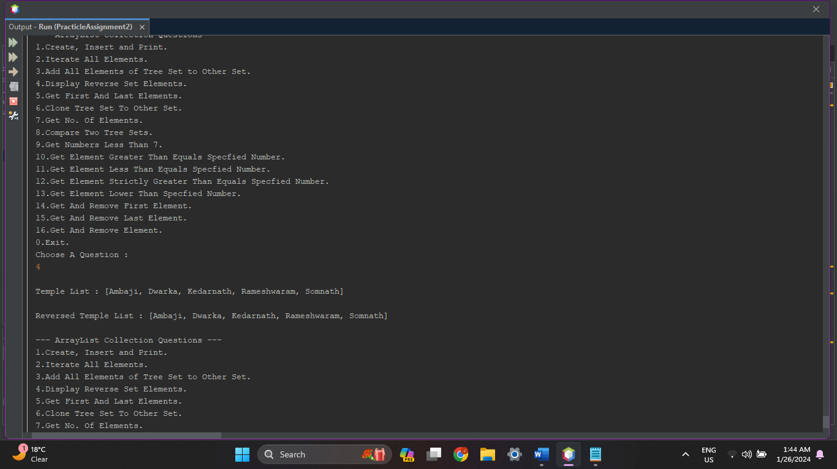

1. **Write a Java program to get the first and last elements in a tree set.**

**Source Code :**

protected void GetFirstLastElements(TreeSet<String> Temples){

System.out.print("\nTemple List : "+Temples);

System.out.println();

System.out.println("\nFirst Temple in List : "+Temples.first());

System.out.println("\nLast Temple in List : "+Temples.last());

System.out.println();

}

**Output :**

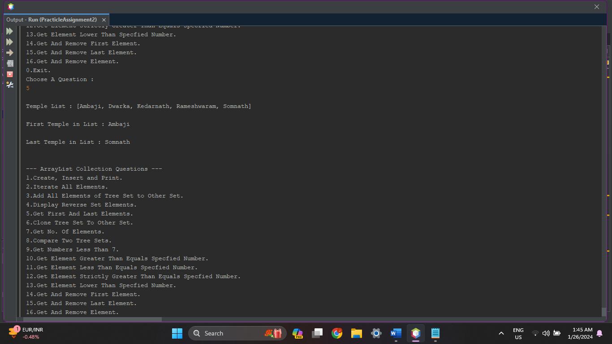

1. **Write a Java program to clone a tree set list to another tree set.**

**Source Code :**

protected void CloneTreeSetToOtherSet(TreeSet<String> Temples){

TreeSet<String> Temples2 = new TreeSet<String>();

System.out.print("\nFirst Temple List : "+Temples);

System.out.println();

Temples2 = (TreeSet<String>)Temples.clone();

System.out.print("\nClonned Temple List : "+Temples2);

System.out.println();

}

**Output :**

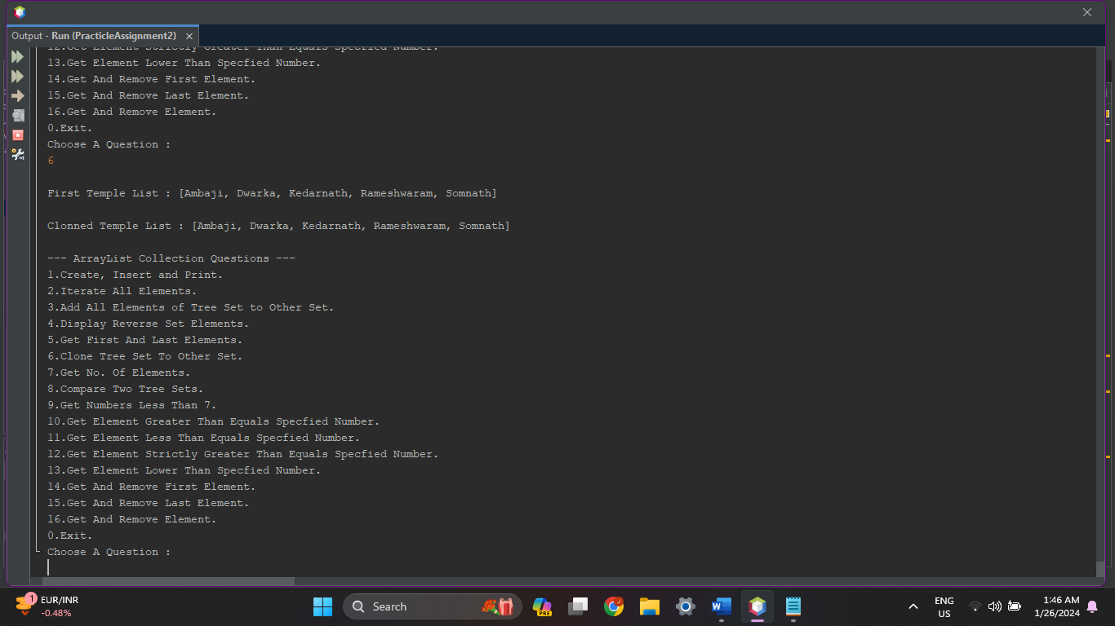

1. **Write a Java program to get the number of elements in a tree set.**

**Source Code :**

protected void GetNumberOfElements(TreeSet<String> Temples){

System.out.print("\nNo. Of Temples in List : "+Temples.size());

System.out.println();

}

**Output :**

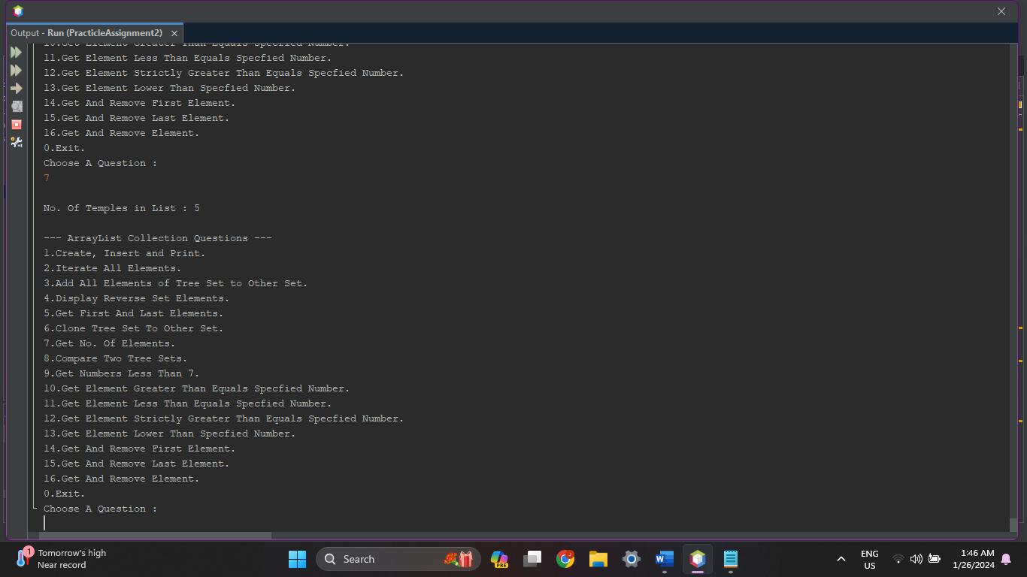

1. **Write a Java program to compare two tree sets.**

**Source Code :**

protected void CompareTwoTreeSets(TreeSet<String> Temples){

TreeSet<String> Temples1 = new TreeSet<String>();

TreeSet<String> Temples2 = new TreeSet<String>();

Temples1.add("Himalay");

Temples1.add("Minaxi(Madurai)");

Temples1.add("Rameshwaram");

Temples1.add("Kashi-Vishwanath");

Temples2.addAll(Temples);

System.out.print("\nYour Temple List : "+Temples);

System.out.print("\nTemple List 1 : "+Temples1);

System.out.print("\nTemple List 2 : "+Temples2);

System.out.println();

if(Temples.equals(Temples1))

{

System.out.print("\nYour Temple List & Temple List 1 is Equal!!");

}

else

{

System.out.print("\nYour Temple List & Temple List 1 is Different!!");

}

if(Temples.equals(Temples2))

{

System.out.print("\nYour Temple List & Temple List 2 is Equal!!");

}

else

{

System.out.print("\nYour Temple List & Temple List 2 is Different!!");

}

System.out.println();

}

**Output :**

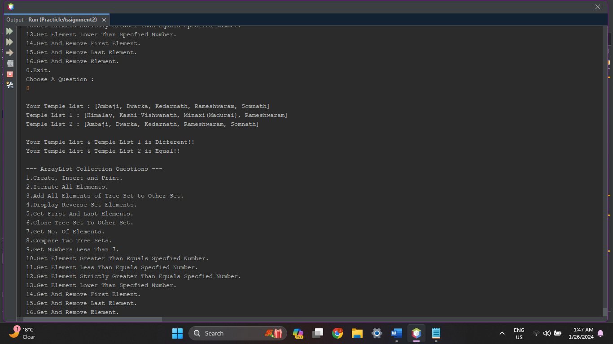

1. **Write a Java program to find numbers less than 7 in a tree set.**

**Source Code :**

protected void NumbersLess7(){

int n;

TreeSet<Integer> Numbers = new TreeSet<Integer>();

System.out.println("\nHow Many Numbers You Want to Insert ? ");

System.out.print("> ");

n = in.nextInt();

System.out.println("Enter Integers : ");

for(int i=0;i<n;i++)

{

Numbers.add(in.nextInt());

}

System.out.print("\nNumbers < 7 : ");

for (Integer num : Numbers) {

if (num < 7) {

System.out.print(num + "\t");

}

}

}

**Output :**

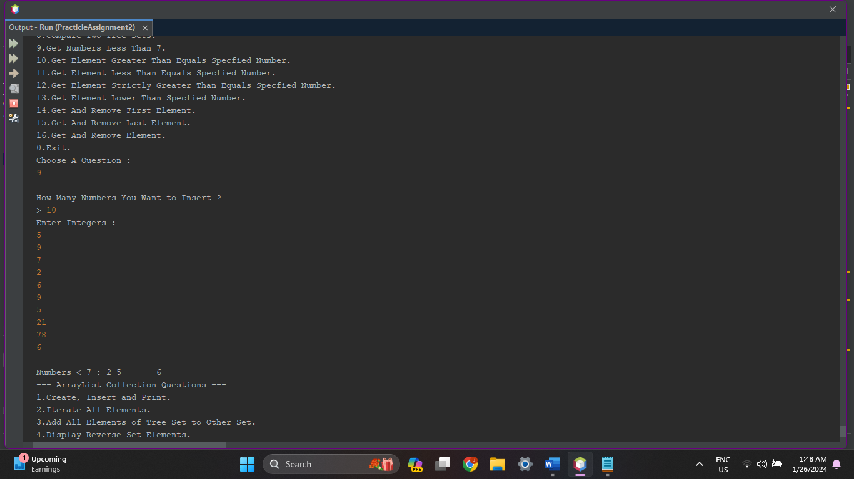

1. **Write a Java program to get the element in a tree set which is greater than or equal to the given element.**

**Source Code :**

protected void GetGreaterEqual(){

int n, no;

TreeSet<Integer> Numbers = new TreeSet<Integer>();

System.out.println("\nHow Many Numbers You Want to Insert ? ");

System.out.print("> ");

n = in.nextInt();

System.out.println("Enter Integers : ");

for(int i=0;i<n;i++)

{

Numbers.add(in.nextInt());

}

System.out.print("\nEnter A Number to Compare : ");

no = in.nextInt();

System.out.print("\nElement >= "+no+" : "+Numbers.ceiling(no));

System.out.println();

}

**Output :**

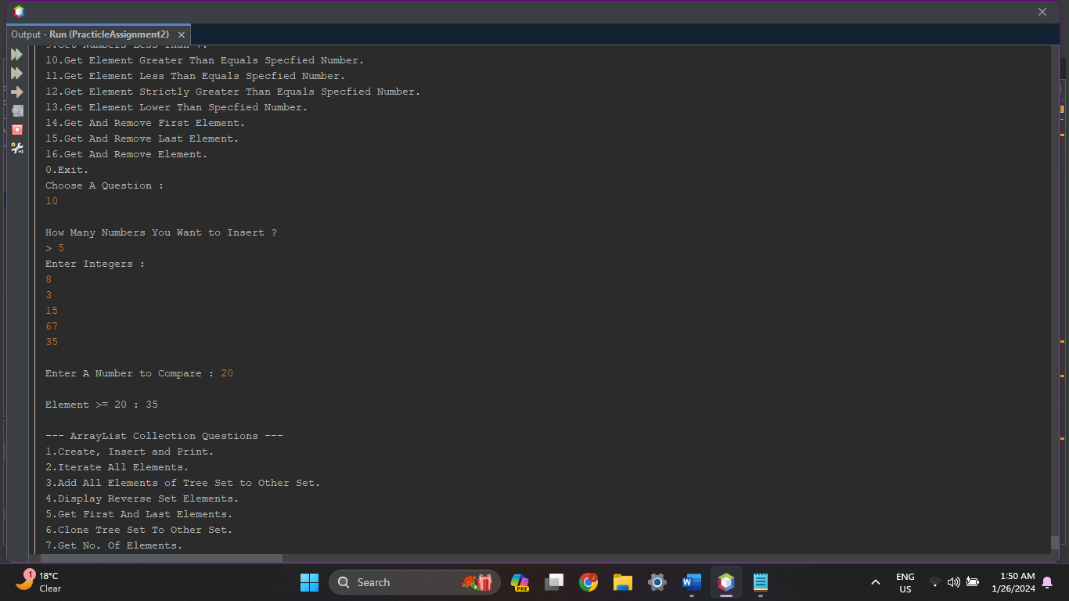

1. **Write a Java program to get the element in a tree set less than or equal to the given element.**

**Source Code :**

protected void GetLessEqual(){

int n, no;

TreeSet<Integer> Numbers = new TreeSet<Integer>();

System.out.println("\nHow Many Numbers You Want to Insert ? ");

System.out.print("> ");

n = in.nextInt();

System.out.println("Enter Integers : ");

for(int i=0;i<n;i++)

{

Numbers.add(in.nextInt());

}

System.out.print("\nEnter A Number to Compare : ");

no = in.nextInt();

System.out.print("\nElement <= "+no+" : "+Numbers.floor(no));

System.out.println();

}

**Output :**

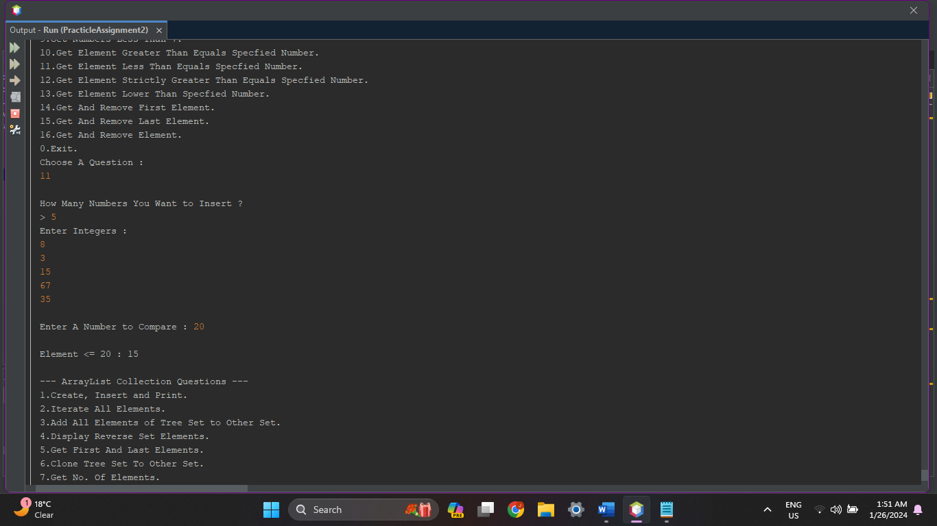

1. **Write a Java program to get the element in a tree set strictly greater than or equal to the given element.**

**Source Code :**

protected void GetStrictlyGreaterEqual(){

int n, no;

TreeSet<Integer> Numbers = new TreeSet<Integer>();

System.out.println("\nHow Many Numbers You Want to Insert ? ");

System.out.print("> ");

n = in.nextInt();

System.out.println("Enter Integers : ");

for(int i=0;i<n;i++)

{

Numbers.add(in.nextInt());

}

System.out.print("\nEnter A Number to Compare : ");

no = in.nextInt();

System.out.print("\nNumber Strictly >= "+no+" : "+Numbers.higher(no));

System.out.println();

}

**Output :**

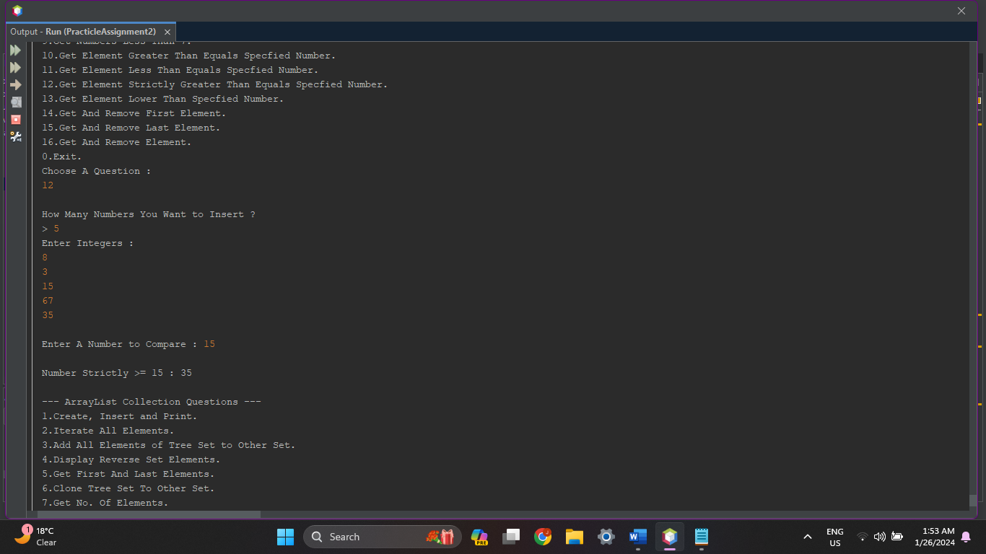

1. **Write a Java program to get an element in a tree set that has a lower value than the given element.**

**Source Code :**

protected void GetLower(){

int n, no;

TreeSet<Integer> Numbers = new TreeSet<Integer>();

System.out.println("\nHow Many Numbers You Want to Insert ? ");

System.out.print("> ");

n = in.nextInt();

System.out.println("Enter Integers : ");

for(int i=0;i<n;i++)

{

Numbers.add(in.nextInt());

}

System.out.print("\nEnter A Number to Compare : ");

no = in.nextInt();

System.out.print("\nElement Lower Than "+no+" : "+Numbers.lower(no));

System.out.println();

}

**Output :**

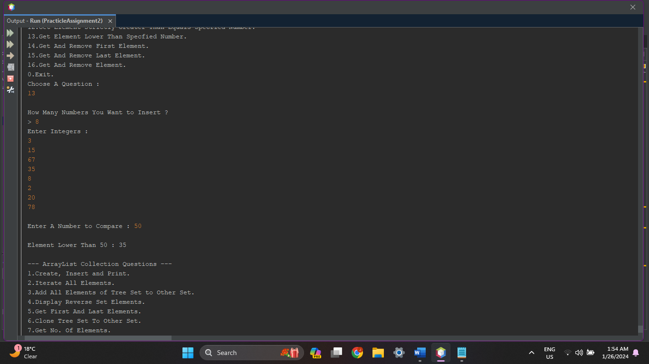

1. **Write a Java program to retrieve and remove the first element of a tree set.**

**Source Code :**

protected void GetAndRemoveFirst(TreeSet<String> Temples){

System.out.print("\nTemple List : "+Temples);

System.out.print("\nGive Temple You Want TO Remove : ");

System.out.println("\n"+Temples.pollFirst()+" Temple Removed!!");;

System.out.println();

}

**Output :**

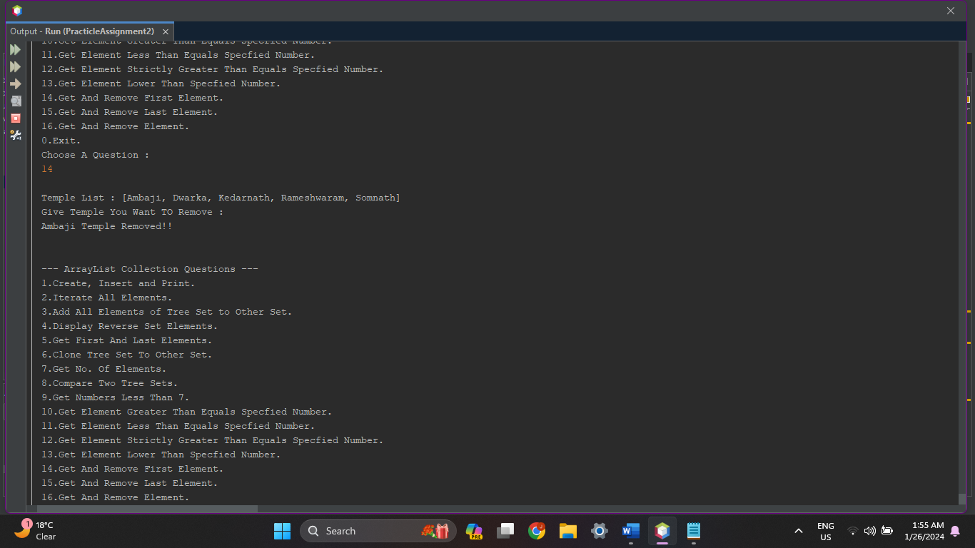

1. **Write a Java program to retrieve and remove the last element of a tree set.**

**Source Code :**

protected void GetAndRemoveLast(TreeSet<String> Temples){

System.out.print("\nTemple List : "+Temples);

System.out.println("\n"+Temples.pollLast()+" Temple Removed!!");;

System.out.println();

}

**Output :**

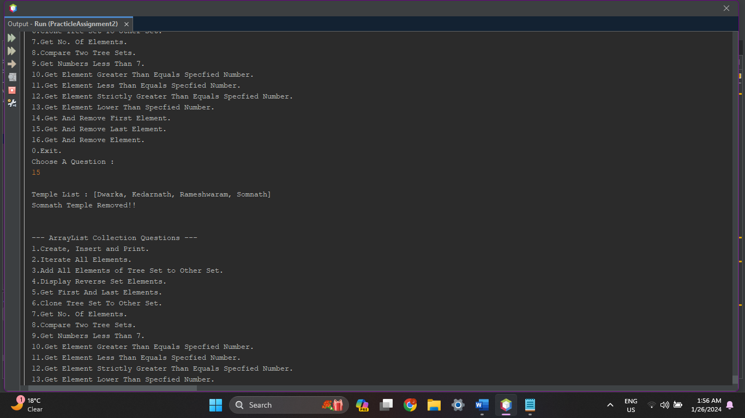

1. **Write a Java program to remove a given element from a tree set.**

**Source Code :**

protected void RemoveElement(TreeSet<String> Temples){

String ele;

System.out.print("\nTemple List : "+Temples);

System.out.print("\nGive Temple You Want To Remove : ");

ele = in.next();

Temples.remove(ele);

System.out.println("\n"+ele+" Temple Removed!!");;

System.out.println();

}

**Output :**

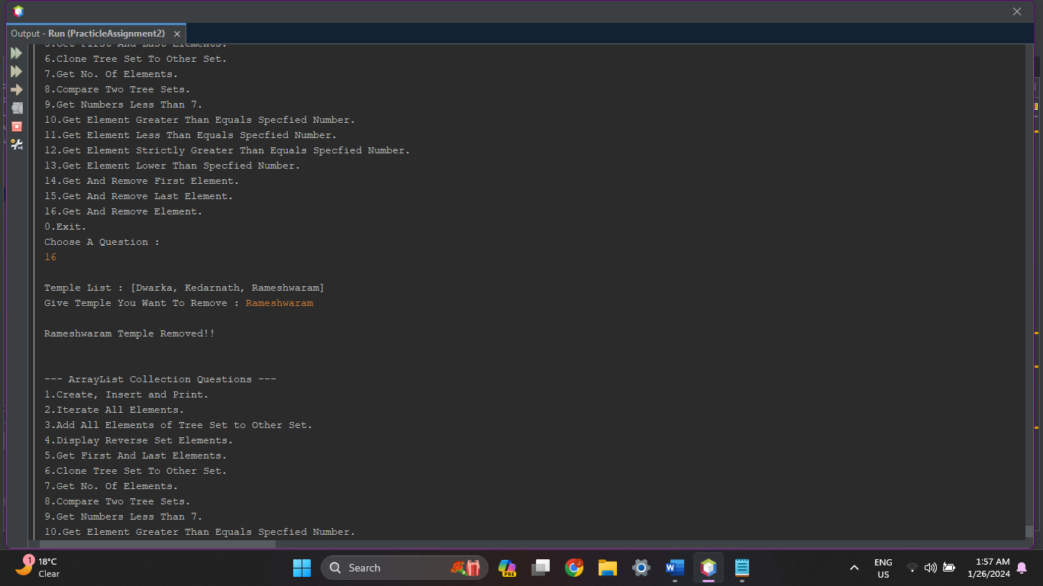

1. **Priority Queue :**

PriorityQueue<String> Shows = new PriorityQueue<String>();

1. **Write a Java program to create a priority queue, add some colors (strings) and print out the elements of the priority queue.**

**Source Code :**

protected PriorityQueue<String> CreateInsertPrint(){

int n;

PriorityQueue<String> Shows = new PriorityQueue<String>();

System.out.println("\nHow Many Shows Names You want to Insert ?");

System.out.print(">");

n = in.nextInt();

System.out.print("\nEnter Show Queue : ");

for (int i = 0; i < n; i++) {

Shows.add(in.next());

}

System.out.print("\nShows Queue : "+Shows);

System.out.println();

return Shows;

}

**Output :**

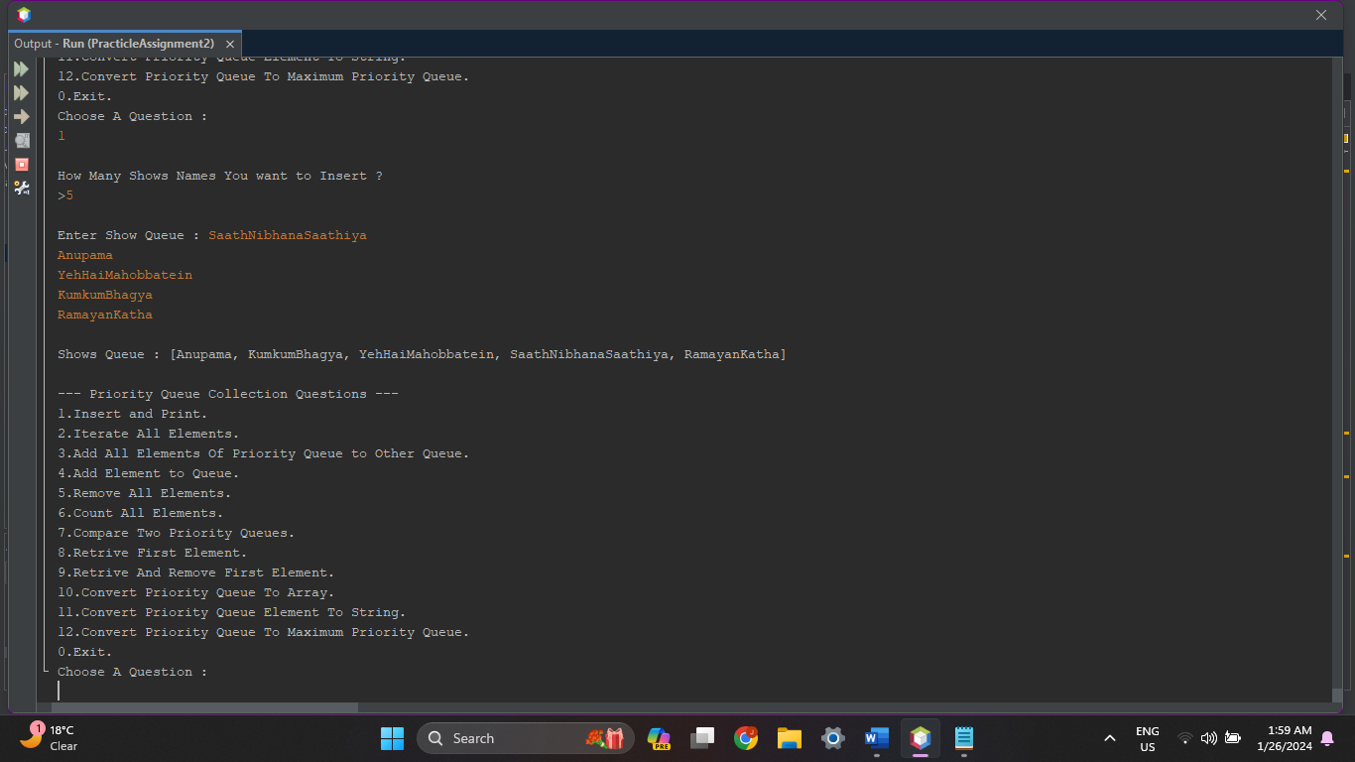

1. **Write a Java program to iterate through all elements in the priority queue.**

**Source Code :**

protected void IterateAllElements(PriorityQueue<String> Shows){

int cnt = 1;

System.out.println("\nShows Queue : ");

for (String s: Shows) {

System.out.print("["+cnt+"] "+s+"\t");

cnt++;

}

System.out.println();

}

**Output :**

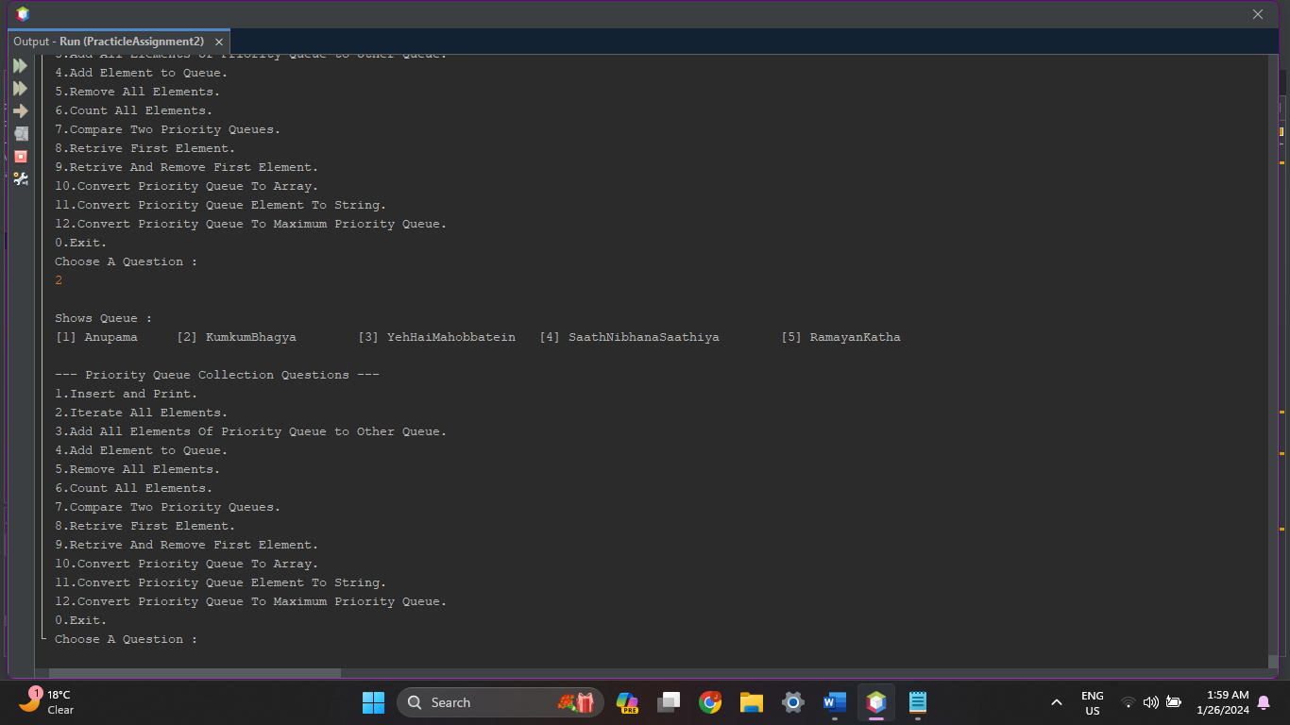

1. **Write a Java program to add all the elements of a priority queue to another priority queue.**

**Source Code :**

protected void AllElementsToOtherQueue(PriorityQueue<String> Shows){

PriorityQueue<String> Shows2 = new PriorityQueue<String>();

System.out.print("\nFirst Shows Queue : "+Shows);

Shows2.addAll(Shows);

System.out.print("\nSecond Shows Queue : "+Shows2);

System.out.println();

}

**Output :**

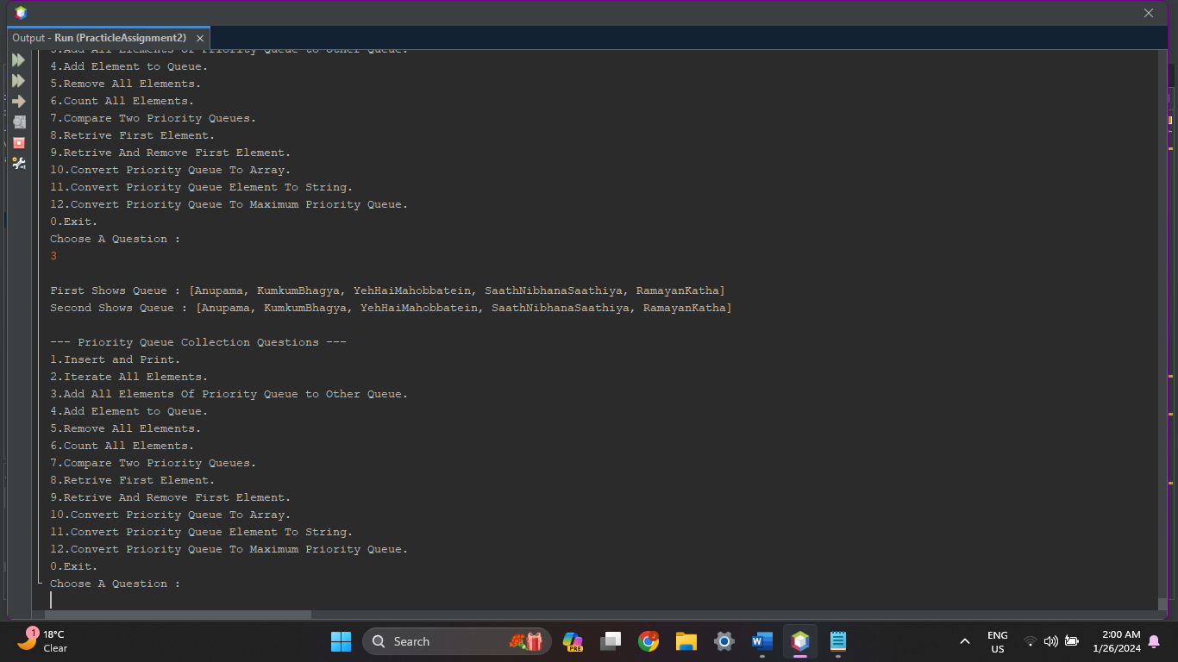

1. **Write a Java program to insert a given element into a priority queue.**

**Source Code :**

protected void InsertAnElement(PriorityQueue<String> Shows){

String show;

System.out.print("\nGive Show Name : ");

show = in.next();

System.out.println(show+" Addded To Queue!!");

Shows.add(show);

System.out.print("\nShows Queue : "+Shows);

System.out.println();

}

**Output :**

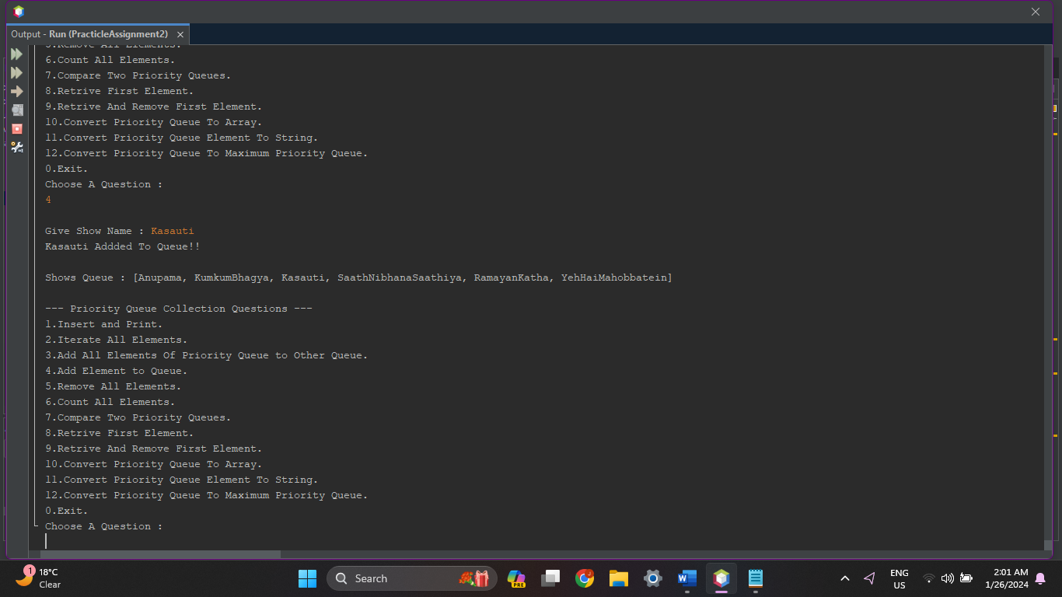

1. **Write a Java program to remove all elements from a priority queue.**

**Source Code :**

protected void RemoveAllElements(PriorityQueue<String> Shows){

Shows.removeAll(Shows);

System.out.println("All Shows Removed!!");

System.out.print("\nShows Queue : "+Shows);

System.out.println();

}

**Output :**

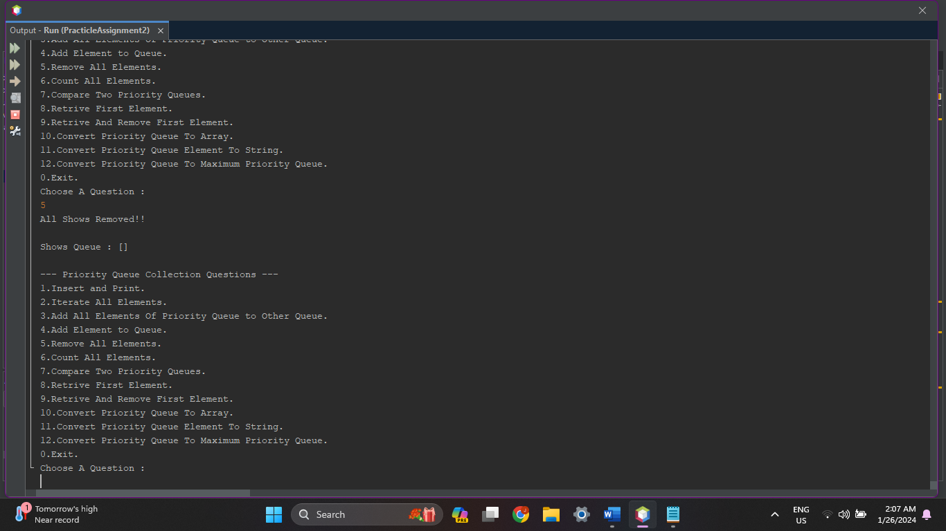

1. **Write a Java program to count the number of elements in a priority queue.**

**Source Code :**

protected void CountAllElements(PriorityQueue<String> Shows){

System.out.print("\nShows Queue : "+Shows);

System.out.print("\nNo. Of Shows : "+Shows.size());

System.out.println();

}

**Output :**

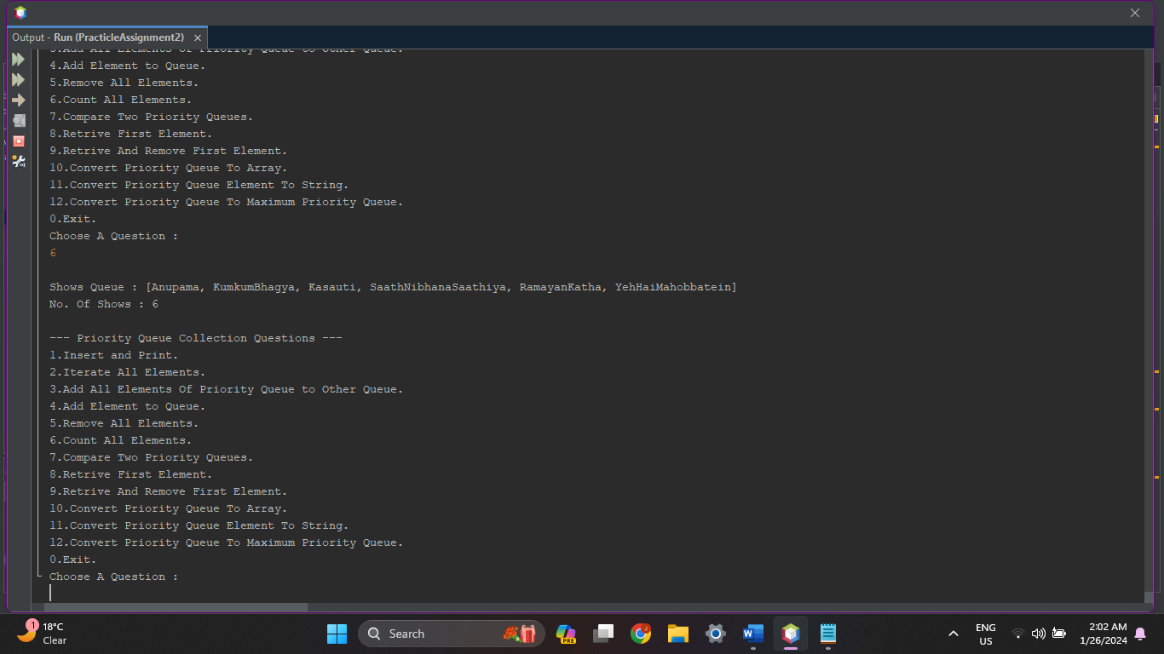

1. **Write a Java program to compare two priority queues.**

**Source Code :**

protected void CompareTwoQueues(PriorityQueue<String> Shows){

PriorityQueue<String> Shows1 = new PriorityQueue<String>();

PriorityQueue<String> Shows2 = new PriorityQueue<String>();

Shows1.add("Ramayan");

Shows1.add("Mahabharat");

Shows1.add("Ganesh");

Shows1.add("Laxmi-Narayan");

Shows2.addAll(Shows);

System.out.print("\nYour Show Queue : "+Shows);

System.out.print("\nShow List 1 : "+Shows1);

System.out.print("\nShow List 2 : "+Shows2);

System.out.println();

if(Shows.equals(Shows1))

{

System.out.print("\nYour Show Queue & Show Queue 1 is Equal!!");

}

else

{

System.out.print("\nYour Show Queue & Show Queue 1 is Different!!");

}

if(Shows.equals(Shows2))

{

System.out.print("\nYour Show Queue & Show Queue 2 is Equal!!");

}

else

{

System.out.print("\nYour Show Queue & Show Queue 2 is Different!!");

}

System.out.println();

}

**Output :**

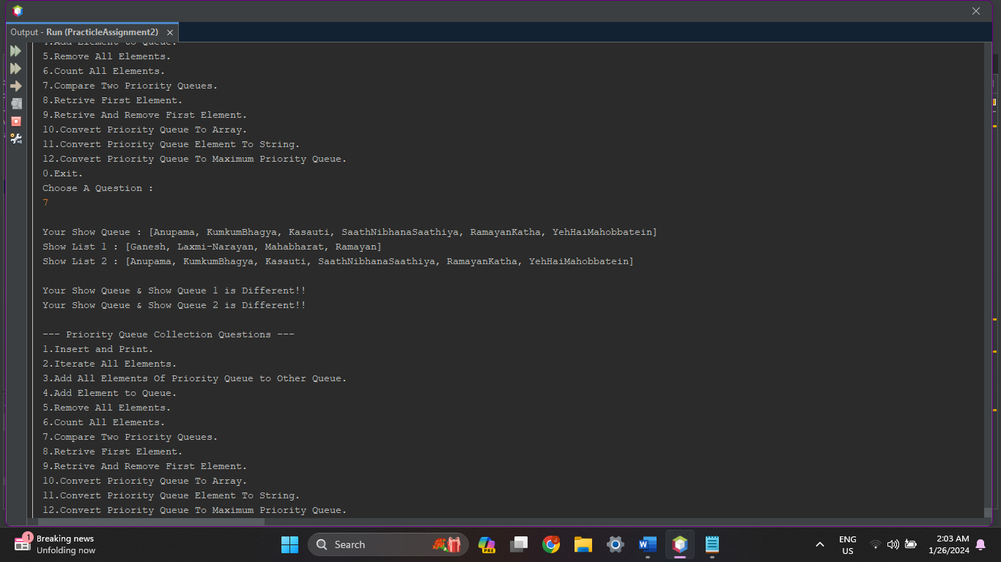

1. **Write a Java program to retrieve the first element of the priority queue.**

**Source Code :**

protected void RetriveFirstElement(PriorityQueue<String> Shows){

System.out.print("\nShows Queue : "+Shows);

System.out.print("\nFirst Shows : "+Shows.element());

System.out.println();

}

**Output :**

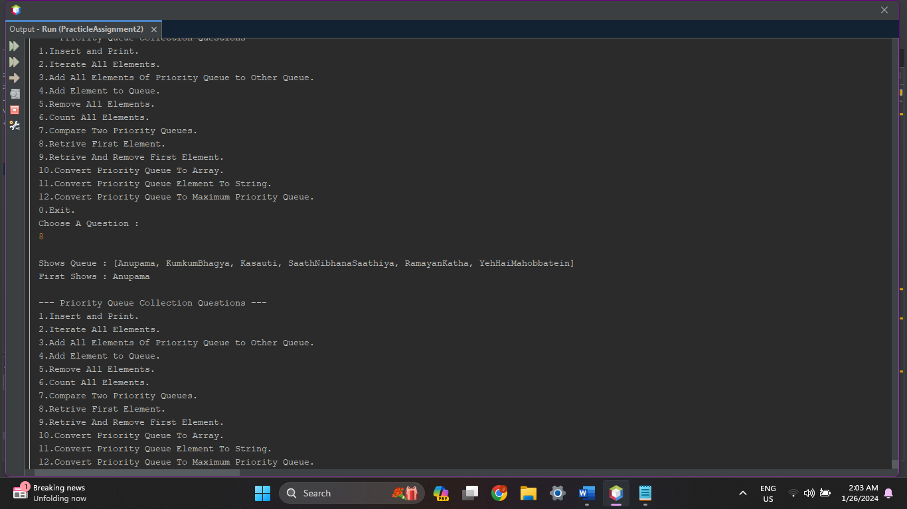

1. **Write a Java program to retrieve and remove the first element.**

**Source Code :**

protected void RetriveRemoveFirstElement(PriorityQueue<String> Shows){

System.out.print("\nShows Queue : "+Shows);

System.out.print("\nFirst Shows "+Shows.remove()+" Removed!!");

System.out.print("\nShows Queue : "+Shows);

System.out.println();

}

**Output :**

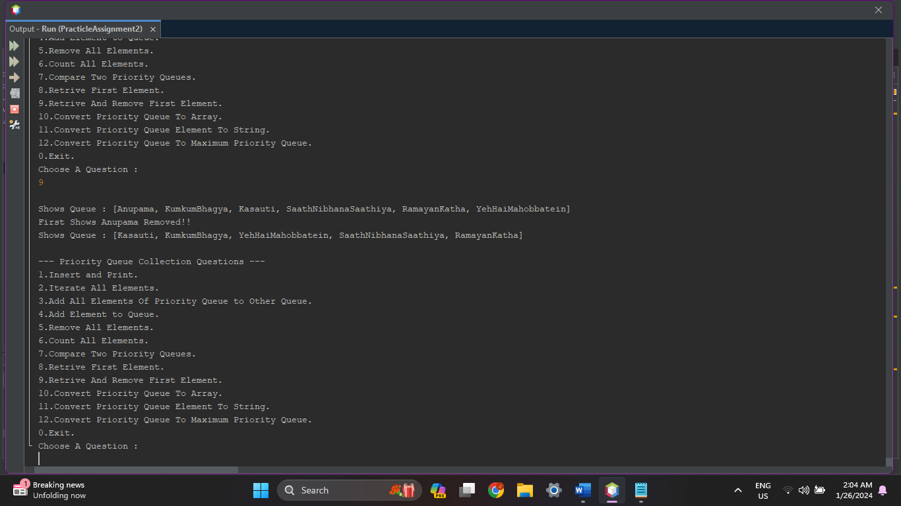

1. **Write a Java program to convert a priority queue to an array containing all its elements.**

**Source Code :**

protected void ConvertPriorityQueueToArray(PriorityQueue<String> Shows){

System.out.print("\nShows Queue : "+Shows);

Object[] Shows2 = Shows.toArray();

System.out.print("\nShows Array : ");

for(int i=0;i<Shows2.length;i++){

System.out.print(Shows2[i]+"\t");

}

System.out.println();

}

**Output :**

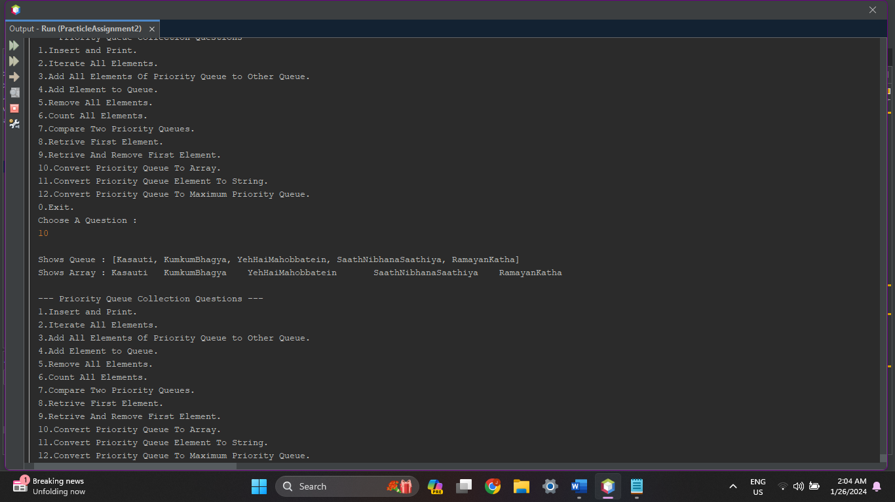

1. **Write a Java program to convert a Priority Queue element to string representations.**

**Source Code :**

protected void ConvertPriorityQueueElementToString(PriorityQueue<String> Shows){

System.out.print("\nShows Queue : "+Shows);

System.out.print("\nShows Queue : "+Shows.toString());

}

**Output :**

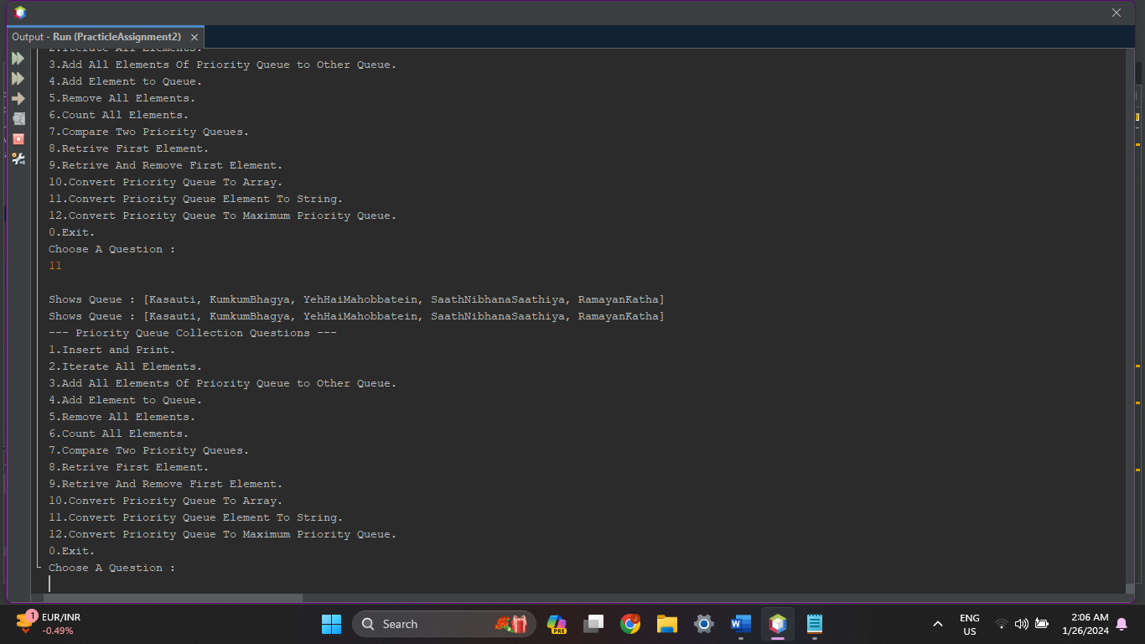

1. **Write a Java program to change priorityQueue to maximum priority queue.**

**Source Code :**

protected void ConvertPriorityQueueToMaximumPriorityQueue(PriorityQueue<String> Shows){

System.out.print("\nShows Queue : "+Shows);

PriorityQueue<String> Shows2 = new PriorityQueue<String>(Collections.reverseOrder());

Shows2.addAll(Shows);

System.out.print("\nMaximum Shows Queue : "+Shows2);

}

**Output :**

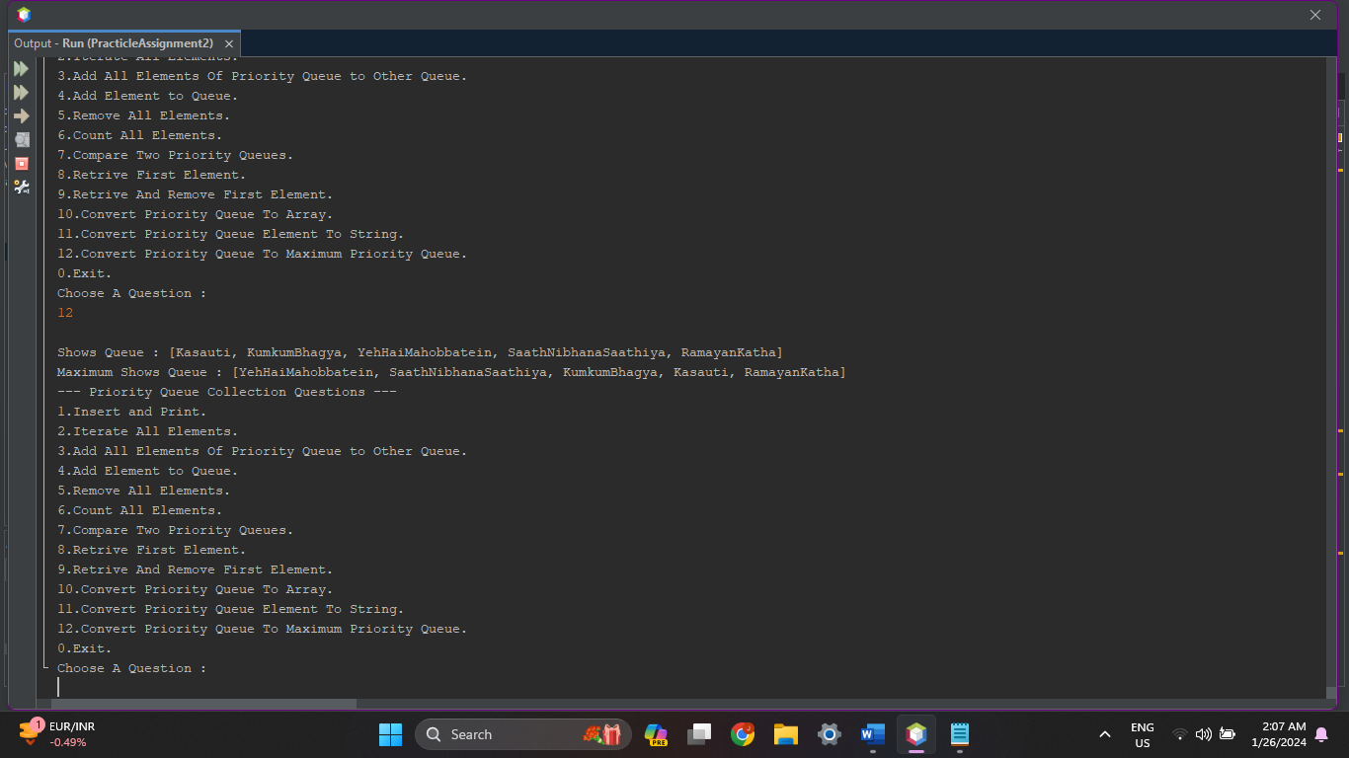

1. **Hash Map :**

HashMap<String, String> Employee = new HashMap<String, String>();

1. **Write a Java program to associate the specified value with the specified key in a HashMap.**

**Source Code :**

protected void AssociateKeyValues(HashMap<String, String> Employee){

String Key, Value;

System.out.println("\nHow Many Employees You Want to Enter ?");

System.out.print(">");

int n = in.nextInt();

for(int i=0;i<n;i++)

{

System.out.print("\nEnter Employee["+i+"] Name : ");

Key = in.next();

System.out.print("\nEnter Employee["+i+"] Designation : ");

Value = in.next();

Employee.put(Key, Value);

System.out.println();

}

System.out.println("Employee List : ");

for(String K:Employee.keySet())

{

System.out.println("Name : "+K.toString());

System.out.println("Designation : "+Employee.get(K));

}

System.out.println();

}

**Output :**

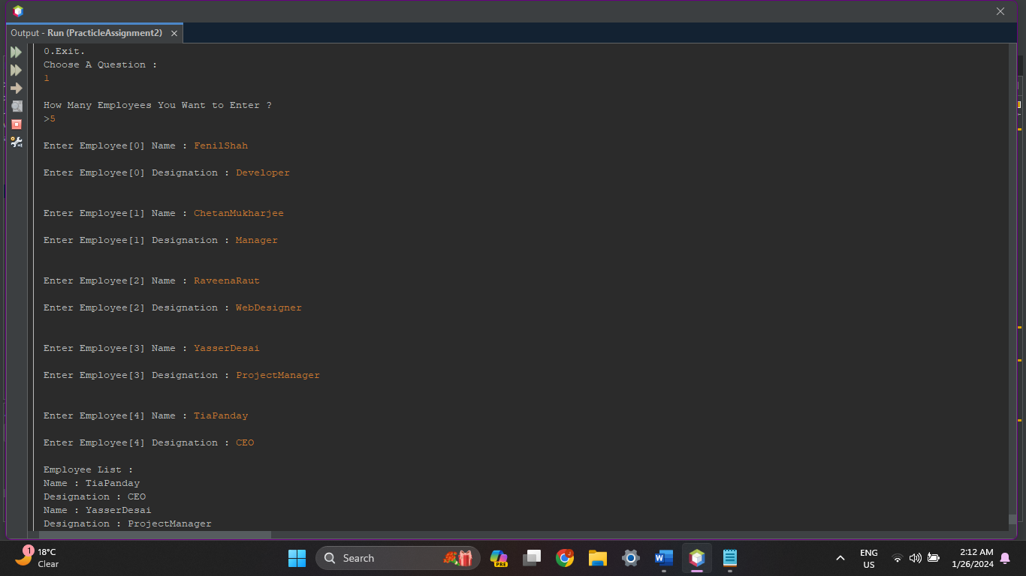

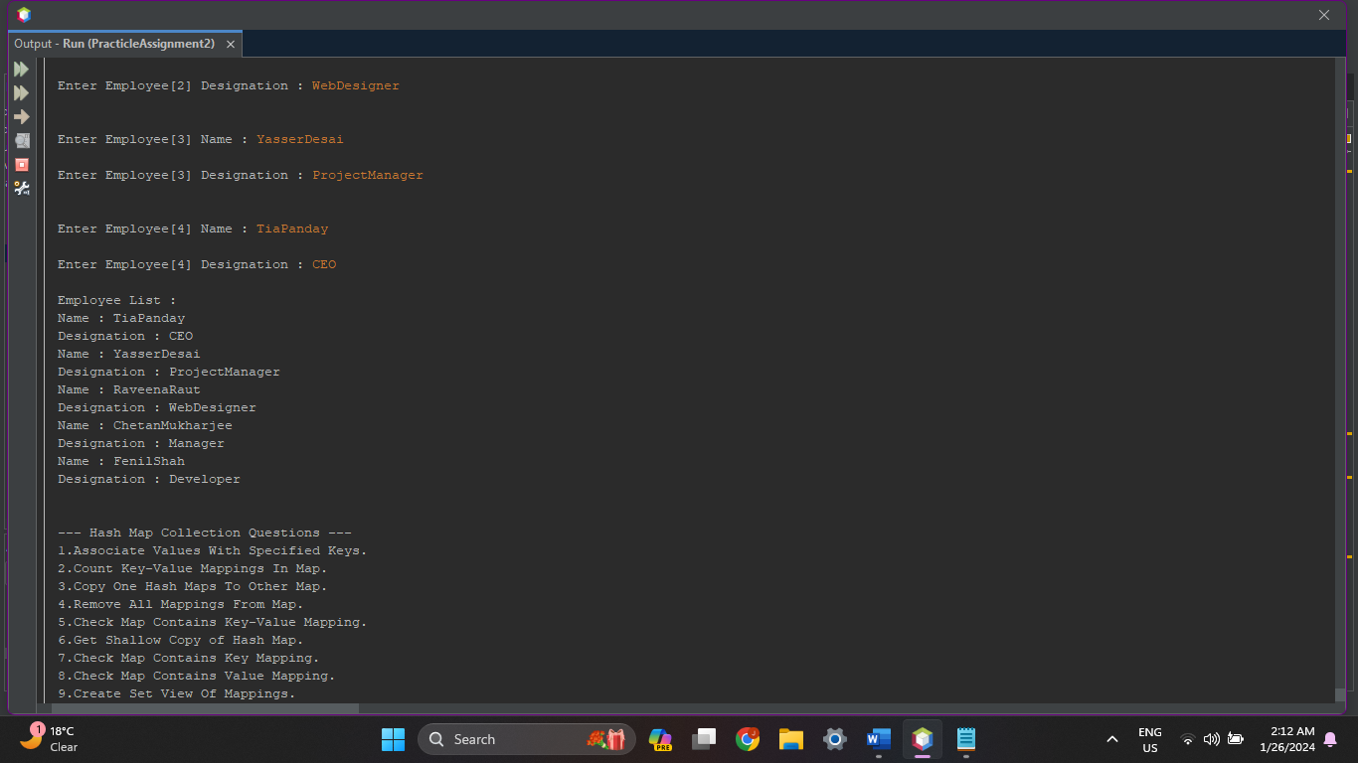

1. **Write a Java program to count the number of key-value (size) mappings in a map.**

**Source Code :**

protected void CountMappings(HashMap<String, String> Employee){

System.out.println("No. Of Employee : "+Employee.size());

System.out.println();

}

**Output :**

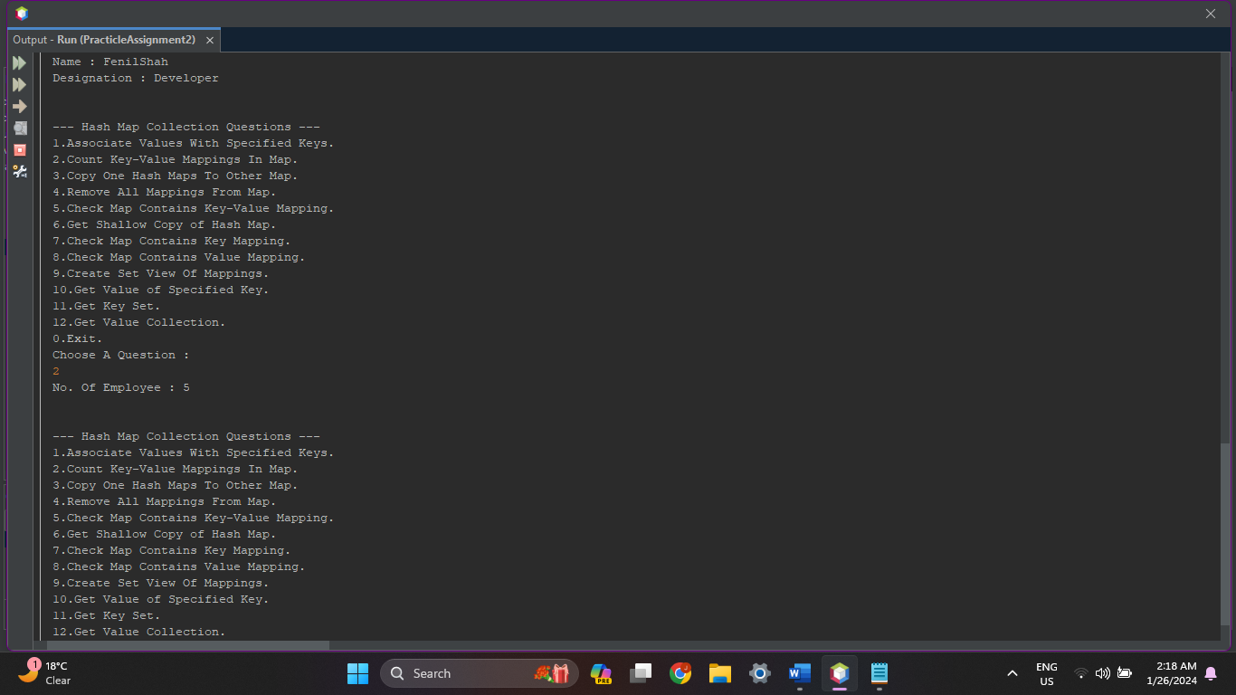

1. **Write a Java program to copy all mappings from the specified map to another map.**

**Source Code :**

protected void CopyOneHashMapToOtherMap(HashMap<String, String> Employee){

System.out.println("Your Employee List : ");

for(String K:Employee.keySet())

{

System.out.println("Name : "+K.toString());

System.out.println("Designation : "+Employee.get(K));

}

HashMap<String, String> Employee2 = new HashMap<String, String>(Employee);

System.out.println("\nCoppied Employee List : ");

for(String K:Employee2.keySet())

{

System.out.println("Name : "+K.toString());

System.out.println("Designation : "+Employee2.get(K));

}

System.out.println();

}

**Output :**

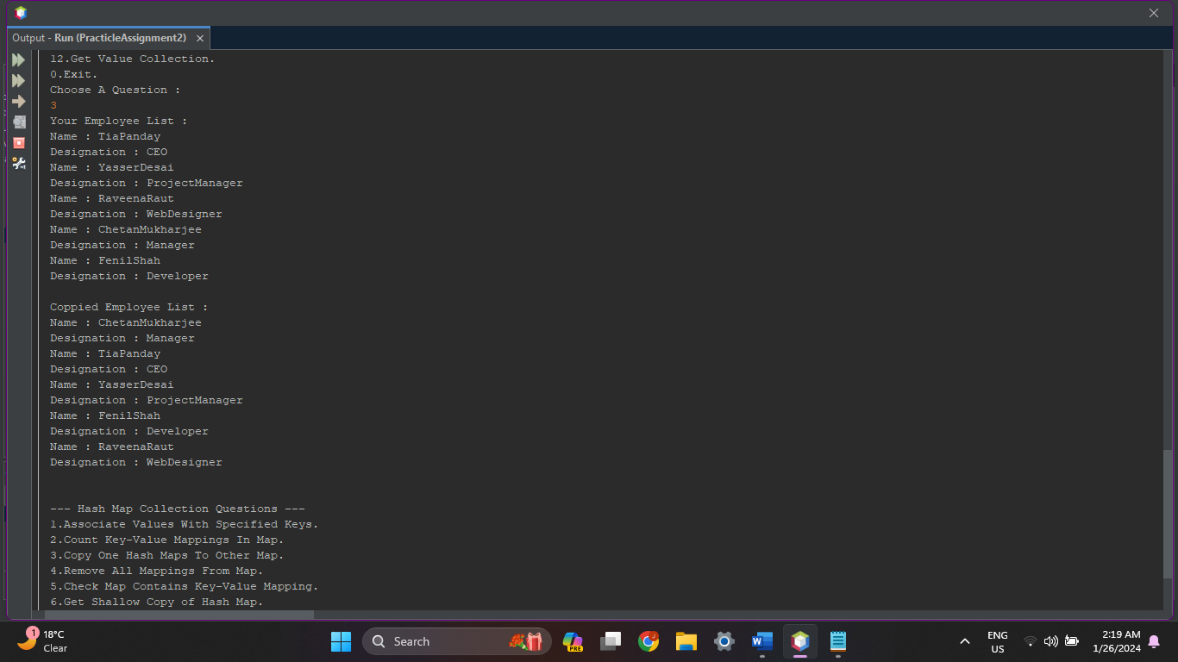

1. **Write a Java program to remove all mappings from a map.**

**Source Code :**

protected void RemoveAllMappings(HashMap<String, String> Employee){

if(Employee.size() <= 0)

{

System.out.println("No Employees Available!!");

}

else

{

Employee.clear();

System.out.println("All Employees Removed!!");

}

System.out.println("Your Employee List : ");

for(String K:Employee.keySet())

{

System.out.println("Name : "+K.toString());

System.out.println("Designation : "+Employee.get(K));

}

System.out.println();

}

**Output :**

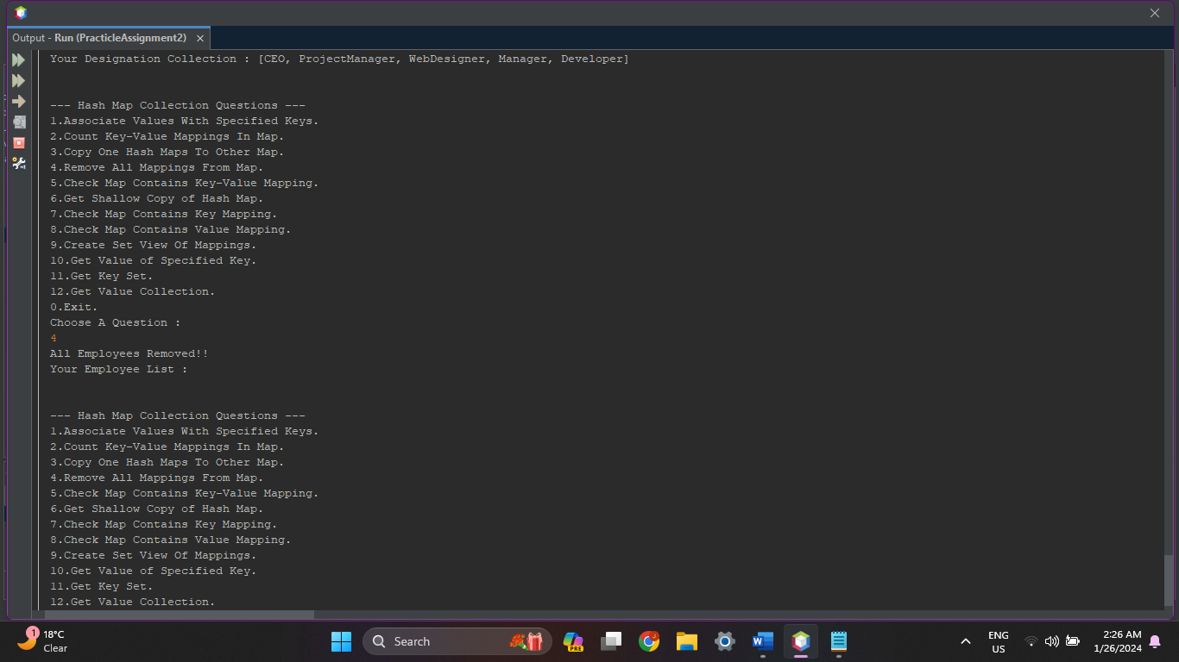

1. **Write a Java program to check whether a map contains key-value mappings (empty) or not.**

**Source Code :**

protected void CheckKeyValueMappings(HashMap<String, String> Employee){

String Key, Value;

System.out.print("\nEnter Employee Name : ");

Key = in.next();

System.out.print("\nEnter Employee Designation : ");

Value = in.next();

if(Employee.containsKey(Key) && Employee.containsValue(Value))

{

System.out.println("Hash Map Contains Employee "+Key+" With Designation "+Value+"...");

}

else

{

System.out.println("No Employee "+Key+" With Designation "+Value+" Found in Hash Map...");

}

System.out.println();

}

**Output :**

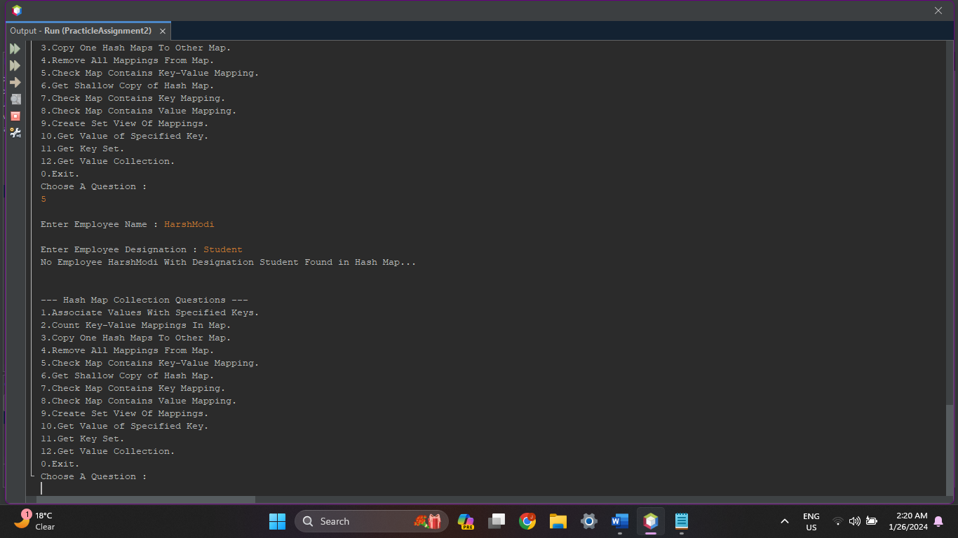

1. **Write a Java program to get a shallow copy of a HashMap instance.**

**Source Code :**

protected void GetShallowCopy(HashMap<String, String> Employee){

System.out.println("Your Employee List : ");

for(String K:Employee.keySet())

{

System.out.println("Name : "+K.toString());

System.out.println("Designation : "+Employee.get(K));

}

HashMap<String, String> Employee2 = (HashMap<String, String>)Employee.clone();

System.out.println("\nCoppied Employee List : ");

for(String K:Employee2.keySet())

{

System.out.println("Name : "+K.toString());

System.out.println("Designation : "+Employee2.get(K));

}

System.out.println();

}

**Output :**

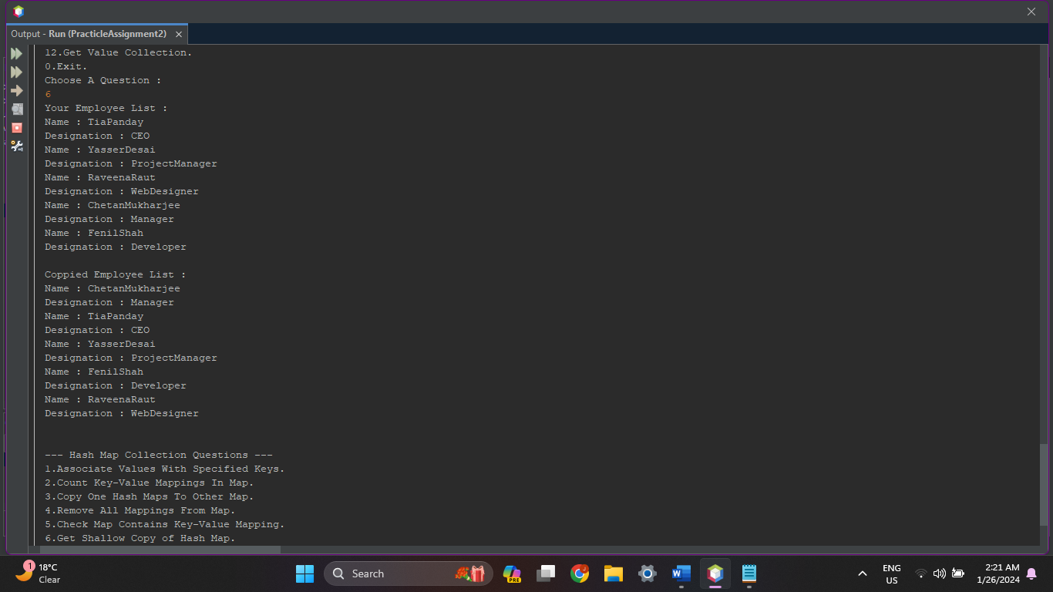

1. **Write a Java program to test if a map contains a mapping for the specified key.**

**Source Code :**

protected void CheckKeyMappings(HashMap<String, String> Employee){

String Key, Value;

System.out.print("\nEnter Employee Name : ");

Key = in.next();

if(Employee.containsKey(Key))

{

System.out.println("Hash Map Contains Employee "+Key+" With Designation "+Employee.get(Key)+"...");

}

else

{

System.out.println("No Employee "+Key+" Found in Hash Map...");

}

System.out.println();

}

**Output :**

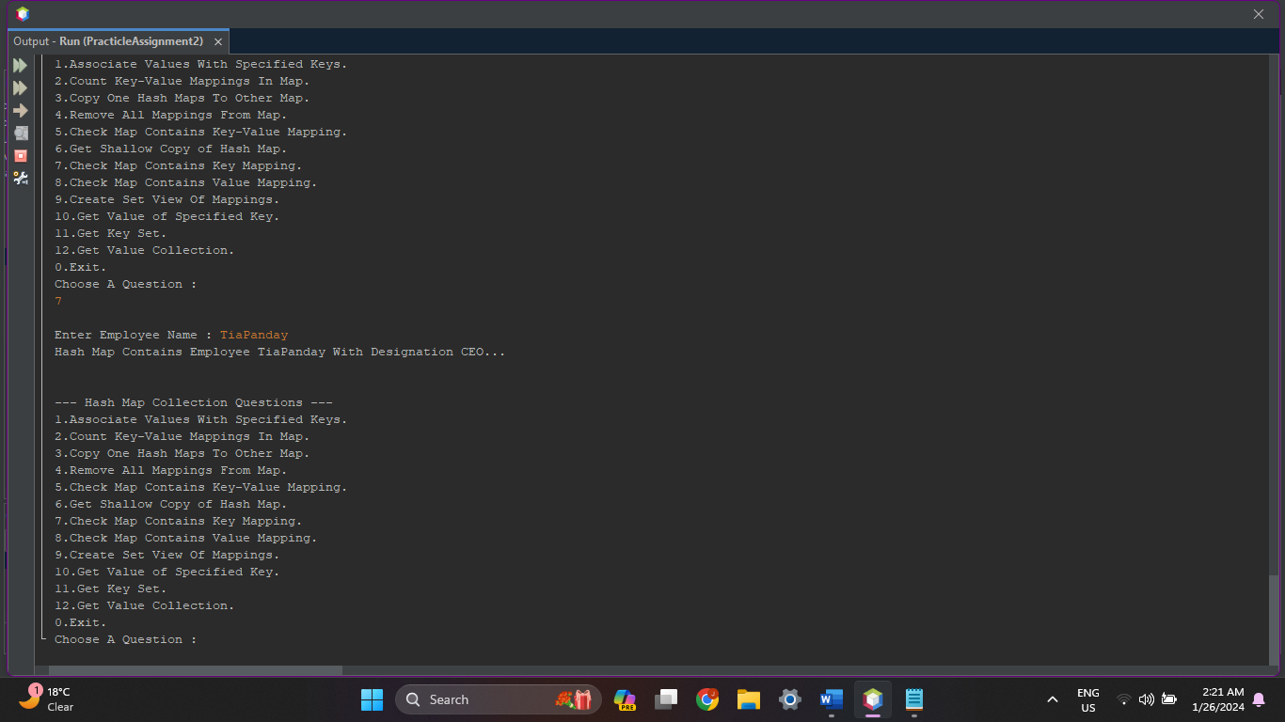

1. **Write a Java program to test if a map contains a mapping for the specified value.**

**Source Code :**

protected void CheckValueMappings(HashMap<String, String> Employee){

String Value;

System.out.print("\nEnter Employee Designation : ");

Value = in.next();

if(Employee.containsValue(Value))

{

System.out.println("Hash Map Contains Designation "+Value+"...");

}

else

{

System.out.println("No Designation "+Value+" Found in Hash Map...");

}

System.out.println();

}

**Output :**

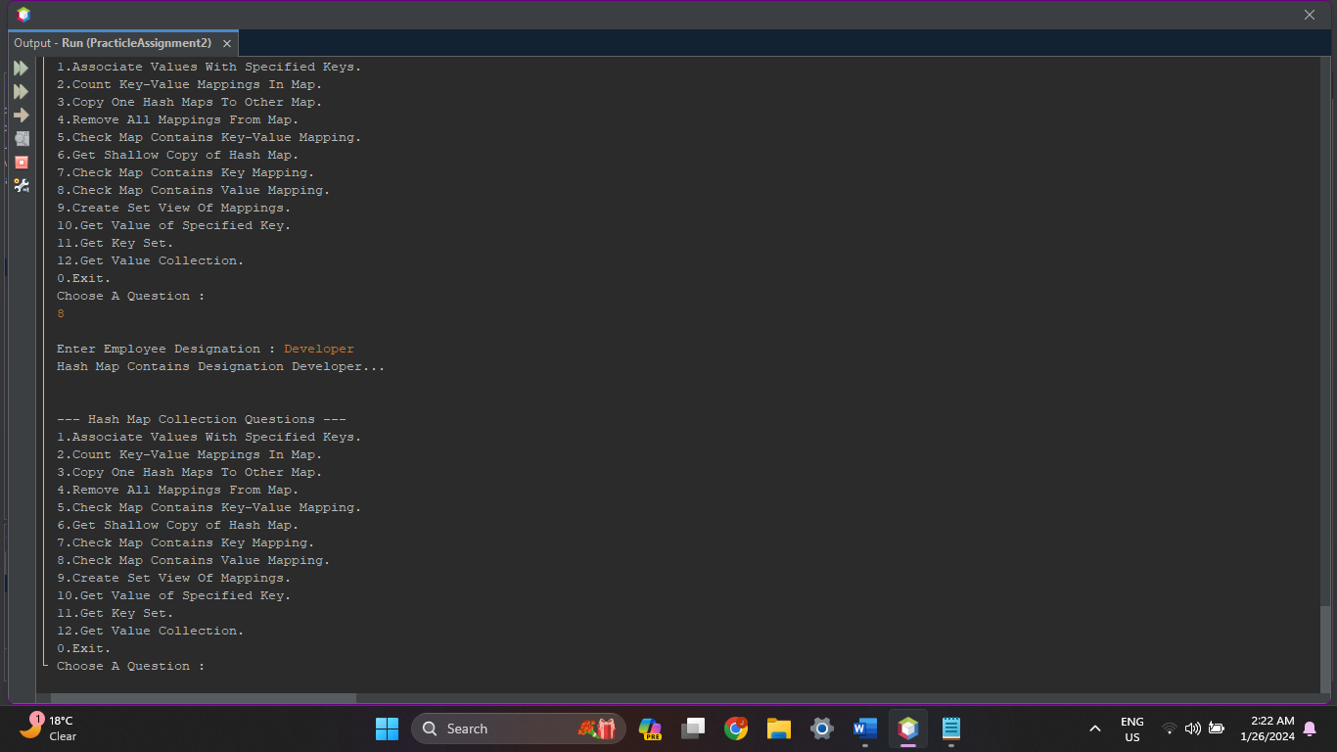

1. **Write a Java program to create a set view of the mappings contained in a map.**

**Source Code :**

protected void CreateSetView(HashMap<String, String> Employee){

System.out.println("Your Employee List : ");

for(String K:Employee.keySet())

{

System.out.println("Name : "+K.toString());

System.out.println("Designation : "+Employee.get(K));

}

Set Employee2 = Employee.entrySet();

System.out.println("Your Employee Set : "+Employee2);

System.out.println();

}

**Output :**

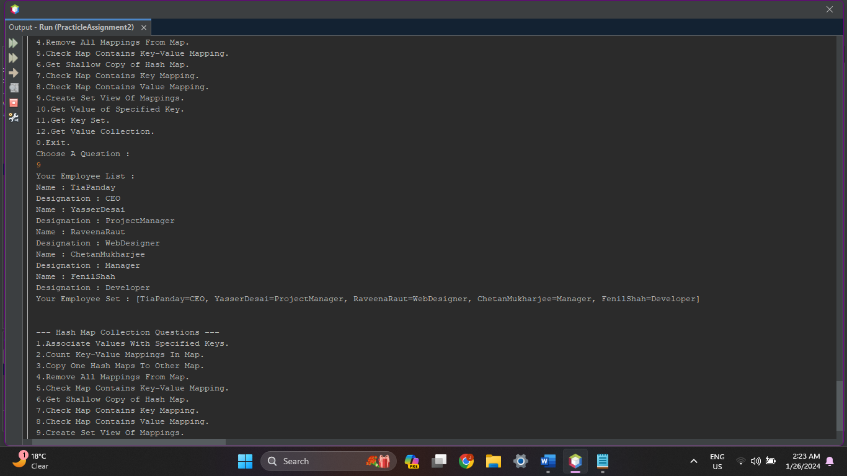

1. **Write a Java program to get the value of a specified key in a map.**

**Source Code :**

protected void GetValueOfKey(HashMap<String, String> Employee){

String Key;

System.out.print("\nEnter Employee Name : ");

Key = in.next();

if(Employee.containsKey(Key))

{

System.out.print("\nEmployee "+Key+" has "+Employee.get(Key)+" Designation ");

}

else

{

System.out.println("No Employee Found With Name "+Key);

}

System.out.println();

}

**Output :**

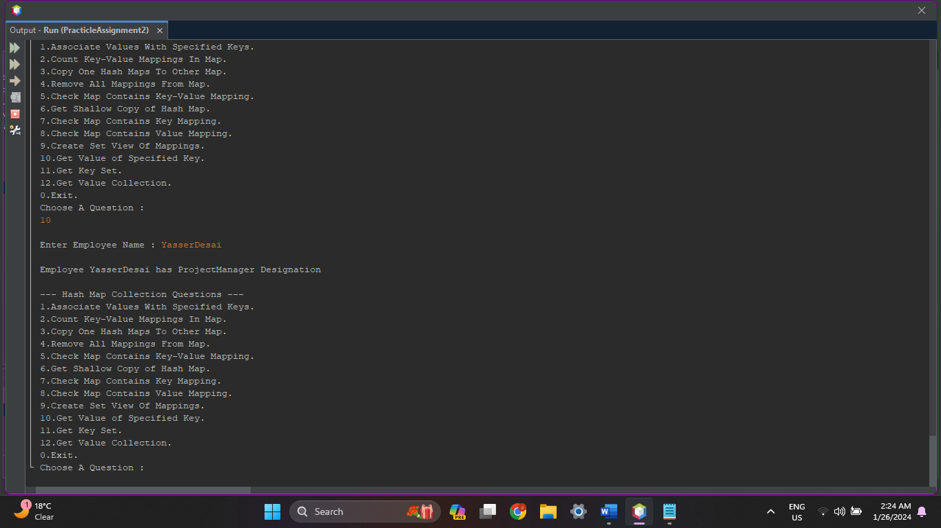

1. **Write a Java program to get a set view of the keys contained in this map.**

**Source Code :**

protected void GetKeySet(HashMap<String, String> Employee){

System.out.println("Your Employee List : ");

for(String K:Employee.keySet())

{

System.out.println("Name : "+K.toString());

System.out.println("Designation : "+Employee.get(K));

}

Set Employee2 = Employee.keySet();

System.out.println("Your Employee Key Set : "+Employee2);

System.out.println();

}

**Output :**

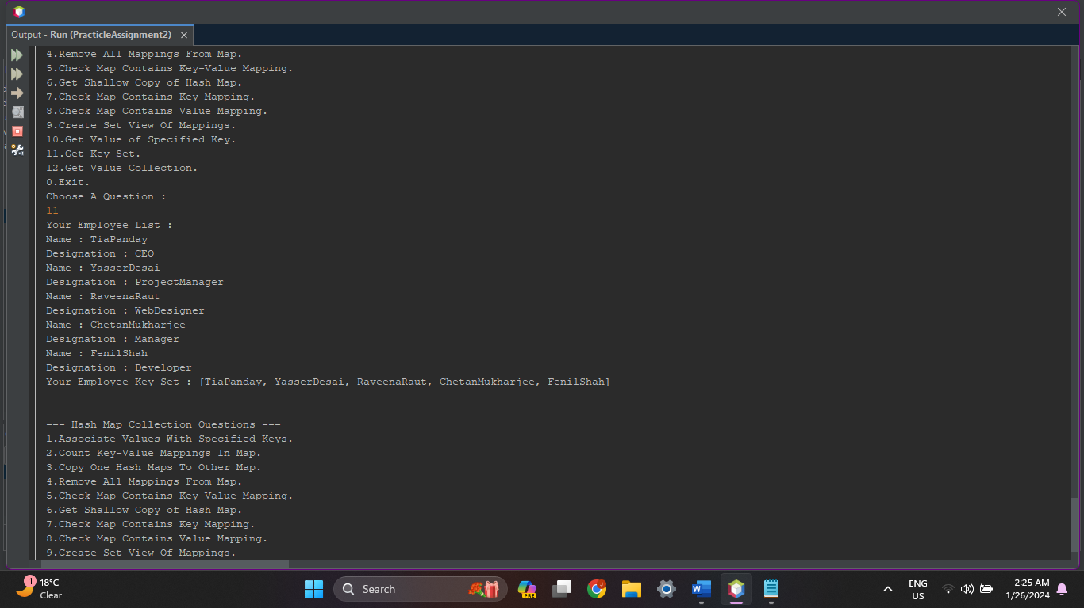

1. **Write a Java program to get a collection view of the values contained in this map.**

**Source Code :**

protected void GetValueCollection(HashMap<String, String> Employee){

System.out.println("Your Employee List : ");

for(String K:Employee.keySet())

{

System.out.println("Name : "+K.toString());

System.out.println("Designation : "+Employee.get(K));

}

Collection<String> Employee2 = Employee.values();

System.out.println("Your Designation Collection : "+Employee2);

System.out.println();

}

**Output :**

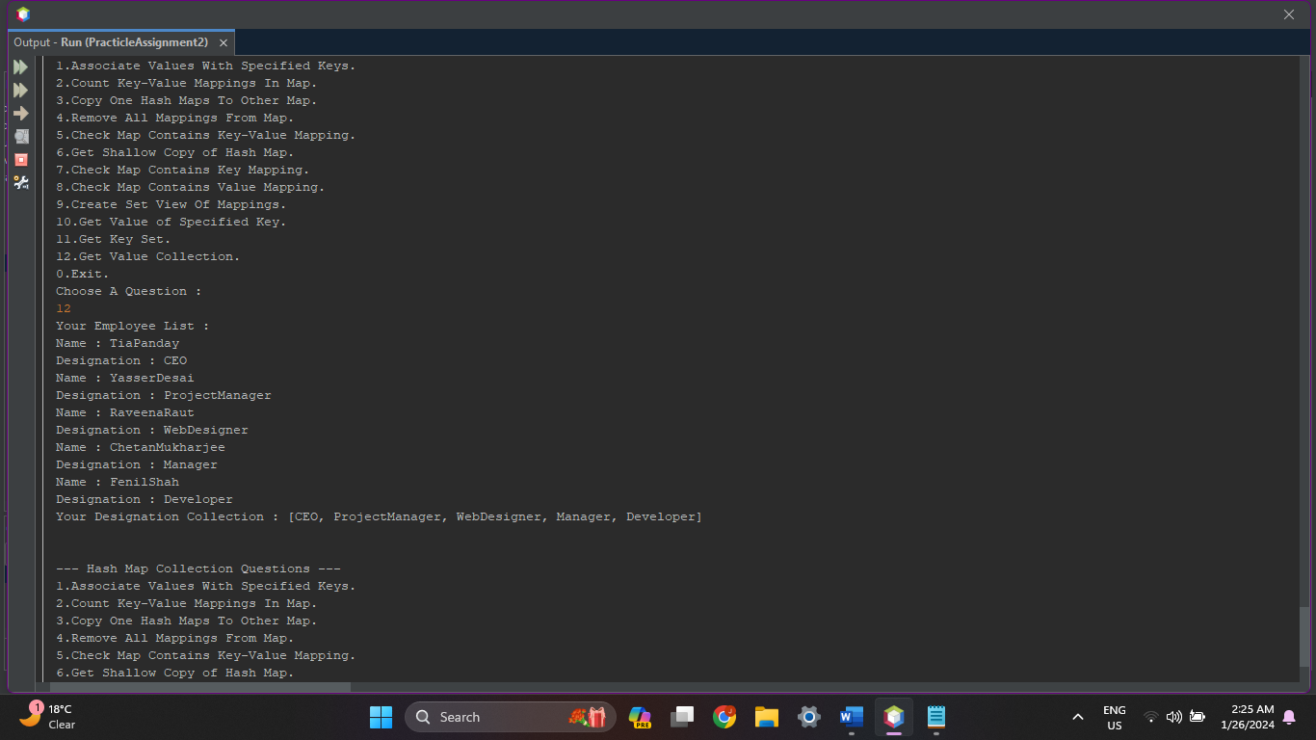

1. **Tree Map :**

TreeMap<String, Integer> Series = new TreeMap<String, Integer>();

1. **Write a Java program to associate the specified value with the specified key in a Tree Map.**

**Source Code :**

protected void AssociateKeyValues(TreeMap<String, Integer> Series){

String Key;

Integer Value;

System.out.println("\nHow Many Series You Want to Enter ?");

System.out.print(">");

int n = in.nextInt();

for(int i=0;i<n;i++)

{

System.out.print("\nEnter Series["+i+"] Name : ");

Key = in.next();

System.out.print("\nEnter Series["+i+"] Episodes : ");

Value = in.nextInt();

Series.put(Key, Value);

System.out.println();

}

System.out.println("Series List : ");

for(String K:Series.keySet())

{

System.out.println("Name : "+K.toString());

System.out.println("Episodes : "+Series.get(K));

}

System.out.println();

}

**Output :**

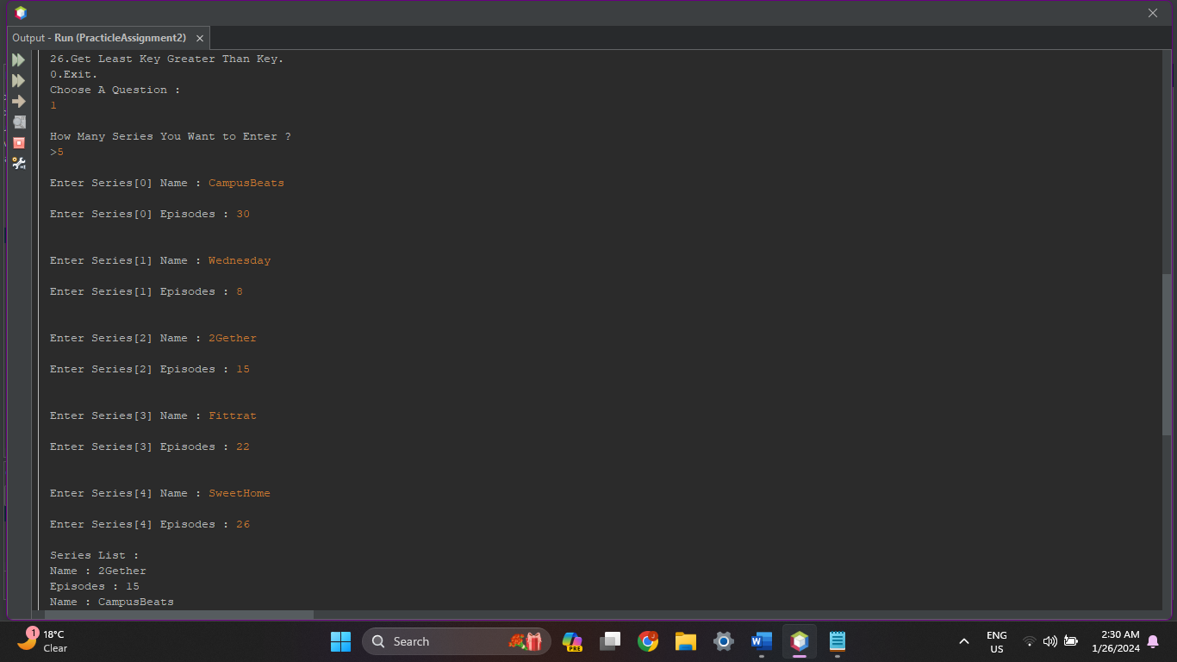

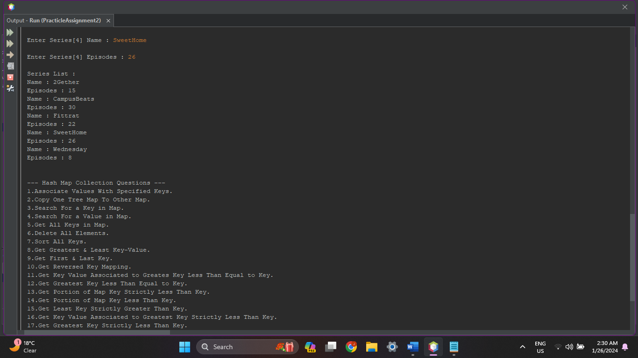

1. **Write a Java program to copy Tree Maps content to another Tree Map.**

**Source Code :**

protected void CopyOneTreeMapToOtherMap(TreeMap<String, Integer> Series){

System.out.println("Your Series List : ");

for(String K:Series.keySet())

{

System.out.println("Name : "+K.toString());

System.out.println("Episodes : "+Series.get(K));

}

TreeMap<String, Integer> Series2 = new TreeMap<String, Integer>(Series);

System.out.println("\nCoppied Employee List : ");

for(String K:Series2.keySet())

{

System.out.println("Name : "+K.toString());

System.out.println("Episodes : "+Series2.get(K));

}

System.out.println();

}

**Output :**

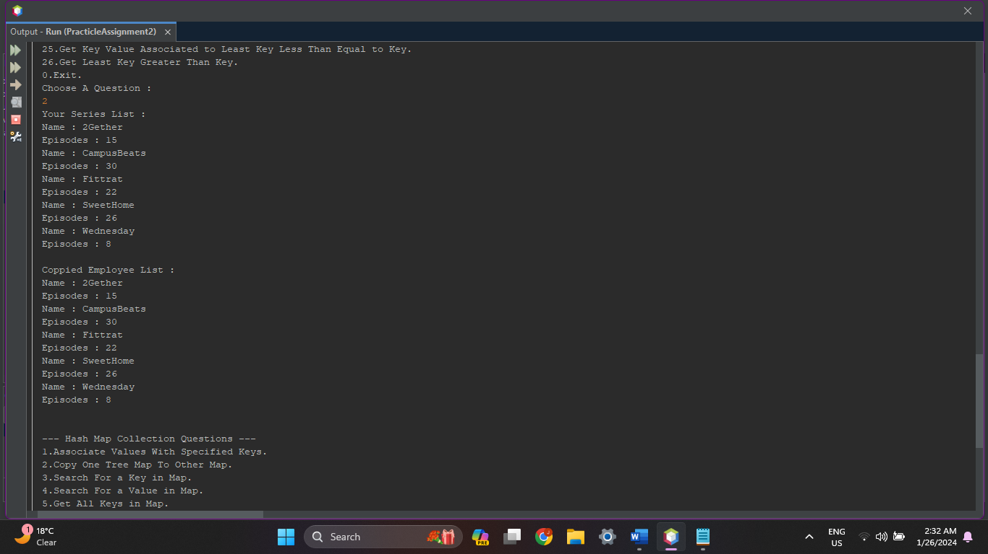

1. **Write a Java program to search for a key in a Tree Map.**

**Source Code :**

protected void SearchKey(TreeMap<String, Integer> Series){

String Key;

System.out.print("\nEnter Series Name : ");

Key = in.next();

if(Series.containsKey(Key))

{

System.out.println("Tree Map Contains Series "+Key+" With No. of Episodes "+Series.get(Key)+"...");

}

else

{

System.out.println("No Series "+Key+" Found in Tree Map...");

}

System.out.println();

}

**Output :**

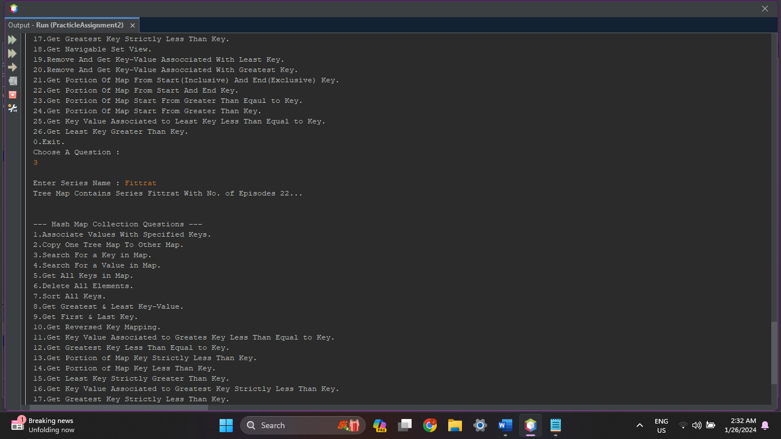

1. **Write a Java program to search for a value in a Tree Map.**

**Source Code :**

protected void SearchValue(TreeMap<String, Integer> Series){

Integer Value;

System.out.print("\nEnter No. Of Episodes : ");

Value = in.nextInt();

if(Series.containsValue(Value))

{

System.out.println("Tree Map Contains Series With No. of Episodes "+Value+"...");

}

else

{

System.out.println("No Series Found in Tree Map with No. of Episodes "+Value+"...");

}

System.out.println();

}

**Output :**

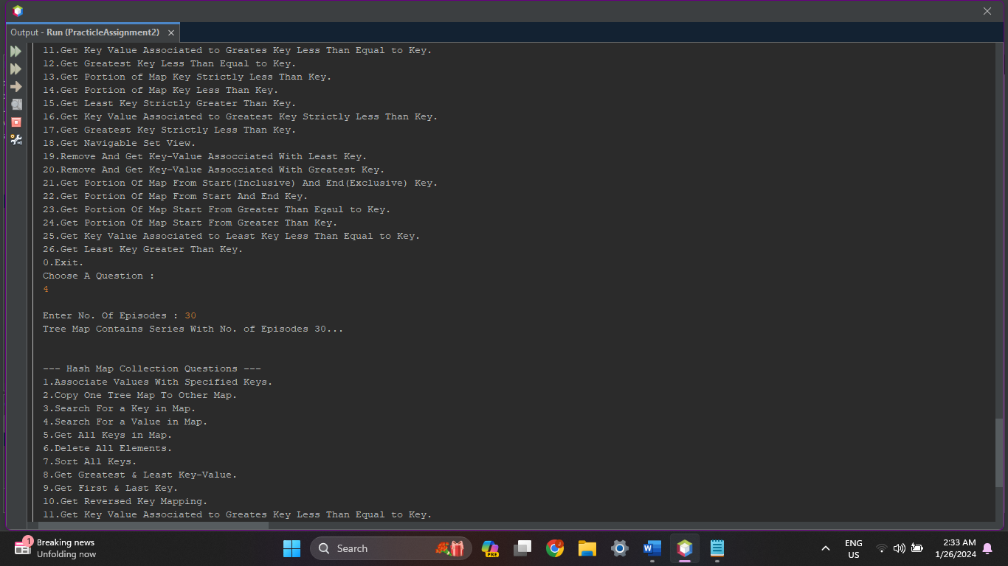

1. **Write a Java program to get all keys from a Tree Map.**

**Source Code :**

protected void GetAllKeys(TreeMap<String, Integer> Series){

System.out.print("\nKey List : "+Series.keySet());

System.out.println();

}

**Output :**

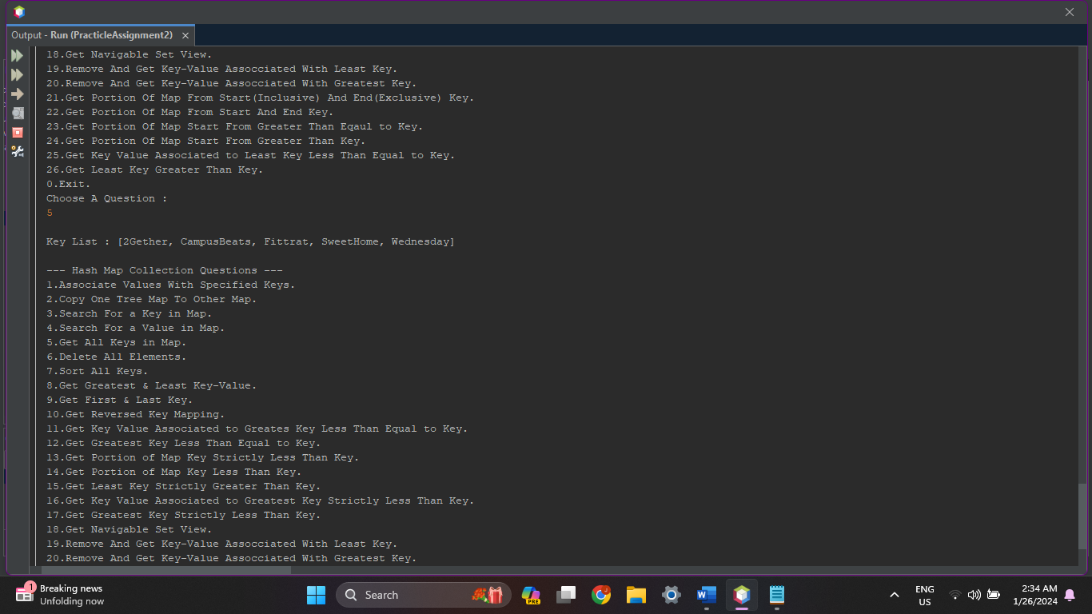

1. **Write a Java program to delete all elements from a Tree Map.**

**Source Code :**

protected void DeleteAllElements(TreeMap<String, Integer> Series){

Series.clear();

System.out.println("All Elements Deleted...");

System.out.println("Your Series List : ");

for(String K:Series.keySet())

{

System.out.println("Name : "+K.toString());

System.out.println("Episodes : "+Series.get(K));

}

System.out.println();

}

**Output :**

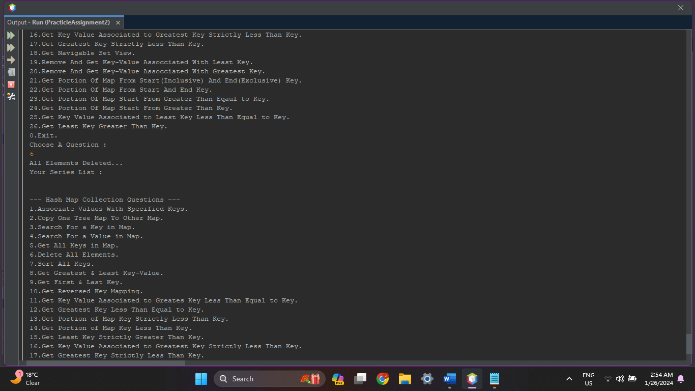

1. **Write a Java program to sort keys in a Tree Map by using a comparator.**

**Source Code :**

class sort_Keys implements Comparator<String>{

@Override

public int compare(String o1, String o2) {

return o1.compareTo(o2);

}

}

protected void SortKeysUsingComparator(TreeMap<String, Integer> Series){

TreeMap<String, Integer> Series2 = new TreeMap<String, Integer>(new sort_Keys());

Series2.putAll(Series);

System.out.println("Your Series List : ");

for(String K:Series.keySet())

{

System.out.println("Name : "+K.toString());

System.out.println("Episodes : "+Series.get(K));

}

System.out.println();

System.out.println("Sorted Series List : ");

for(String K:Series2.keySet())

{

System.out.println("Name : "+K.toString());

System.out.println("Episodes : "+Series2.get(K));

}

System.out.println();

}

**Output :**

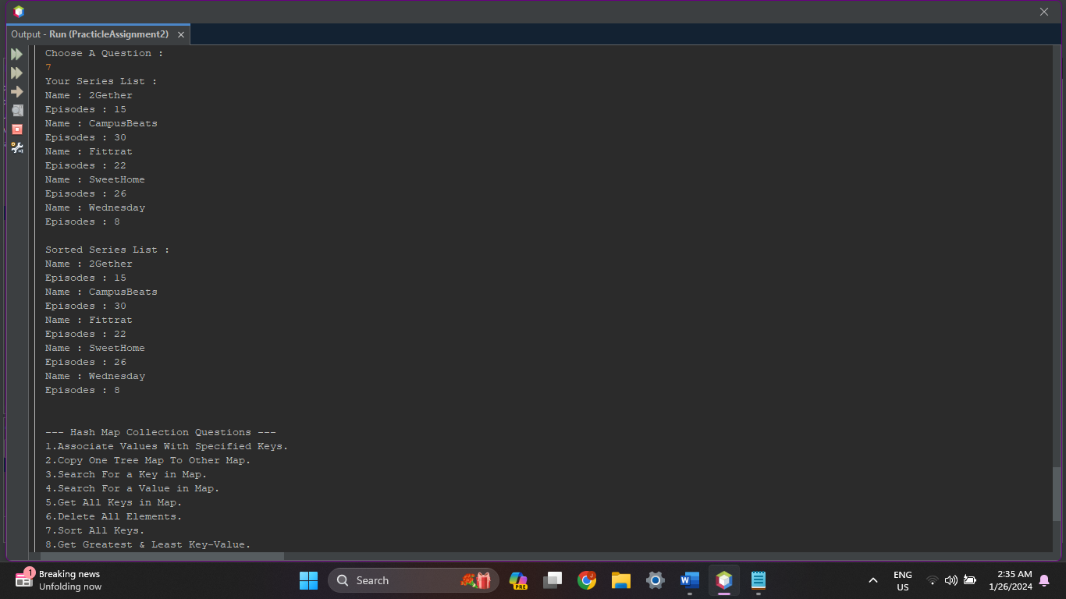

1. **Write a Java program to get a key-value mapping associated with the greatest key and the least key in a map.**

**Source Code :**

protected void GetGreaterLeastKeyValue(TreeMap<String, Integer> Series){

System.out.println("Your Series List : ");

for(String K:Series.keySet())

{

System.out.println("Name : "+K.toString());

System.out.println("Episodes : "+Series.get(K));

}

System.out.println("Greatest Key-Value in List : "+Series.firstEntry());

System.out.println("Least Key-Value in List : "+Series.lastEntry());

System.out.println();

}

**Output :**

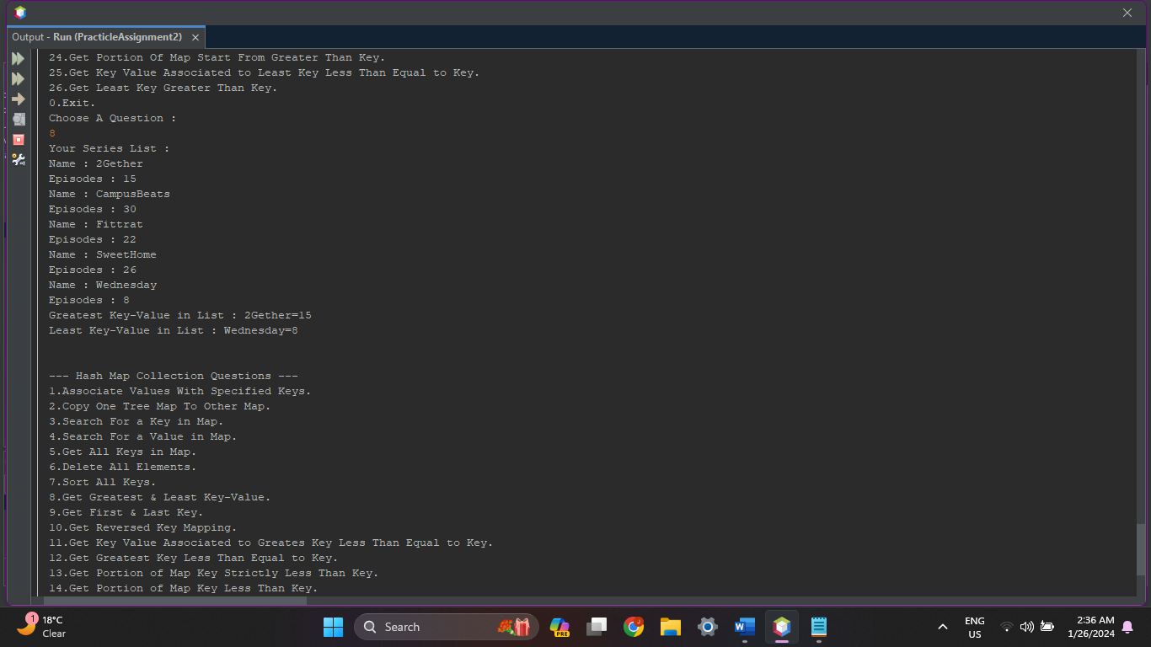

1. **Write a Java program to get the first (lowest) key and the last (highest) key currently in a map.**

**Source Code :**

protected void GetFirstLastKey(TreeMap<String, Integer> Series){

System.out.println("Your Series List : ");

for(String K:Series.keySet())

{

System.out.println("Name : "+K.toString());

System.out.println("Episodes : "+Series.get(K));

}

System.out.println("First Key in List : "+Series.firstKey());

System.out.println("Last Key in List : "+Series.lastKey());

System.out.println();

}

**Output :**

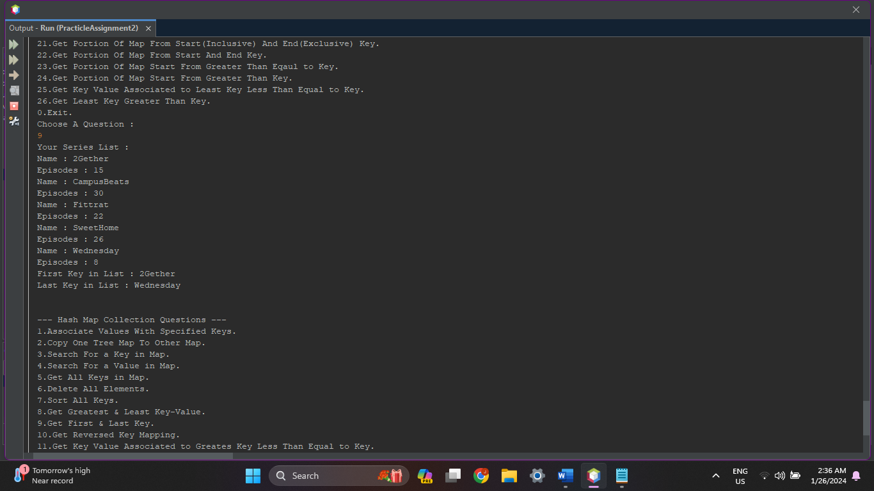

1. **Write a Java program to get a reverse order view of the keys contained in a given map.**

**Source Code :**

protected void GetReversedKeys(TreeMap<String, Integer> Series){

System.out.print("\nYour Key List : "+Series.keySet());

System.out.print("\nReversed Key List : "+Series.descendingMap());

System.out.println();

}

**Output :**

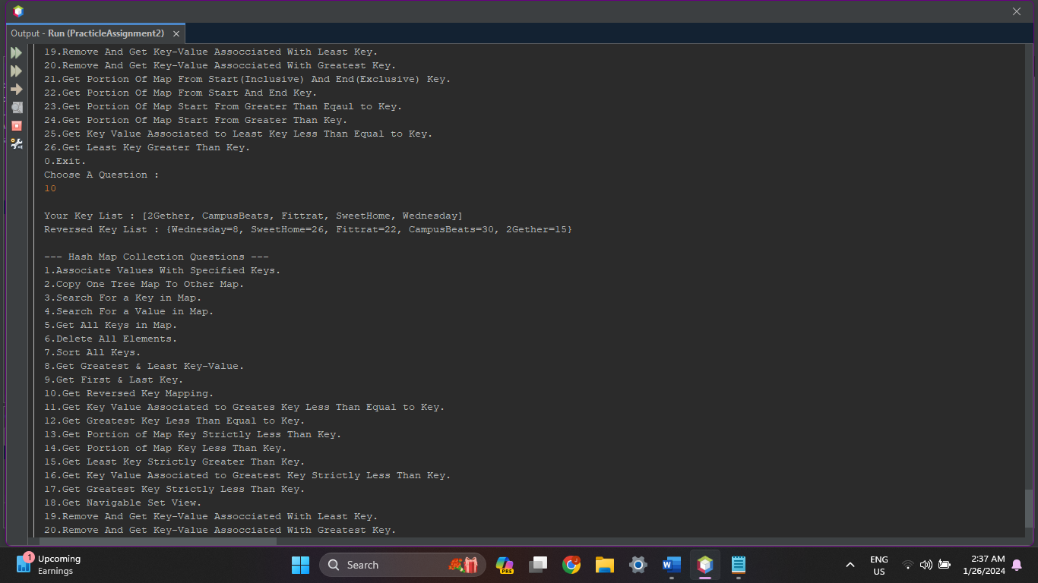

1. **Write a Java program to get a key-value mapping associated with the greatest key less than or equal to the given key.**

**Source Code :**

protected void GetKeyValueGreatestLessEqual(TreeMap<String, Integer> Series){

System.out.print("\nYour Key List : "+Series);

System.out.print("\nEnter Key : ");

String Key = in.next();

System.out.print("\nKey-Value Associated To Greatest key Less Equal to "+Key+" : "+Series.floorEntry(Key));

System.out.println();

}

**Output :**

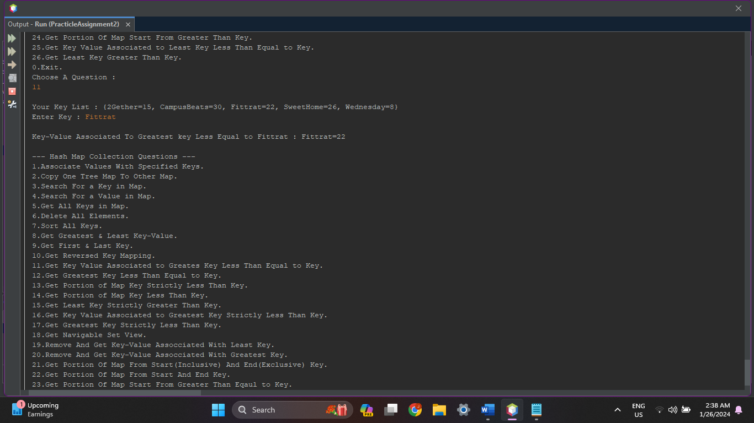

1. **Write a Java program to get the greatest key less than or equal to the given key.**

**Source Code :**

protected void GetGreatestKeyLessEqual(TreeMap<String, Integer> Series){

System.out.print("\nYour Key List : "+Series);

System.out.print("\nEnter Key : ");

String Key = in.next();

System.out.print("\nGreatest key Less Equal to "+Key+" : "+Series.floorKey(Key));

System.out.println();

}

**Output :**

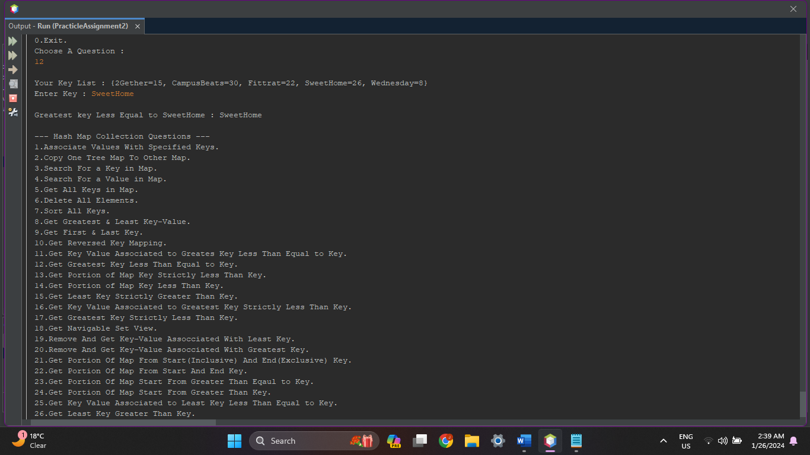

1. **Write a Java program to get the portion of a map whose keys are strictly less than a given key.**

**Source Code :**

protected void GetPortionStriuctlyLessThanKey(TreeMap<String, Integer> Series){

System.out.println("Your Series List : "+Series);

System.out.print("\nGive Key : ");

String Key = in.next();

System.out.println("Portion of Series List : "+Series.headMap(Key));

System.out.println();

}

**Output :**

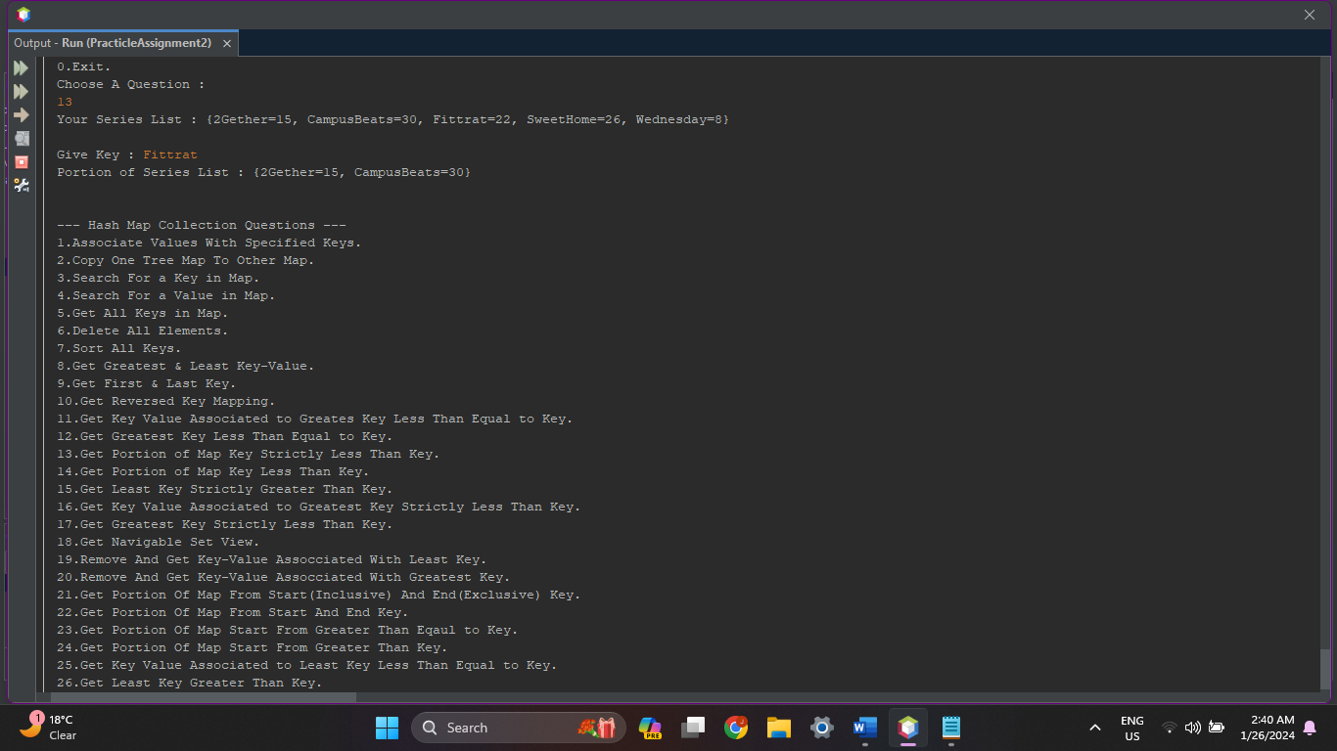

1. **Write a Java program to get the portion of this map whose keys are less than (or equal to, if inclusive is true) a given key.**

**Source Code :**

protected void GetPortionLessThanKey(TreeMap<String, Integer> Series){

System.out.println("Your Series List : "+Series);

System.out.print("\nGive Key : ");

String Key = in.next();

System.out.println("Portion of Series List : "+Series.headMap(Key, true));

System.out.println();

}

**Output :**

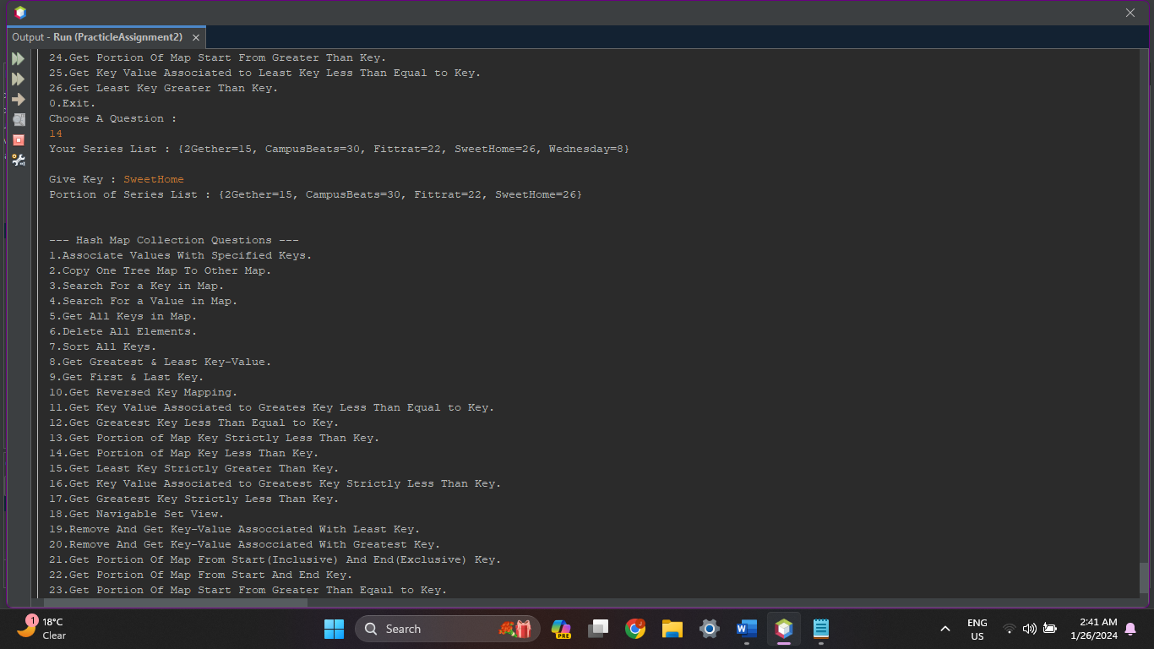

1. **Write a Java program to get the least key strictly greater than the given key. Return null if there is no such key.**

**Source Code :**

protected void GetLeastKeyStrictlyGreaterThanKey(TreeMap<String, Integer> Series){

System.out.print("\nYour Key List : "+Series);

System.out.print("\nEnter Key : ");

String Key = in.next();

System.out.print("\nLeast key Strictly Greater than "+Key+" : "+Series.higherKey(Key));

System.out.println();

}

**Output :**

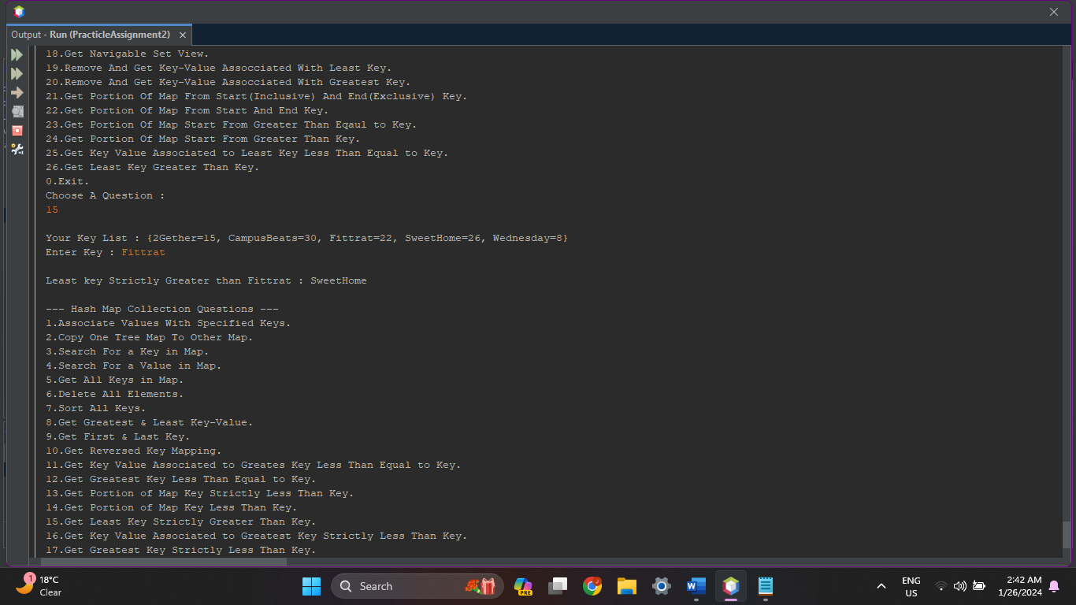

1. **Write a Java program to get a key-value mapping associated with the greatest key strictly less than the given key. Return null if there is no such key.**

**Source Code :**

protected void GetKeyValueGreatestKeyLessThan(TreeMap<String, Integer> Series){

System.out.print("\nYour Key List : "+Series);

System.out.print("\nEnter Key : ");

String Key = in.next();

System.out.print("\nKey-Value Associated To Greatest Key Strictly Less than "+Key+" : "+Series.lowerEntry(Key));

System.out.println();

}

**Output :**

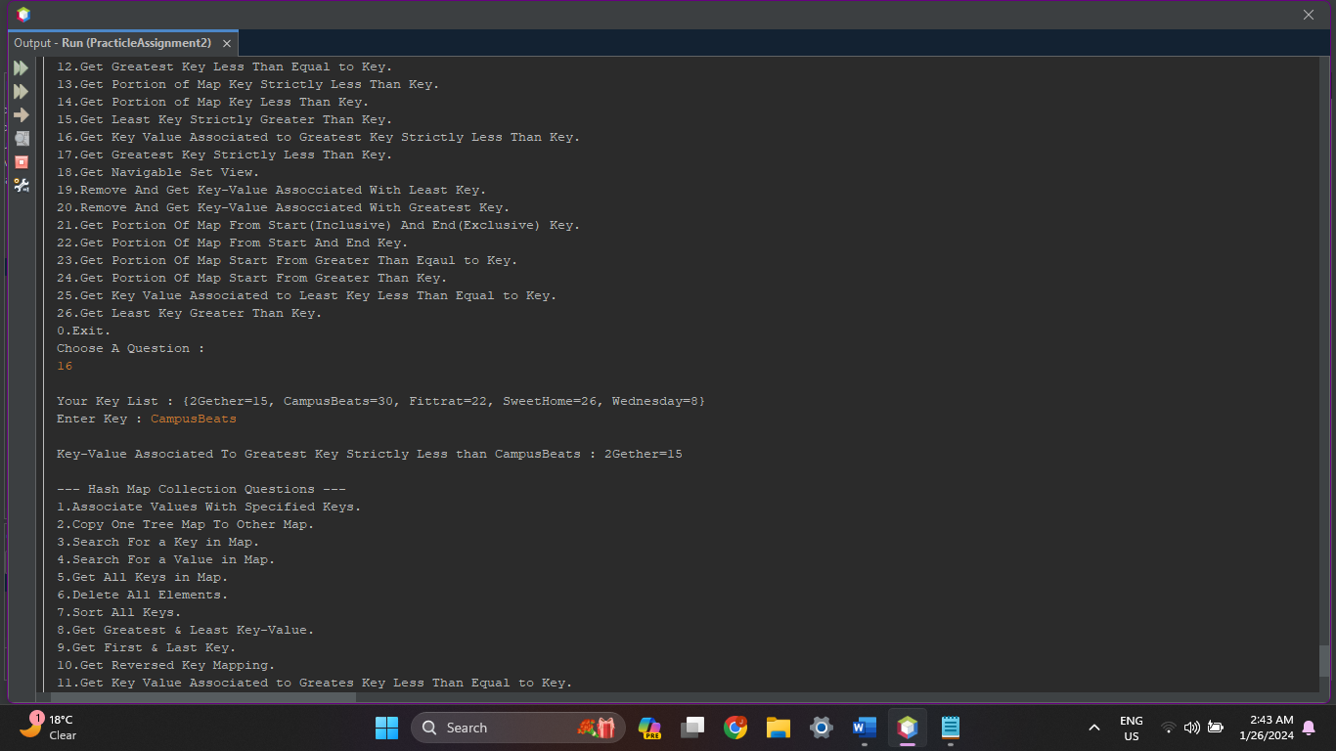

1. **Write a Java program to get the greatest key strictly less than the given key. Return null if there is no such key.**

**Source Code :**

protected void GetGreatestKeyStrictlyLessThan(TreeMap<String, Integer> Series){

System.out.print("\nYour Key List : "+Series);

System.out.print("\nEnter Key : ");

String Key = in.next();

System.out.print("\nGreatest Key Strictly Less than "+Key+" : "+Series.lowerKey(Key));

System.out.println();

}

**Output :**

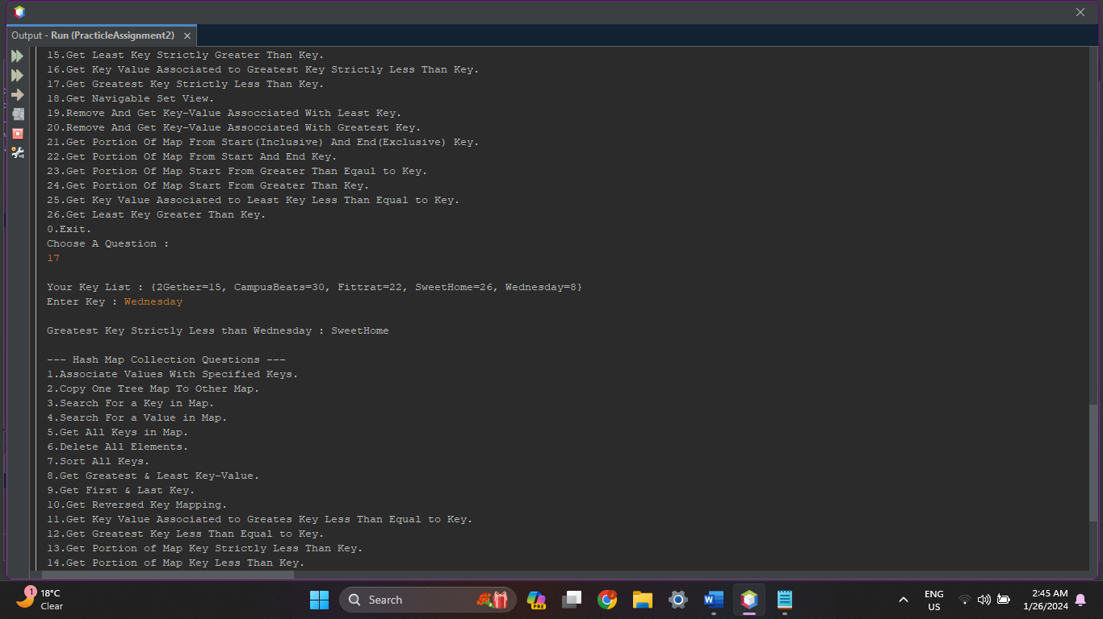

1. **Write a Java program to get a NavigableSet view of keys in a map.**

**Source Code :**

protected void GetNavigableSetView(TreeMap<String, Integer> Series){

System.out.print("\nNavigable Set View : "+Series.navigableKeySet());

System.out.println();

}

**Output :**

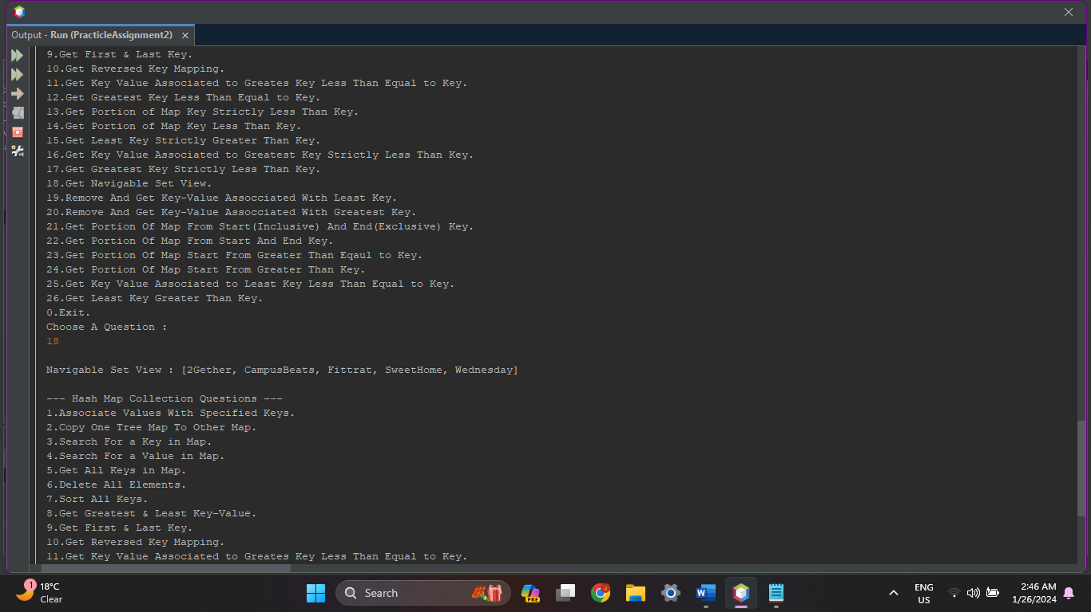

1. **Write a Java program to remove and get a key-value mapping associated with the least key in a map.**

**Source Code :**

protected void RemoveReturnLeastKeyValue(TreeMap<String, Integer> Series){

System.out.print("\nYour Key List : "+Series);

System.out.println("\n"+Series.pollFirstEntry()+" Removed!!");

System.out.println();

}

**Output :**

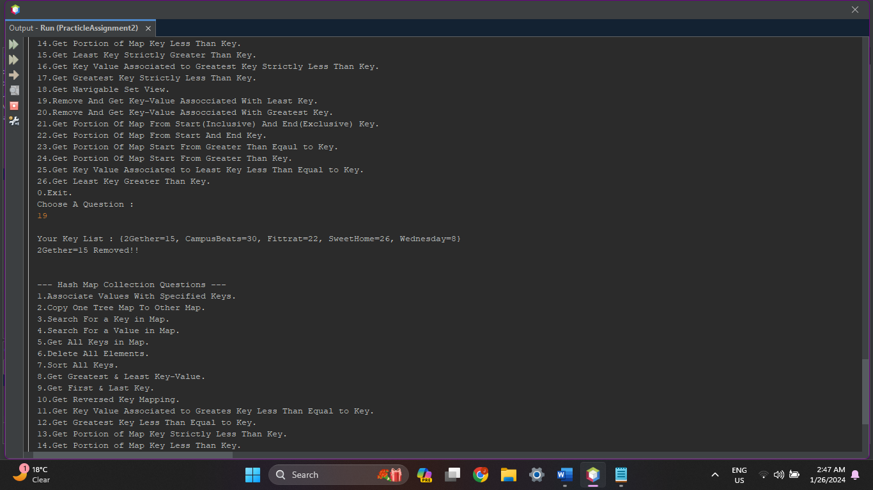

1. **Write a Java program to remove and get a key-value mapping associated with the greatest key in this map.**

**Source Code :**

protected void RemoveReturnGreatestKeyValue(TreeMap<String, Integer> Series){

System.out.print("\nYour Key List : "+Series);

System.out.println("\n"+Series.pollLastEntry()+" Removed!!");

System.out.println();

}

**Output :**

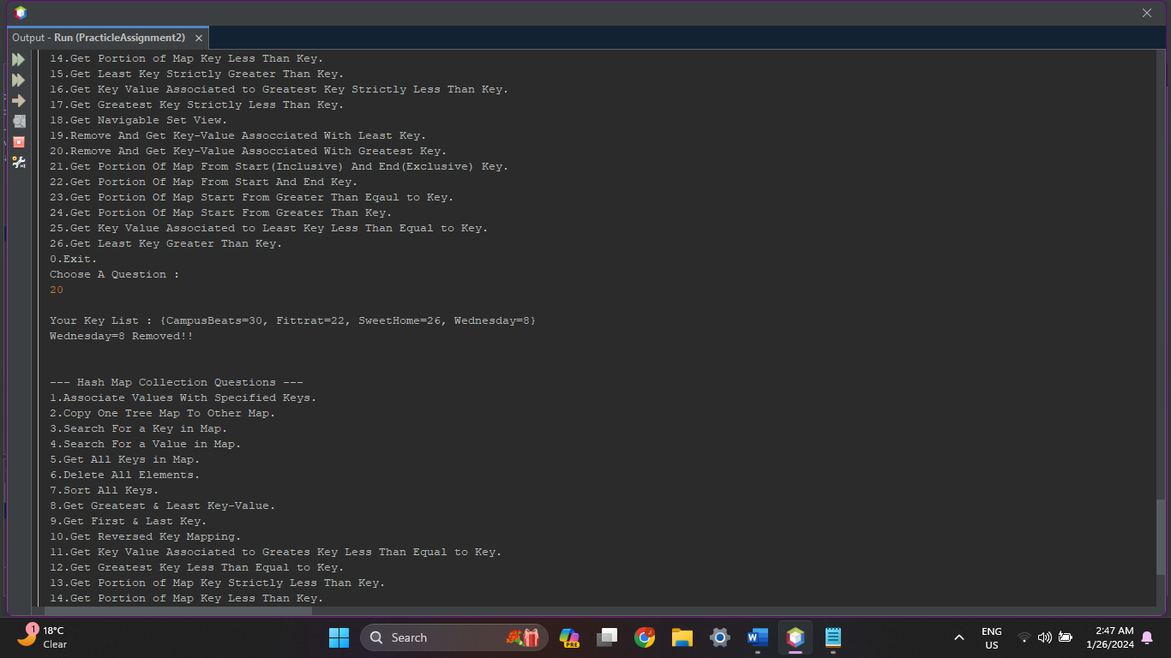

1. **Write a Java program to get the portion of a map whose keys range from a given key (inclusive) to another key (exclusive).**

**Source Code :**

protected void GetPortionInclusiveExclusive(TreeMap<String, Integer> Series){

System.out.print("\nGive Start Key : ");

String Start = in.next();

System.out.print("\nGive End Key : ");

String End = in.next();

System.out.println("\nPortion of Map : "+Series.subMap(Start, true, End, true));

System.out.println();

}

**Output :**

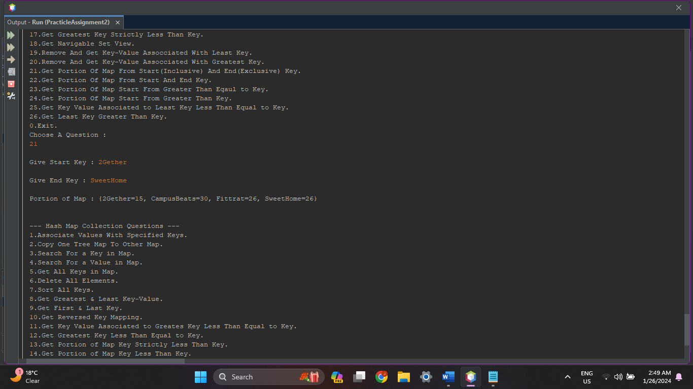

1. **Write a Java program to get the portion of a map whose keys range from a given key to another key.**

**Source Code :**

protected void GetPortion(TreeMap<String, Integer> Series){

System.out.print("\nGive Start Key : ");

String Start = in.next();

System.out.print("\nGive End Key : ");

String End = in.next();

System.out.println("\nPortion of Map : "+Series.subMap(Start, End));

System.out.println();

}

**Output :**

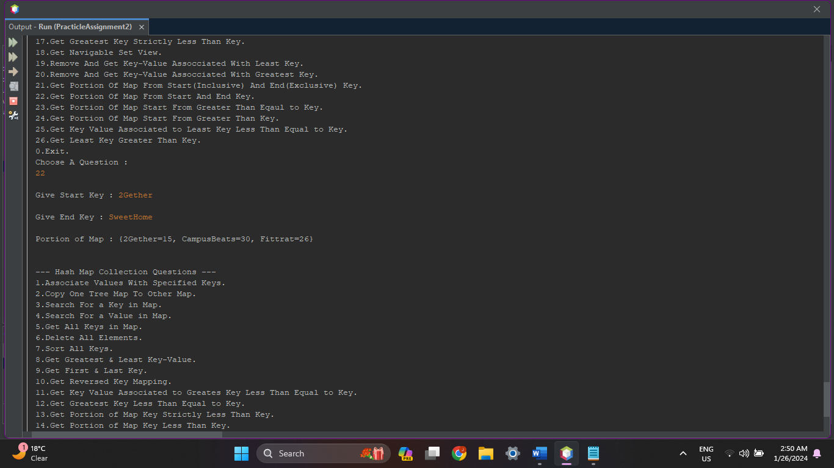

1. **Write a Java program to get a portion of a map whose keys are greater than or equal to a given key.**

**Source Code :**

protected void GetPortionKeyGreaterEqualKey(TreeMap<String, Integer> Series){

System.out.print("\nGive Key : ");

String Start = in.next();

System.out.println("\nPortion of Map : "+Series.tailMap(Start));

System.out.println();

}

**Output :**

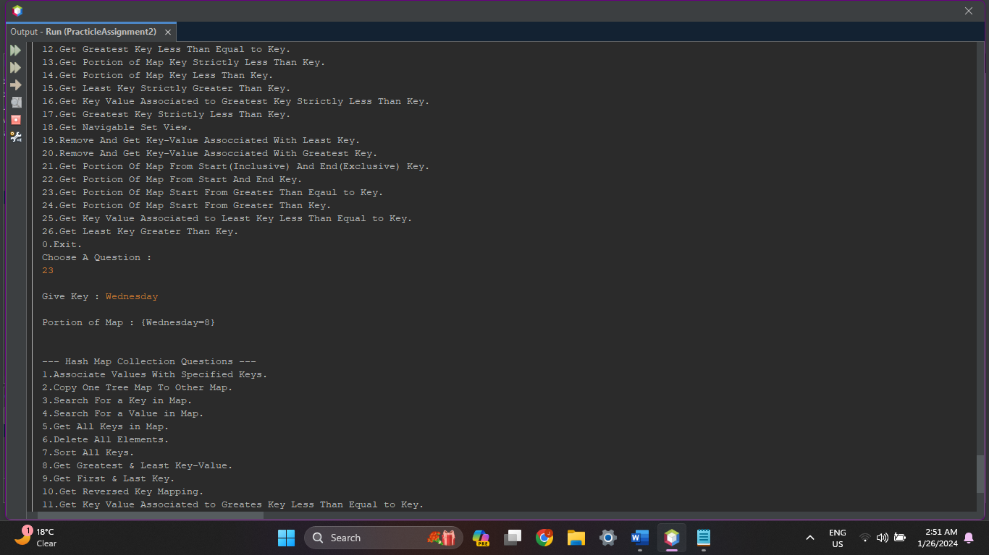

1. **Write a Java program to get a portion of a map whose keys are greater than a given key.**

**Source Code :**

protected void GetPortionKeyGreaterThanKey(TreeMap<String, Integer> Series){

System.out.print("\nGive Key : ");

String Start = in.next();

System.out.println("\nPortion of Map : "+Series.tailMap(Start, true));

System.out.println();

}

**Output :**

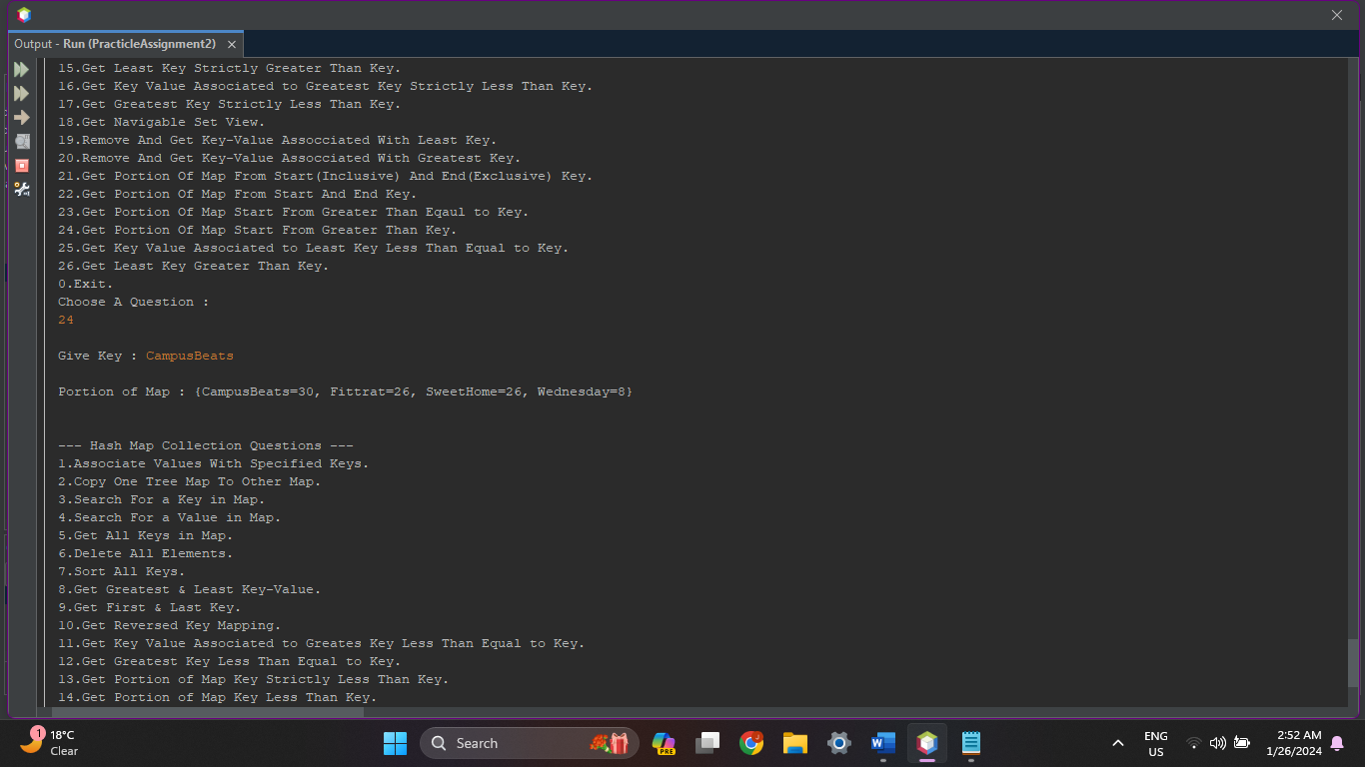

1. **Write a Java program to get a key-value mapping associated with the least key greater than or equal to the given key. Return null if there is no such key.**

**Source Code :**

protected void GetKeyValueLeastGreaterEqual(TreeMap<String, Integer> Series){

System.out.print("\nYour Key List : "+Series);

System.out.print("\nEnter Key : ");

String Key = in.next();

System.out.print("\nKey-Value Associated To Least Key Greater Equal to "+Key+" : "+Series.ceilingEntry(Key));

System.out.println();

}

**Output :**

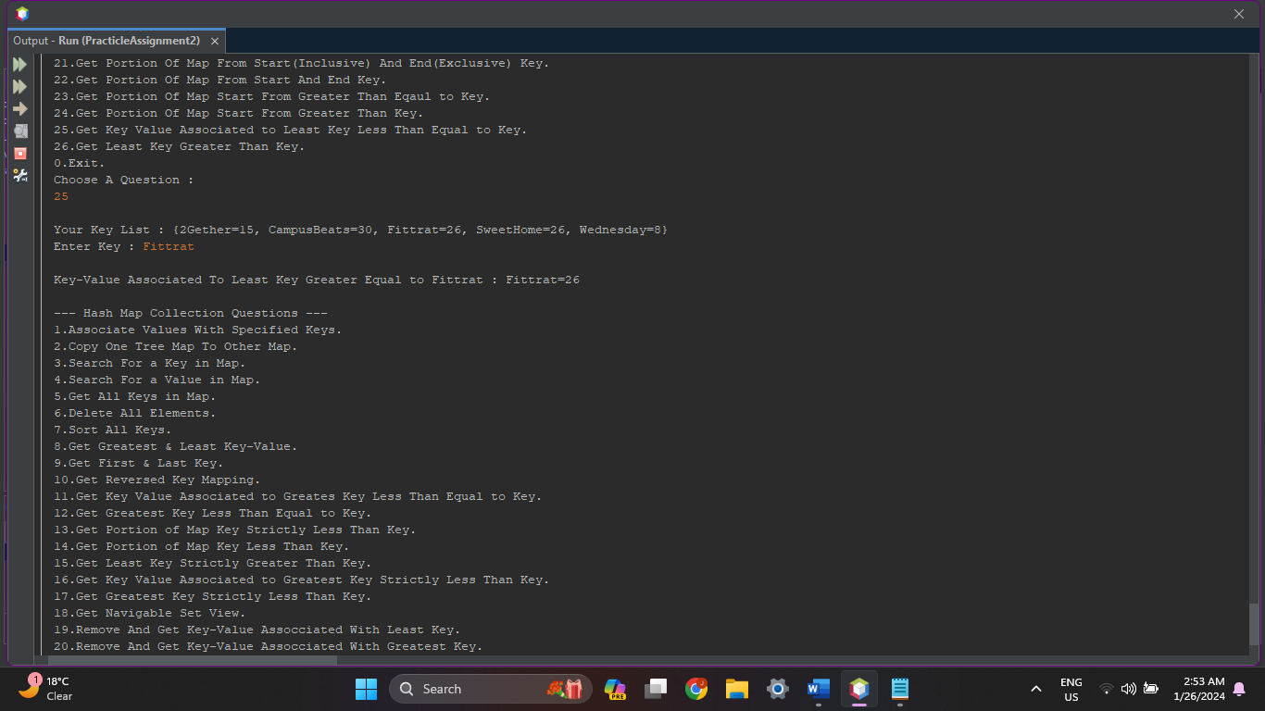

1. **Write a Java program to get the least key greater than or equal to the given key. Returns null if there is no such key.**

**Source Code :**

protected void GetLeastKeyGreaterThan(TreeMap<String, Integer> Series){

System.out.print("\nYour Key List : "+Series);

System.out.print("\nEnter Key : ");

String Key = in.next();

System.out.print("\nLeast Key Greater Than Equal to "+Key+" : "+Series.ceilingKey(Key));

System.out.println();

}

**Output :**



